Migrant Lifestyle Bibliography Links
Title |  | Author/ Illustrator | Publisher | ISBN | Age | Languages | Summary | Links
Family Pictures  Cuadros de familia | 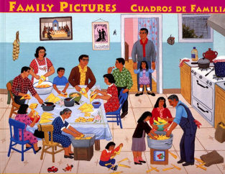 | Carmen Lomas Garza / Carmen Lomas Garza | Children’s Book Press | 978-0-89239-207-0 | All | Bilingual  English & Spanish | The author describes, in bilingual text and illustrations, her experiences growing up in a Hispanic community in Texas. | http://www.amazon.com/Cuadros-familia-Family-Pictures-Carmen/dp/0892391081
Calling the Doves  El canto de las palomas | 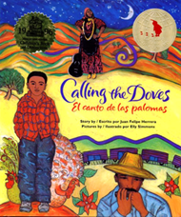 | Juan Felipe Herrera / Elly Simmons | Children’s Book Press | 978-0-89239-166-0 | Elem | Bilingual  English & Spanish | EZRA JACK KEATS BOOK AWARD  The author recalls his childhood in the mountains and valleys of California with his farm worker parents who inspired him with poetry and song. | http://www.amazon.com/s/ref=nb_sb_noss?url=search-alias%3Dstripbooks&field-keywords=Calling+the+Doves+El+canto+de+las+palomas&x=14&y=16
My Diary from Here to There  Mi diario de aquí hasta allá | 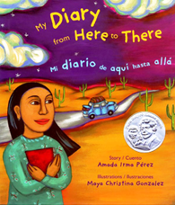 | Amada Irma Pérez / Maya Christina Gonzalez | Children’s’ Book Press | 978-0-89239-175-2 | Elem  Early Secondary | Bilingual  English & Spanish | PURA BELPRÉ HONOR BOOK  A young girl describes her feelings when her family decides to leave their home in Mexico to look for work in the United States. | http://www.amazon.com/s/ref=nb_sb_noss?url=search-alias%3Dstripbooks&field-keywords=Calling+the+Doves+El+canto+de+las+palomas&x=14&y=16#/ref=nb_sb_noss?url=search-alias%3Dstripbooks&field-keywords=My+Diary+from+Here+to+There+Mi+diario+de+aqu%C3%AD+hasta+all%C3%A1&rh=n%3A283155%2Ck%3AMy+Diary+from+Here+to+There+Mi+diario+de+aqu%C3%AD+hasta+all%C3%A1
First Day in Grapes | 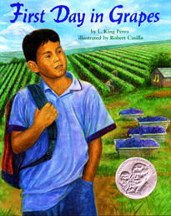 | L. King Pérez / Robert Casilla | Lee & Low Books | 978-1-58430-045-8 | Elem | English  Teacher guide available | PURA BELPRÉ HONOR BOOK  When Chico starts the third grade after his migrant family moves to begin harvesting California grapes, he finds that self-confidence and math skills help him cope with the first day of school. | http://www.amazon.com/s/ref=nb_sb_noss?url=search-alias%3Dstripbooks&field-keywords=Calling+the+Doves+El+canto+de+las+palomas&x=14&y=16#/ref=nb_sb_noss?url=search-alias%3Dstripbooks&field-keywords=First+Day+in+Grapes&rh=n%3A283155%2Ck%3AFirst+Day+in+Grapes
Title |  | Author/ Illustrator | Publisher | ISBN | Age | Languages | Summary | Links
Harvesting Hope  The Story of Cesar Chavez | 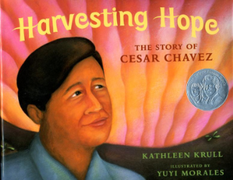 | Kathleen Krull /  Yuyi Morales | Harcourt | 978-0-15-201437-7 | Elem.  Early Secondary | English | PURA BELPRÉ HONOR BOOK  A biography of Cesar Chavez, from age ten when he and his family lived happily on their Arizona ranch, to age thirty-eight when he led a peaceful protest against California migrant workers’ miserable working conditions. | http://www.amazon.com/Harvesting-Hope-Story-Cesar-Chavez/dp/0152014373
Gathering the Sun: An Alphabet In Spanish And English | 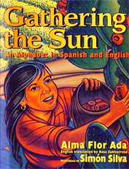 | Alma Flor Ada / Simón Silva | Harper Collins Publishers | 9780688170677 | All ages | Bilingual  English & Spanish | PURA BELPRÉ HONOR BOOK  Simple words and sundrenched paintings take us into the lives of migrant farmworkers. The Spanish alphabet is a template for twenty-eight poems that celebrate pride, family, heritage, and the harvest. | http://www.amazon.com/Gathering-Sun-Alphabet-Spanish-English/dp/0688170676/ref=pd_sim_b_2#reader_0688170676
Abuela’s Weave | 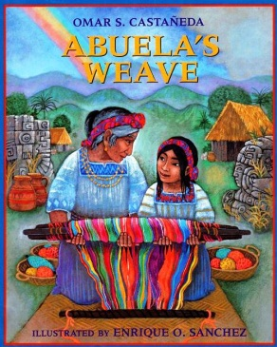 | Omar S. Castañeda/  Enrique O Sánchez | Lee and Low Books | 1-880000-00-8 | Elem. | English | PARENT’S CHOICE AWARD HONOREE  A Young Guatemalan girl and her grandmother grow closer as they weave some special creations and then make a trip to the market in hopes of selling them. | http://www.amazon.com/Abuelas-Weave-Omar-S-Castaneda/dp/1880000202
Amelia’s Road | 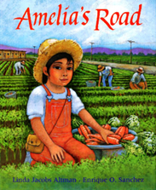 | Linda Altman / Enrique Sanchez | Lee & Low Books | 978-1-8800 00-04-5 | Elem. | English | Tired of moving around so much, Amelia, the daughter of migrant farm workers, dreams of a stable home | http://www.amazon.com/s/ref=nb_sb_noss?url=search-alias%3Dstripbooks&field-keywords=Amelia%E2%80%99s+Road&rh=n%3A283155%2Ck%3AAmelia%E2%80%99s+Road&ajr=0
Title |  | Author/ Illustrator | Publisher | ISBN | Age | Languages | Summary | Links
The Upside Down Boy  El niño de cabaza | 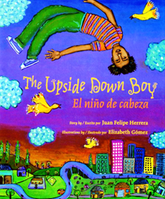 | Juan Felipe Herrera /  Elizabeth Gómez | Children’s book Press | 978-0-89239-162-2 | Elem | Bilingual  English & Spanish | The author recalls the year when his farm worker parents settled down in the city so that he could go to school for the first time. | http://www.amazon.com/s/ref=nb_sb_noss?url=search-alias%3Dstripbooks&field-keywords=The+Upside+Down+Boy+El+ni%C3%B1o+de+cabaza+&x=12&y=20
La Mariposa | 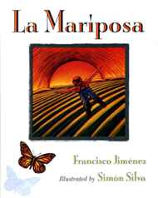 | Francísco Jimenez /  Simón Silva | Houghton Mifflin Company | 0-395-81663-7 (Eng.) | Primary | English & Spanish editions | Because he can only speak Spanish, Francisco, son of a migrant worker, has trouble when he begins first grade, but his fascination with the caterpillar in the classroom helps him begin to fit in. | http://www.amazon.com/s/ref=nb_sb_noss?url=search-alias%3Dstripbooks&field-keywords=Calling+the+Doves+El+canto+de+las+palomas&x=14&y=16#/ref=nb_sb_noss?url=search-alias%3Dstripbooks&field-keywords=La+Mariposa&rh=n%3A283155%2Ck%3ALa+Mariposa
The Harvest Birds  Los pájaros de la cosecha | 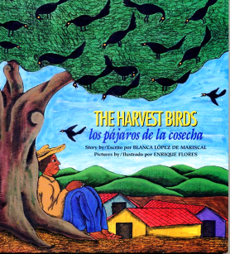 | Blanca López /  Enrique Flores | Children’s Book Press | 0-89239-131-6 | Elem. | Bilingual  English & Spanish | Juan Zanate dreams of being a farmer likes his father before him, but when his father died there was only enough land for his two older brothers. In this story from the Indian tradition in Mexico, Juan learns to determine his own destiny | http://www.amazon.com/s/?ie=UTF8&keywords=the+harvest+birds&tag=googhydr-20&index=stripbooks&hvadid=6064956025&ref=pd_sl_6x9jlg2ial_b
Radio Man  Also in the same book;  Children’s Broadcasting Radio;  La Fresa;  Mis Padres | 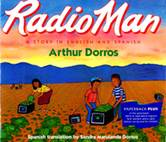 | Arthur Dorros / Sandra Marulanda Dorros | Houghton Mifflin | 0-395-73244-1 | Elem. | Bilingual  English & Spanish | This migrant lifestyle story is told as a family travels looking for work in Texas, Arizona, California and Sunnyside Washington. The book includes articles and poetry about fieldwork, El Teatro Campesino and a children’s broadcasting radio station. | http://www.amazon.com/s/ref=nb_sb_noss?url=search-alias%3Dstripbooks&field-keywords=Calling+the+Doves+El+canto+de+las+palomas&x=14&y=16#/ref=nb_sb_noss?url=search-alias%3Dstripbooks&field-keywords=Radio+Man&rh=n%3A283155%2Ck%3ARadio+Man
Title |  | Author/ Illustrator | Publisher | ISBN | Age | Languages | Summary | Links
A Gift for Abuelita Celebrating the Day of the Dead  Un regalo para abuelita | 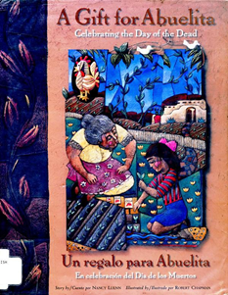 | Nancy Luenn /  Robert chapman | Rising Moon | 0-87358-688-3 | Elem. | Bilingual  English & Spanish | After her beloved grandmother dies, Rosita hopes to be reunited with Abuelita as she prepares a gift to give her when her family celebrates the Day of the Dead  (The author lives in Yakima Wa.) | http://www.amazon.com/Gift-Abuelita-regalo-para-Multilingual/dp/0873586883
Carlos and the Squash Plant  Carlos y la planta de calabaza | 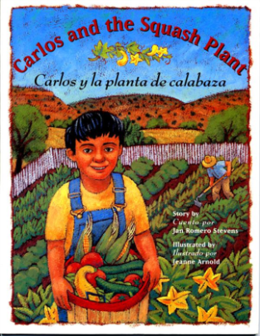 | Jan Romero Stevens / Jeanne Arnold | Northland Publishing | 0-87358-625-5 | Primary  Elem. | Bilingual  English & Spanish | Having ignored his mother’s warnings about what will happen if he doesn’t’ bath after working on his family’s farm, Carlos awakens one morning to find a squash growing out of his ear. | http://www.amazon.com/Carlos-Squash-planta-calabaza-Multilingual/dp/0873586255
Friends from the Other Side  Amigos del otro lado | 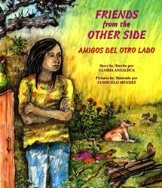 | Gloria Anzaldúa /  Consuelo Méndez | Children’s Book Press | 0-89239-113-8 | Elem.  Early Secondary | Bilingual  English & Spanish | Having crossed the Rio Grande into Texas with his mother in search of a new life, Joaquín receives help and friendship from Prietita, a brave young Mexican American girl | http://www.amazon.com/s/ref=nb_sb_noss?url=search-alias%3Dstripbooks&field-keywords=The+Upside+Down+Boy+El+ni%C3%B1o+de+cabaza+&x=12&y=20#/ref=nb_sb_noss?url=search-alias%3Dstripbooks&field-keywords=Friends+from+the+Other+Side+Amigos+del+otro+lado+&rh=n%3A283155%2Ck%3AFriends+from+the+Other+Side+Amigos+del+otro+lado+
Voices from the Fields  Children of Migrant Farmworkers Tell their Stories | 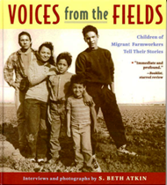 | S. Beth Atkin; Interviews and photos | Little, Brown and Co. | 0-316-05620-0 | Secondary Adult | English | ALA BEST BOOK FOR YOUNG ADULTS  Photographs, poems, and interviews with nine children reveal the hardships and hopes of Mexican American migrant farm workers and their families. | http://www.amazon.com/s/?ie=UTF8&keywords=voices+from+the+field&tag=googhydr-20&index=aps&hvadid=7014391637&ref=pd_sl_1bypkk895x_b
Title |  | Author/ Illustrator | Publisher | ISBN | Age | Languages | Summary | Links
Where the Cinnamon Winds Blow  Donde soplan los vientos de canela | 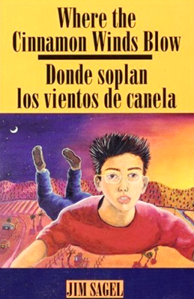 | Jim Sagel | Red Crane Books | 1-878610-32-5 | Secondary | Bilingual  English & Spanish | Spiced with traditional Hispanic folk tales, this magical fantasy is rooted in ten-year-old Tomás’s relationship with his wise and eccentric aunt Zulema. His journey toward maturity and self-realization is dramatized by a dream adventure in his quest to reconcile his feelings for the loss of his father. | http://www.amazon.com/Where-Cinnamon-Winds-Blow-vientos/dp/1878610325
Cesar Chavez | 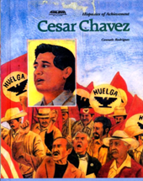 | Consuelo Rodriguez | Chelsea House Publishers | 0-7910-1259-X | Secondary Adult | English | Biography of the Mexican-American labor activist who organized and led the migrant farm workers in their struggle for better working condition. | http://www.amazon.com/s/ref=nb_sb_noss?url=search-alias%3Dstripbooks&field-keywords=The+Upside+Down+Boy+El+ni%C3%B1o+de+cabaza+&x=12&y=20#/ref=nb_sb_noss?url=search-alias%3Dstripbooks&field-keywords=Cesar+Chavez&rh=n%3A283155%2Ck%3ACesar+Chavez
With My Hands Full Con mis manos llenas | 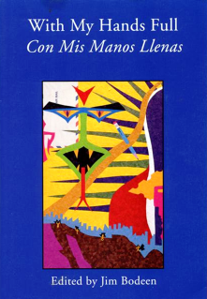 | By Latino high school students Edited by Jim Bodeen | Blue Begonia Press | 0-911287-33-7 | Secondary | Bilingual  English & Spanish | Stories and poems written by students enrolled in a writing course at Davis High School in Yakima WA. Great works of Latin American writers provide models. | http://www.alibris.com/search/books/qwork/4535923/used/My%20Hands%20Full%20Con%20MIS%20Manos%20Llenas%3A%20Anthology%20of%20Young%20Latino%20Voices
People Who Follow the Crops  (1978) | 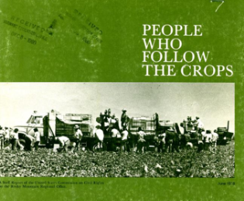 | Report by U.S. Commission on Civil Rights | U.S. Government Printing Office |  | Secondary  Adult | English | A photographic essay tells the story of perennial problems of migrant farmworkers who by definition are poor in terms of housing, health and education. The report calls for increased public attention. | http://openlibrary.org/books/OL17647970M/People_who_follow_the_crops  Download PDF of the book  http://cdn.calisphere.org/data/28722/4z/bk0003z5z4z/files/bk0003z5z4z-FID1.pdf
Title |  | Author/ Illustrator | Publisher | ISBN | Age | Languages | Summary | Links
The Circuit | 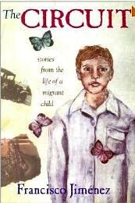 | Francisco Jiménez |  |  |  |  | "The Circuit," the story of young Panchito and his trumpet, is one of the most widely anthologized stories in Chicano literature. At long last, Jiménez offers more about the wise, sensitive little boy who has grown into a role model for subsequent generations of immigrants. | http://openlibrary.org/books/OL17647970M/People_who_follow_the_crops  http://www.amazon.com/The-Circuit-Stories-Migrant-Child/dp/0826317979
Breaking Through | 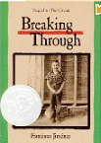 | Francisco Jiménez | Hampton-Brown |  | Secondary  Adult | English with Spanish phrases  Includes scaffolding and definitions of tier 2 words on each page | Young Francisco and his family had a hard life after leaving Mexico. They worked day after day as migrant farm workers. The family earned little money. They struggled to have the things they needed.  Francisco had to make a tough decision. He was a good student and he wanted a better life. But his father wanted him to stay and help his family. Was “Panchito” able to please his father without giving up his future? | http://openlibrary.org/books/OL17647970M/People_who_follow_the_crops
 | 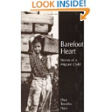 |  |  |  |  |  |  | http://openlibrary.org/books/OL17647970M/People_who_follow_the_crops
 | 