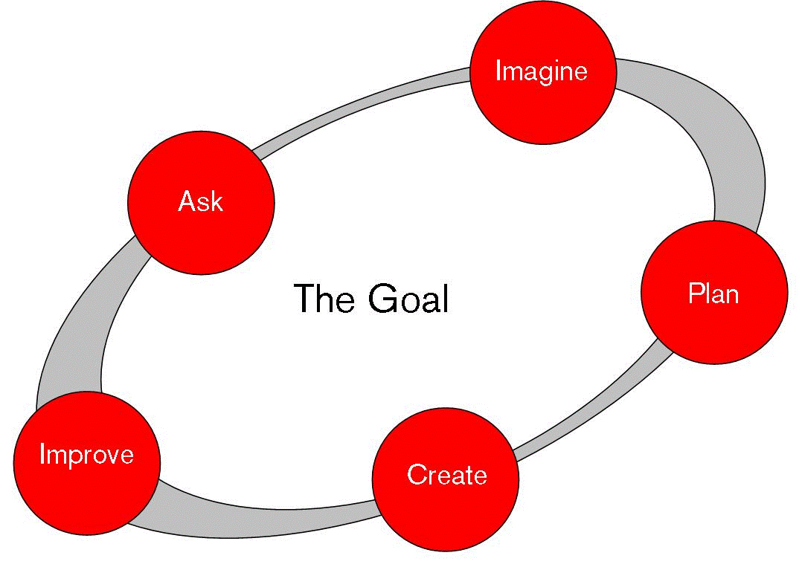
Engineering is Elementary: A Sticky Situation Designing Walls
Home School Connection: Lesson Two

Find and draw an object from your home.

What properties does your object have?
What properties does the material of the object have?
Ask your parents how they have used the design process in their home. Draw and label the steps of how they solved a problem that was solved through engineering at home, like grandpa.

