Engineering is Elementary: A Sticky Situation Designing Walls
Home School Connection: Lesson One

Teotihuacan, Mexico  Pyramid of the Moon taken from the Pyramid of the Sun |  | 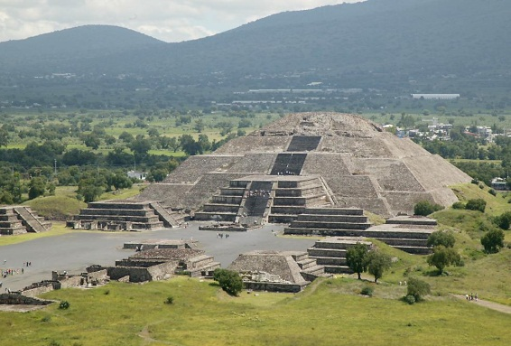
- What tools do you think the workers used to build the Pyramid of the Moon?

- Do you think they used the Engineering Design Process?

- Do you think they tested and improved the materials that they used? Why or why not?

- As your parents what their homes were made of when they were children? | An Adobe Mexican Home

