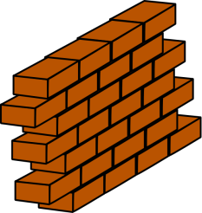
Engineering is Elementary: A Sticky Situation Designing Walls
Home School Connection: Lesson Three

Draw an inside or outside wall in your home.

How does your wall stay up?

What earth materials are used in your wall?

What are earth materials near your home that could be used for mortar?

