[](http://www.google.com/imgres?q=wall+mortar&um=1&safe=active&hl=en&biw=1366&bih=594&tbm=isch&tbnid=jrrBLRQVEMhKSM:&imgrefurl=http://depositphotos.com/10583549/stock-photo-Trowel-with-glove-hand-plastering-cement-mortar.html&docid=byNzCxfLo1eptM&imgurl=http://static8.depositphotos.com/1053932/1058/i/950/depositphotos_10583549-Trowel-with-glove-hand-plastering-cement-mortar.jpg&w=950&h=689&ei=5WPkUZ-lG86brQHB6ICQBw&zoom=1&ved=1t:3588,r:14,s:0,i:121&iact=rc&page=1&tbnh=178&tbnw=264&start=0&ndsp=16&tx=111&ty=60)

[](http://www.google.com/imgres?q=wall+mortar&um=1&safe=active&hl=en&biw=1366&bih=594&tbm=isch&tbnid=STSq_WLDJ82nxM:&imgrefurl=http://depositphotos.com/5255748/stock-photo-Brick-and-Mortar-Wall.html&docid=gcTUjV5yvoG0uM&imgurl=http://static5.depositphotos.com/1057757/525/i/950/depositphotos_5255748-Brick-and-Mortar-Wall.jpg&w=1024&h=682&ei=5WPkUZ-lG86brQHB6ICQBw&zoom=1&ved=1t:3588,r:9,s:0,i:106&iact=rc&page=1&tbnh=177&tbnw=273&start=0&ndsp=16&tx=196&ty=47)

[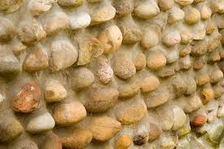](http://www.google.com/imgres?q=mortar+walls&um=1&safe=active&hl=en&biw=1366&bih=594&tbm=isch&tbnid=J5gh4mkbeJAW8M:&imgrefurl=http://www.ehow.com/how_7674393_build-rock-wall-mortar.html&docid=mKV5cMKFmda7hM&imgurl=http://img.ehowcdn.com/article-new/ehow/images/a07/a6/gp/build-rock-wall-mortar-800x800.jpg&w=424&h=283&ei=N2jkUfunBYHWrgHYloDAAw&zoom=1&ved=1t:3588,r:6,s:0,i:97&iact=rc&page=1&tbnh=183&tbnw=257&start=0&ndsp=17&tx=121&ty=59)

[](http://www.google.com/url?sa=i&rct=j&q=mortar+walls&source=images&cd=&cad=rja&docid=V9snhLvuV8qdeM&tbnid=xWwk-XyO8q1utM:&ved=0CAUQjRw&url=http://www.familyhandyman.com/masonry/how-to-repair-mortar-joints/view-all&ei=ZmjkUbf6JJDOqQG4oYG4Bw&bvm=bv.48705608,d.aWM&psig=AFQjCNElySQRKvvGD0A13th1-5n1gpScVQ&ust=1374009783476756)

[](http://www.google.com/imgres?q=mortar+walls&um=1&safe=active&hl=en&biw=1366&bih=594&tbm=isch&tbnid=59rnd5OcCKGakM:&imgrefurl=http://www.yelp.com/biz_photos/frazier-tile-danville?select=a12c9nEsTrkyiT82To9Yaw&docid=yF0nfV3BNzmE2M&imgurl=http://s3-media1.ak.yelpcdn.com/bphoto/a12c9nEsTrkyiT82To9Yaw/l.jpg&w=533&h=400&ei=N2jkUfunBYHWrgHYloDAAw&zoom=1&ved=1t:3588,r:56,s:0,i:255&iact=rc&page=4&tbnh=175&tbnw=259&start=52&ndsp=20&tx=132&ty=85)

[](http://www.google.com/imgres?q=mortar+walls&um=1&safe=active&hl=en&biw=1366&bih=594&tbm=isch&tbnid=AsDjH6NNaAYrlM:&imgrefurl=http://footage.shutterstock.com/clip-2278064-stock-footage-builder-aligns-the-angle-of-the-walls-with-putty.html&docid=YsB_rN4c5FImIM&imgurl=http://ak2.picdn.net/shutterstock/videos/1550158/preview/stock-footage-man-tiling-a-wall-applying-mortar-to-a-kitchen-wall-side-view-wide-angle.jpg&w=400&h=224&ei=N2jkUfunBYHWrgHYloDAAw&zoom=1&ved=1t:3588,r:61,s:0,i:270&iact=rc&page=4&tbnh=168&tbnw=299&start=52&ndsp=20&tx=108&ty=77)

[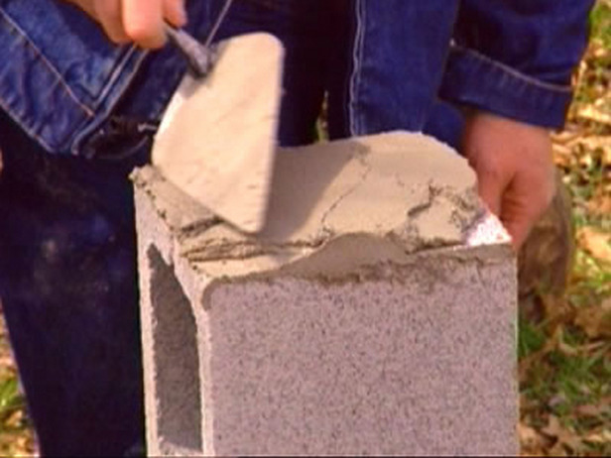](http://www.google.com/url?sa=i&rct=j&q=mortar+walls&source=images&cd=&cad=rja&docid=xghHpEjmzkQGDM&tbnid=FP5SBiJYVLQxFM:&ved=0CAUQjRw&url=http://www.diynetwork.com/how-to/how-to-build-a-stone-wall/&ei=2mjkUZfZIMWLqgHUxIGwAw&bvm=bv.48705608,d.aWM&psig=AFQjCNFAnvxlPHrvUXQ1so4k7kipzmzhhw&ust=1374009942366786)

[](http://www.google.com/imgres?q=engineers+testing+mortar+walls&um=1&safe=active&hl=en&biw=1366&bih=594&tbm=isch&tbnid=M-yC2RbzchXU0M:&imgrefurl=http://inberg-miller.com/projects/schools/k-12/&docid=KyXGkPweCGYYzM&imgurl=http://inberg-miller.com/wp-content/uploads/2010/08/PCSD1New-High-School-8-15-0606-560.jpg&w=560&h=373&ei=AGnkUbypA4S4qgH83oDgDA&zoom=1&ved=1t:3588,r:79,s:0,i:324&iact=rc&page=5&tbnh=183&tbnw=275&start=76&ndsp=16&tx=87&ty=67)

[](http://www.google.com/imgres?q=brick&safe=active&hl=en&biw=1366&bih=594&tbm=isch&tbnid=tTqRP6uKtXg79M:&imgrefurl=http://www.fatherryan.org/page.cfm?p=558&docid=tUeFAcaKDev6JM&imgurl=http://www.fatherryan.org/uploaded/Athletic_Complex/shutterstock_755319.jpg&w=1044&h=574&ei=AszlUdvZNM_lqAGX_IGgCA&zoom=1&ved=1t:3588,r:18,s:0,i:133&iact=rc&page=2&tbnh=166&tbnw=303&start=15&ndsp=16&tx=94&ty=77)

[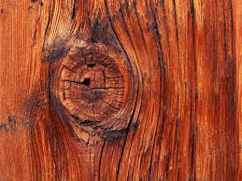](http://www.google.com/imgres?q=wood&safe=active&hl=en&biw=1366&bih=594&tbm=isch&tbnid=olrMjOILfsDzHM:&imgrefurl=http://cosmosflooring.com/blog/?p=302&docid=k5uROE2WOB12KM&imgurl=http://cosmosflooring.com/blog/wp-content/uploads/2013/05/wood.jpg&w=1600&h=1200&ei=IMzlUZboOsabrAGIhoD4CQ&zoom=1&ved=1t:3588,r:3,s:0,i:88&iact=rc&page=1&tbnh=178&tbnw=246&start=0&ndsp=16&tx=116&ty=60)

[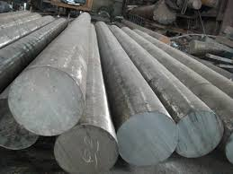](http://www.google.com/imgres?q=steel&safe=active&hl=en&biw=1366&bih=594&tbm=isch&tbnid=sj62_5UJwapRYM:&imgrefurl=http://jianhuisteel.en.made-in-china.com/productimage/obWQCHqlreRv-2f0j00seNEASLMGjuC/China-41Cr4-40Cr-ASTM5140-SCr440-Hot-Rolled-Alloy-Steel-Round-Bars.html&docid=THyQSP1_4TTBfM&imgurl=http://image.made-in-china.com/2f0j00kerQpPzmCMuA/41Cr4-40Cr-ASTM5140-SCr440-Hot-Rolled-Alloy-Steel-Round-Bars.jpg&w=2304&h=1728&ei=V8zlUbymLsfWqAHmuYGgCQ&zoom=1&ved=1t:3588,r:85,s:0,i:344&iact=rc&page=5&tbnh=190&tbnw=234&start=70&ndsp=16&tx=74&ty=76)

[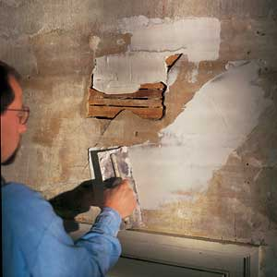](http://www.google.com/url?sa=i&rct=j&q=plaster&source=images&cd=&cad=rja&docid=PgG_k3QW1OUgYM&tbnid=GcKTypsj1aHFiM:&ved=&url=http://www.thisoldhouse.com/toh/article/0,,1172537,00.html&ei=mMzlUYzSEoLuqQHh_4CIDA&bvm=bv.49405654,d.aWM&psig=AFQjCNEAIOdVM-5WuvpmvZuxO2uWy-40Xg&ust=1374101016725294)

[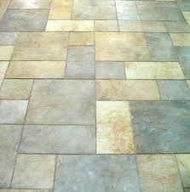](http://www.google.com/imgres?q=ceramic+tiles&safe=active&hl=en&biw=1366&bih=594&tbm=isch&tbnid=UXBVPsuBYTqv9M:&imgrefurl=http://www.seibertsmith.com/industry-updates/tile-porcelain-or-ceramic/&docid=f84JBF4n-lDTvM&imgurl=http://www.seibertsmith.com/wp-content/uploads/2012/04/porcelain-tile-flooring-2.jpg&w=400&h=405&ei=v8zlUeToBo-zrgH_yYGADw&zoom=1&ved=1t:3588,r:24,s:0,i:162&iact=rc&page=2&tbnh=175&tbnw=183&start=14&ndsp=24&tx=81&ty=43)

[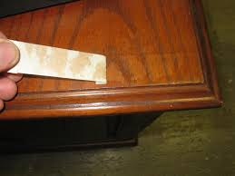](http://www.google.com/url?sa=i&rct=j&q=adhesion&source=images&cd=&cad=rja&docid=96RKCfbuJhZsVM&tbnid=F5kkoH1RMo995M:&ved=0CAUQjRw&url=http://denverhousepaintingpro.com/how-to-check-the-adhesion-of-a-paint-stain-coating/&ei=lqbtUdCwIseJrgGq9YDgAQ&bvm=bv.49478099,d.aWM&psig=AFQjCNHMRtd4ZToX0rJnmCXCu8ScewsKGA&ust=1374615511650778)

[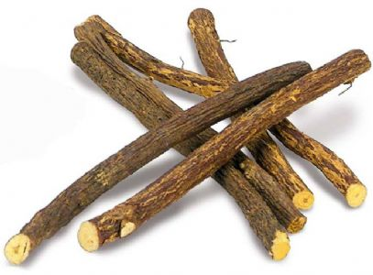](http://www.google.com/url?sa=i&rct=j&q=sticks&source=images&cd=&cad=rja&docid=6t-aEfW6xONAlM&tbnid=hK3kEVQ-YJ5VHM:&ved=0CAUQjRw&url=http://www.confectionaffection.net/6-liquorice-root-sticks-3949-p.asp&ei=v6btUf2rCofArQG1_oHoAg&bvm=bv.49478099,d.aWM&psig=AFQjCNERnplHzdBWkPmftc5Lu3npUcm3Cw&ust=1374615597917624)

[](http://www.google.com/url?sa=i&rct=j&q=twigs&source=images&cd=&cad=rja&docid=veMSwFH_k_tsJM&tbnid=Xr3_oSWuj3wKzM:&ved=0CAUQjRw&url=http://www.garyolsen.com/goclarke/digitalphotography/2007-1/feenstra/index.htm&ei=36btUcyHCIWSqwG_uoDACQ&bvm=bv.49478099,d.aWM&psig=AFQjCNEwhLTHHfVHHYPfyaE8r78gQ6cDXQ&ust=1374615643934699)

[](http://www.google.com/imgres?q=soil&safe=active&hl=en&biw=1366&bih=594&tbm=isch&tbnid=5iF4KmNpPobC5M:&imgrefurl=http://www.wakeforestnc.gov/soil-erosion-101-.aspx&docid=cr56npxl-LVt8M&imgurl=http://www.wakeforestnc.gov/Data/Sites/1/media/departments/engineering/soil.jpg&w=480&h=480&ei=96btUcDPNMbjrQGX64HYAg&zoom=1&ved=1t:3588,r:3,s:0,i:90&iact=rc&page=1&tbnh=193&tbnw=188&start=0&ndsp=17&tx=93&ty=98)

[](http://www.google.com/url?sa=i&rct=j&q=experiment&source=images&cd=&cad=rja&docid=5-QyMq1tfrUHDM&tbnid=fYHH-h747C1JrM:&ved=0CAUQjRw&url=http://www.photo-dictionary.com/phrase/6466/experiment.html&ei=SaftUenRAcr0qAHBoIH4Cw&bvm=bv.49478099,d.aWM&psig=AFQjCNFAD4WUMb9om37zhAv8sQE3mmyGLQ&ust=1374615748929447)[](http://www.google.com/url?sa=i&rct=j&q=experiment&source=images&cd=&cad=rja&docid=W7_LUoX1kiuGMM&tbnid=mntwIVjsMfCCRM:&ved=0CAUQjRw&url=http://protectportelos.org/the-mike-bravo-experiment-thwarting-retaliation/&ei=NqftUaKSGMShqQGV54GwCw&bvm=bv.49478099,d.aWM&psig=AFQjCNHPvQL-zPN8idHcOxCMI8xHc4ti5Q&ust=1374615729759891)

[](http://www.google.com/imgres?q=sand&safe=active&hl=en&biw=1366&bih=594&tbm=isch&tbnid=k8mA5dmLLsblYM:&imgrefurl=http://wisconsingeologicalsurvey.org/silica-sand.htm&docid=s3mCzi99e95kFM&imgurl=http://wisconsingeologicalsurvey.org/images/silica-sand.jpg&w=2816&h=2112&ei=WKftUZibNMnlrQGI-4H4BQ&zoom=1&ved=1t:3588,r:1,s:0,i:84&iact=rc&page=1&tbnh=182&tbnw=211&start=0&ndsp=16&tx=104&ty=116)

[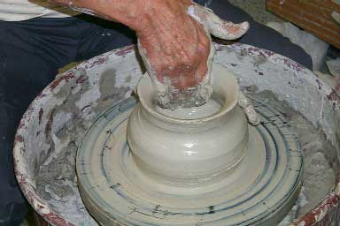](http://www.google.com/url?sa=i&rct=j&q=clay&source=images&cd=&cad=rja&docid=5ar7aCGyx6_53M&tbnid=OH7liIqdago8YM:&ved=0CAUQjRw&url=http://www.historyforkids.org/learn/arts/clay.htm&ei=hKftUZz0OciErQHPkYCYAg&bvm=bv.49478099,d.aWM&psig=AFQjCNFPOE3ICry0Edi0X0Fiuo-lfuyJDA&ust=1374615789758389)

[](http://www.google.com/url?sa=i&rct=j&q=crack&source=images&cd=&cad=rja&docid=DTY6QEiPhiv40M&tbnid=Pa2wrqarjpOkOM:&ved=0CAUQjRw&url=http://depositphotos.com/3399230/stock-photo-Elegant-split-crack-in-on-white-surface.html&ei=xKftUYLgE4a9qQHr1IGwBA&bvm=bv.49478099,d.aWM&psig=AFQjCNH7Lt-rdnRmIQ-zWrmbzepeN02_MA&ust=1374615865244472)

[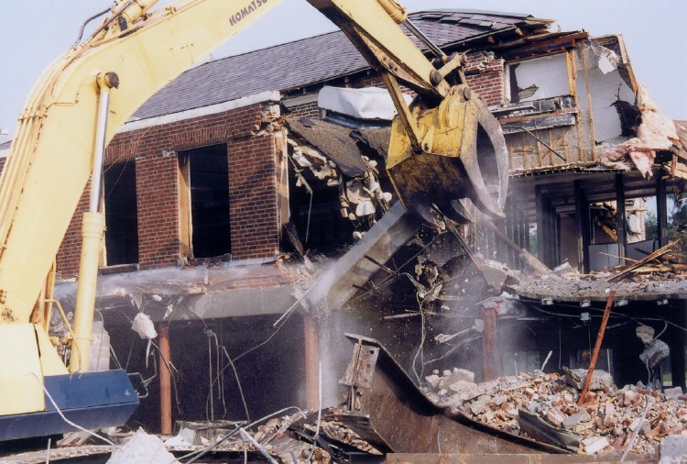](http://www.google.com/url?sa=i&rct=j&q=demolition&source=images&cd=&cad=rja&docid=v4znEd1Bv6s7dM&tbnid=GsHnHFuw5KRDyM:&ved=0CAUQjRw&url=http://www.alfredandsonsdemo.com/&ei=8KftUbWkFseSrQHYyYGoDw&bvm=bv.49478099,d.aWM&psig=AFQjCNF9bZq1Kwk8v8SFlUN_n02LWIOO4w&ust=1374615914562054)

[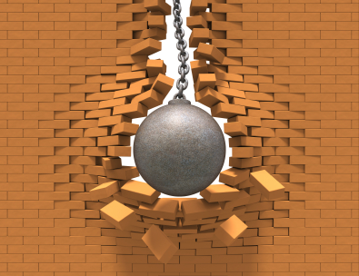](http://www.google.com/url?sa=i&rct=j&q=demolition+ball&source=images&cd=&cad=rja&docid=Qc6aHL6SWa497M&tbnid=TCb5AKy1dEZs1M:&ved=0CAUQjRw&url=http://www.traceyroad.com/this-weeks-dirt-blog/bid/133853/The-Risks-of-Cutting-Corners-in-Demolition&ei=DKjtUY-wG4aXrQGq5YDIDA&bvm=bv.49478099,d.aWM&psig=AFQjCNFa9J2_4VfJ-6m9_ZaNjRakzUOzYQ&ust=1374615943706234)

[](http://www.google.com/url?sa=i&rct=j&q=durability&source=images&cd=&cad=rja&docid=W5T5igndEQ67zM&tbnid=4UnMP67HiFQK5M:&ved=0CAUQjRw&url=http://landoftechnology.com/2013/sony-xperia-z-release-source-code-before-the-device-is-launched-worldwide/xperia-z-durability-water-resistance/&ei=eajtUZ_xGcTBrgGSlIDYBg&bvm=bv.49478099,d.aWM&psig=AFQjCNENiBhahTo18uy_QC1ojeNAzmG1Jw&ust=1374615989774529)

[](http://www.google.com/url?sa=i&rct=j&q=mixture&source=images&cd=&cad=rja&docid=EEWvN-OgIb58bM&tbnid=bo8e0Lk6gQhJbM:&ved=0CAUQjRw&url=http://www.jossparkessearchlight.org.uk/joss-sweet-shop/dolly-mixture/&ei=qKjtUZi-D8eCrgHGqYHoBw&bvm=bv.49478099,d.aWM&psig=AFQjCNHhXnwTuHHBstKGZqjuhC1LLDzujw&ust=1374616074710011)

[](http://www.google.com/url?sa=i&rct=j&q=mortar&source=images&cd=&cad=rja&docid=c5_rnSF7DyK3WM&tbnid=-hL0UgLT6bfkJM:&ved=0CAUQjRw&url=http://www.euromortar.com/product-range/definition-of-mortar/&ei=26jtUcquMc3FqQG7kYAY&bvm=bv.49478099,d.aWM&psig=AFQjCNEcU5XfxVWkSz7BQJdoR5rM9WhfCQ&ust=1374616139451039)

[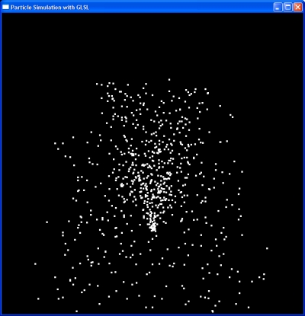](http://www.google.com/url?sa=i&rct=j&q=particle&source=images&cd=&cad=rja&docid=fXJ4_DGGFwMiCM&tbnid=LME6MENDAqRWFM:&ved=0CAUQjRw&url=http://surflab.cise.ufl.edu/wiki/Sample_OpenGL_shader_code_for_the_particle_simulation_(Pixel_shader_with_GPU_textures)&ei=CantUd7OH4ixqgGGsYHwAQ&bvm=bv.49478099,d.aWM&psig=AFQjCNFIkgEmuMzWwM-aZ2DuCEyHANeNAQ&ust=1374616175646148)

[](http://www.google.com/url?sa=i&rct=j&q=predict&source=images&cd=&cad=rja&docid=3TB4tWV7rTFszM&tbnid=LiwBJVozwu-21M:&ved=0CAUQjRw&url=http://www.mayadarshan.com/how-to-predict-future/&ei=N6ntUZ68O8qiqgHD1oHICA&bvm=bv.49478099,d.aWM&psig=AFQjCNGLB7AsmzqI8RtVls7wznMyiIWGBQ&ust=1374616220748662)

[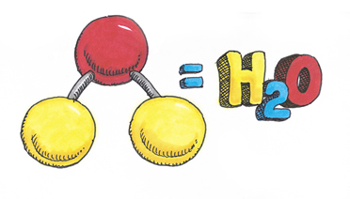](http://www.google.com/url?sa=i&rct=j&q=science%20property&source=images&cd=&cad=rja&docid=wRXtk4lLcQLVzM&tbnid=8fjIshNrUm55TM:&ved=0CAUQjRw&url=http://watereducation.utah.gov/waterscience/Properties/default.asp&ei=sqntUYe8GpT1qwHP_YDICw&bvm=bv.49478099,d.aWM&psig=AFQjCNH92wGfpehy2IAm0g38DqIdc6nuGA&ust=1374616354147912)

[](http://www.google.com/imgres?q=science+testing+experiment&safe=active&hl=en&biw=1366&bih=594&tbm=isch&tbnid=ordbx20i37pK6M:&imgrefurl=http://spaceplace.nasa.gov/science-fair/&docid=xAwywvLYKUIsVM&imgurl=http://spaceplace.nasa.gov/review/science-fair/enose_kidsflt.en.png&w=400&h=231&ei=7antUaDREs6DrQGWiIDQCA&zoom=1&ved=1t:3588,r:0,s:0,i:79&iact=rc&page=1&tbnh=158&tbnw=275&start=0&ndsp=19&tx=91&ty=81)

[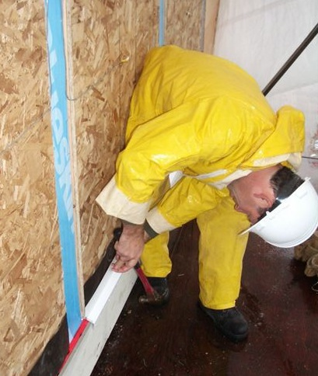](http://www.google.com/url?sa=i&rct=j&q=design%20science%20wall&source=images&cd=&cad=rja&docid=nw7Dq3QiME8ZyM&tbnid=-_nA3Z7C3F14uM:&ved=0CAUQjRw&url=http://vancouver.buildingscience.com/&ei=W6rtUaaVM86AqwG51IFw&bvm=bv.49478099,d.aWM&psig=AFQjCNE7-ef3OHdhewOp24uu4h1kSxsDzQ&ust=1374616491738854)

[](http://www.google.com/imgres?q=goal&safe=active&hl=en&biw=1366&bih=594&tbm=isch&tbnid=sx1vFVE-kv4eyM:&imgrefurl=http://careergirlnetwork.com/6-ways-to-go-for-the-goal/&docid=qmK6cjokidOi5M&imgurl=http://careergirlnetwork.com/wp-content/uploads/2013/05/SettingGoals.jpg&w=2560&h=1920&ei=eartUYTSDYXKqgHn6YG4DA&zoom=1&ved=1t:3588,r:0,s:0,i:79&iact=rc&page=1&tbnh=175&tbnw=251&start=0&ndsp=15&tx=121&ty=50)

[](http://www.google.com/imgres?q=redesign&safe=active&hl=en&biw=1366&bih=594&tbm=isch&tbnid=3huvbthAE2-7WM:&imgrefurl=http://www.vulexo.com/web-redesigning/&docid=8HU73-hddltUrM&imgurl=http://www.vulexo.com/main/wp-content/uploads/2013/05/website-redesign.jpg&w=600&h=450&ei=sqrtUfr4Ncf-qgG-moHoDw&zoom=1&ved=1t:3588,r:69,s:0,i:294&iact=rc&page=5&tbnh=180&tbnw=207&start=67&ndsp=16&tx=141&ty=48)

[](http://www.google.com/url?sa=i&rct=j&q=problem&source=images&cd=&cad=rja&docid=kTfke84bnoIk1M&tbnid=sJ2PmJqjbuDKRM:&ved=0CAUQjRw&url=http://www.ringelfordelegate.com/2011/09/water-heating-problem/problem-sign/&ei=-KrtUcTINcT1qwHZhoGYAQ&psig=AFQjCNHFgYBLs_Y5SpmA0j0qPj8m3vOMbw&ust=1374616675605470)

[](http://www.google.com/imgres?q=teamwork&safe=active&hl=en&biw=1366&bih=594&tbm=isch&tbnid=nAxjM2nkrr05ZM:&imgrefurl=http://www.medixteam.com/blog/currently-employed/tips-for-building-teamwork/&docid=N18X8ZqawMJ79M&imgurl=http://www.medixteam.com/blog/wp-content/uploads/2013/06/teamwork.jpg&w=2400&h=1617&ei=RavtUbueF4btrQHR2oGYBQ&zoom=1&ved=1t:3588,r:5,s:0,i:94&iact=rc&page=1&tbnh=171&tbnw=268&start=0&ndsp=16&tx=160&ty=62)

[](http://www.google.com/imgres?q=imagine&safe=active&hl=en&biw=1366&bih=594&tbm=isch&tbnid=BdwBVNGX6KY8uM:&imgrefurl=http://www.dafont.com/forum/read/6463/imagine&docid=gBIjN5hcIBEaaM&imgurl=http://i289.photobucket.com/albums/ll208/jspash/lennon-imagine-1.jpg&w=2272&h=1704&ei=XqvtUbT_L87fqAGOvYGwBQ&zoom=1&ved=1t:3588,r:10,s:0,i:109&iact=rc&page=1&tbnh=191&tbnw=231&start=0&ndsp=17&tx=128&ty=76)

[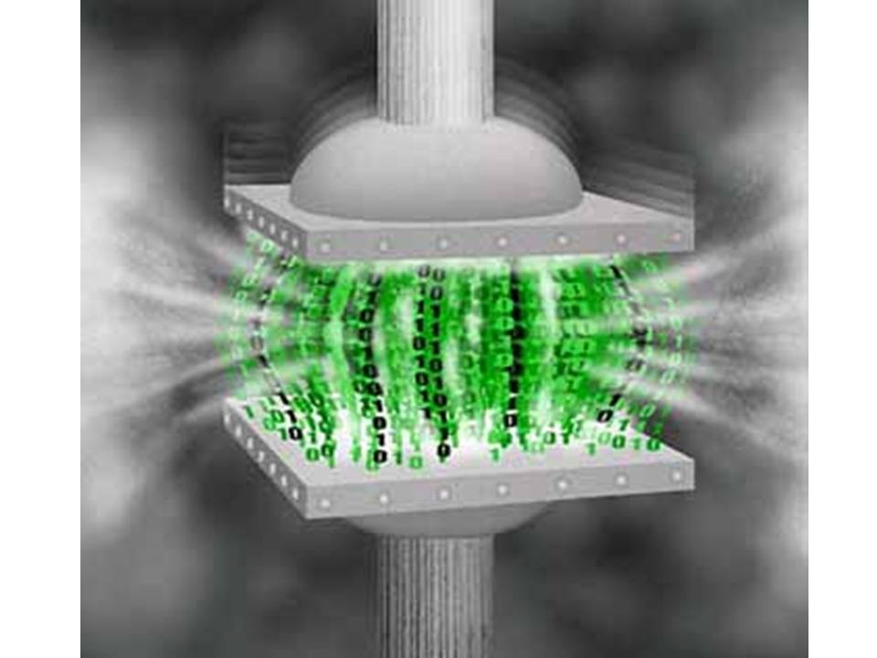](http://www.google.com/url?sa=i&rct=j&q=compression&source=images&cd=&cad=rja&docid=e2JyUZwb0NhE8M&tbnid=72P8HglaCNkT_M:&ved=0CAUQjRw&url=http://wikibon.org/wiki/v/Pitfalls_of_compressing_online_storage&ei=8avtUeemO4X2qwHotYDwBQ&bvm=bv.49478099,d.aWM&psig=AFQjCNFjDBJSt0f8Uv5vCxac5nWyS3RZtg&ust=1374616941755996)

[](http://www.google.com/url?sa=i&rct=j&q=tension&source=images&cd=&cad=rja&docid=HLfe01oo_F9lEM&tbnid=BHkecFpkLAZtaM:&ved=0CAUQjRw&url=http://www.123rf.com/photo_2177225_business-tension-business-people-playing-tug-of-war-in-them-everyday.html&ei=H6ztUbfaCoL3qQHb3YG4AQ&bvm=bv.49478099,d.aWM&psig=AFQjCNHitjFo28Y1TVy3oNhs-os-K42hww&ust=1374616971489708)

[](http://www.google.com/url?sa=i&rct=j&q=wall%20crumble&source=images&cd=&cad=rja&docid=1OvAabMYy5htAM&tbnid=f8TFI-P-KkFyWM:&ved=0CAUQjRw&url=http://www.last.fm/group/True+Listener/forum/13294/_/2031109/4&ei=iaztUbmjAcfCrgHvsICgCw&bvm=bv.49478099,d.aWM&psig=AFQjCNFzx0ZPhyp22lsyskvbsr3ThR_-pA&ust=1374617068779314)