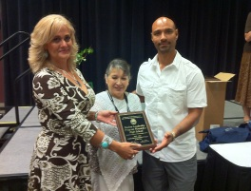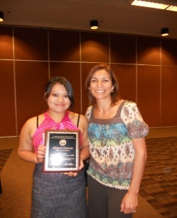

|  |
| --- |
| October 10, 2013  8:30 a.m. – 1:00 p.m. |
| **SUMMARY AGENDA** |
| * **8:30-9:45**   Segment 1:MGS/MSA Roles and Responsibilities   * **9:45-11:30**   Segment 2:Migrant Student Selection and Documentation Requirements   * **11:30-12:20**   Segment 3:MGS/MSA Strategies in Action   * **12:20-1:10**   Segment 4:ESD Program Implementation Plan |

