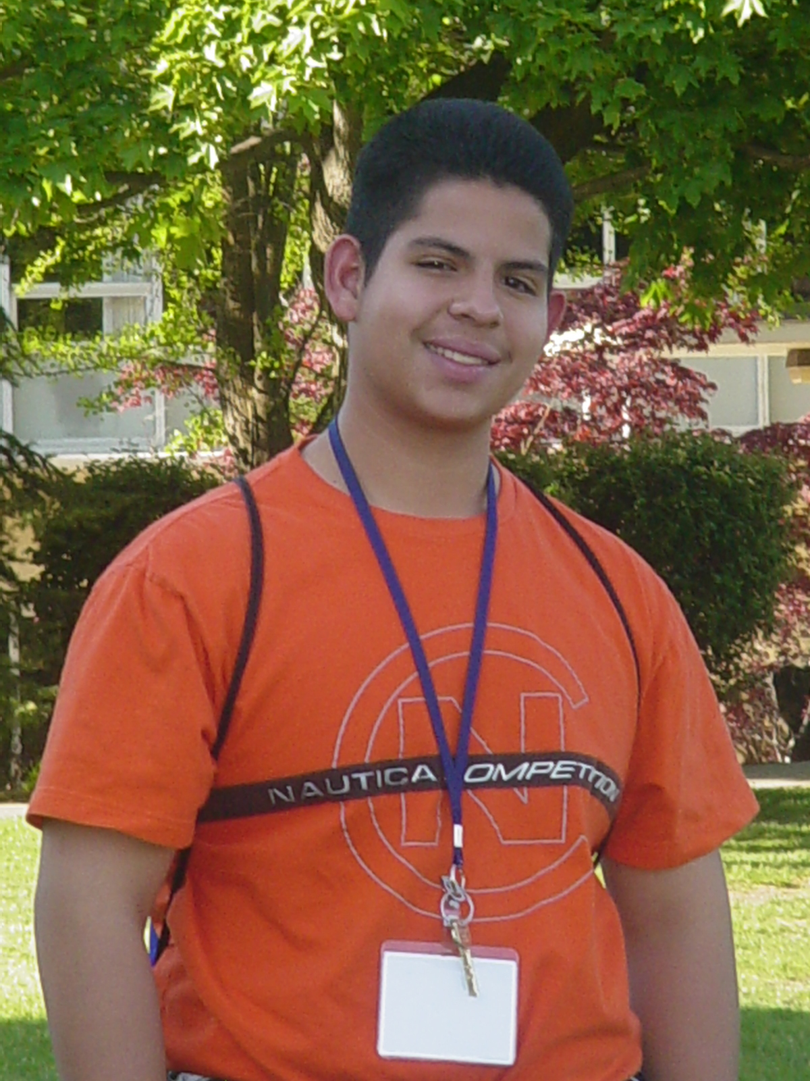

**Find Scholarships and Other College and Career Planning Resources for Migrant Students at www.msdr.org**

**Prepare** **NOW**!

According to the Higher Education Coordinating Board, the average cost of tuition ranges from $3,542 - $10,223 per term.

The cost of not going to college is even higher! The average college graduate will earn $1 million more in their lifetime and is more likely to experience improved health than someone who only has a high school diploma.

**How can scholarships help?**

Scholarships are funds that can be used to pay for some or all tuition, book, or other college or technical school expenses. Scholarships do not need to be paid back. To be considered students must research and apply for them.

**Scholarships can be found for students who:**

* come from migrant/agricultural, ethnic, or culturally diverse backgrounds
* are the first to go to college in their family
* are undocumented
* are involved in community service or extracurricular activities
* plan to pursue a degree or seek employment in specific content areas
* possess special talents
* maintain a high grade point average
* and other additional criteria…there’s a scholarship for anyone working hard to earn one!

**Scholarships may be awarded through:**

* colleges, universities, technical education schools
* local community clubs, banks, credit unions, and employers
* the Military
* local/national contest opportunities

**ALL GRADE LEVELS - SCHOLARSHIP PREPARATION**

* **Set and monitor academic goals!** Maintain min. 3.2 GPA
* **Participate** in college preparation programs offered at school: AVID, Navigation 101/advisories, GEAR UP, etc.
* **Identify** mentors and develop a support network
* **Create a portfolio to organize:** upcoming scholarship deadlines, copies of submitted applications, letters of recommendation, special recognitions, community service and extracurricular activities, contact information of potential references
* **Research** scholarships or local/national scholarships contests and apply for them
* **Get involved in:** community service projects or extracurricular activities (SLP or other clubs, sports, school newspaper, etc.)
* **Demonstrate leadership through:** coordinating a community service project, being the team captain, serving as student government officer, taking leadership responsibilities at your job, etc.
* **Maintain** appropriate content on social networks (i.e. Facebook, Twitter, My Space, etc)

**MIDDLE SCHOOL - SCHOLARSHIP PREPARATION**

* **Enroll** in honor and high level courses, when possible
* **7th and 8th graders** apply for the College Bound Scholarship at [www.hecb.wa.gov](http://www.hecb.wa.gov).
* Explore careers; plan for high school and beyond

**HIGH SCHOOL - SCHOLARSHIP PREPARATION**

* **Keep** updated copy of transcript and know how to read it
* **Be aware** of class rankings and place in the top 10% or as high as you can - get tutoring when necessary! Access your support network!
* **Ensure you are on track to graduate:** meet local and state exam and graduation requirements, complete your culminating project, and portfolio
* **Enroll** in honor level, advanced placement, or community college courses, when possible
* **Ensure** the courses you are taking meet college admission requirements and explore college campuses and careers
* **Plan** to take the ACT, PSAT, NMSQT, PLAN, and SAT tests
* **Apply** for FAFSA, if possible—early!

**QUESTIONS? Contact the migrant student advocate in your school or connect with Migrant Student Data and Recruitment at** [**pass@msdr.org**](mailto:pass@msdr.org) **or (800) 274-6084.**