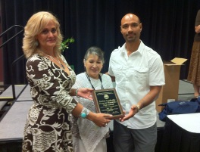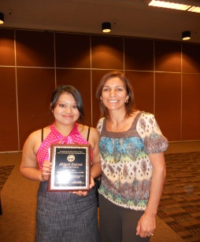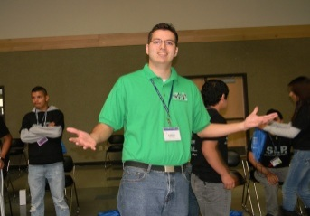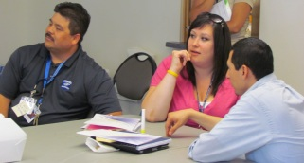

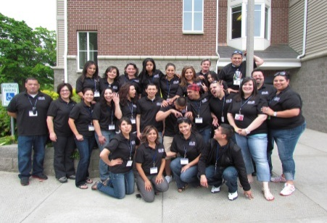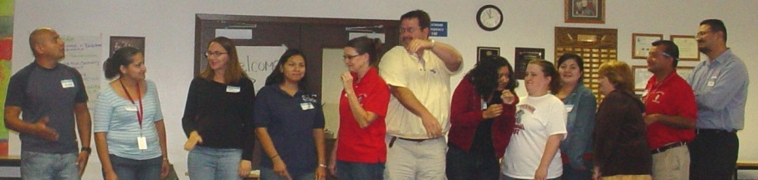

|  |  |  |
| --- | --- | --- |
| **Need help finding resources for your migrant students?** **The** **Migrant Education Program is here to help!** The enclosed resources and tools just are for you and your migrant students. Share these resources and use these tools with your migrant students to support your responsibilities of:   * Academic Guidance * Non-Academic Guidance * Career Education and Postsecondary Preparation | | |