Could you survive in middle class?
COMPLETE THE QUIZ:
Put a check by each item you know how to do.
- I know how to get my children into Little League, piano lessons, soccer, etc.
- I know how to set a table properly.
- I know which stores are most likely to carry the clothing brands my family wears.
- My children know the best name brands in clothing.
- I know how to order in a nice restaurant.
- I know how to use a credit card, checking account, and savings account—and I understand an annuity. I understand term life insurance, disability insurance, and 20/80 medical insurance policy, as well as house insurance, flood insurance, and replacement insurance.
- I talk to my children about going to college.
- I know how to get one of the best interest rates on my new-car loan.
- I understand the difference among the principal, interest, and escrow statements on my house payment.
- I know how to help my children with their homework and do not hesitate to call the school if I need additional information.
- I know how to decorate the house for the different holidays.
- I know how to get a library card.
- I know how to use most of the tools in the garage.
- I repair items in my house almost immediately when they break—or know a repair service and call it.

Could you survive in poverty?
COMPLETE THE QUIZ:
Put a check by each item you know how to do.
- I know which churches and sections of town have the best rummage sales.
- I know which rummage sales have “bag sales” and when.
- I know which grocery stores’ garbage bins can be accessed for thrown-away food.
- I know how to get someone out of jail.
- I know how to physically fight and defend myself physically.
- I know how to get a gun, even if I have a police record.
- I know how to keep my clothes from being stolen at the Laundromat.
- I know what problems to look for in a used car.
- I know how to live without a checking account.
- I know how to live without electricity and a phone.
- I know how to use a knife as scissors.
- I can entertain a group of friends with my personality and stories.
- I know what to do when I don’t have money to pay the bills.
- I know how to move in half a day.
- I know how to get and use food stamps or an electronic card for benefits.
- I know where the free medical clinics are.
- I am very good at trading and bartering.
- I can get by without a car.

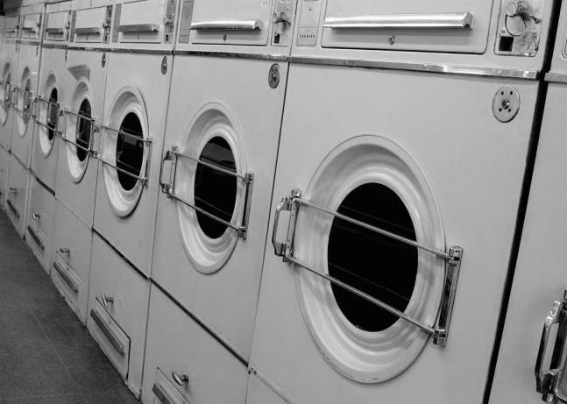
Could you survive in wealth?
COMPLETE THE QUIZ:
Put a check by each item you know how to do.
- I can read a menu in French, English, and another language.
- I have several favorite restaurants in different countries of the world.
- During the holidays, I know how to hire a decorator to identify the appropriate themes and items with which to decorate the house.
- I know who my preferred financial advisor, legal service, designer, domestic-employment service, and hairdresser are.
- I have at least two residences that are staffed and maintained.
- I know how to ensure confidentiality and loyalty from my domestic staff.
- I have at least two or three “screens” that keep people whom I do not wish to see away from me.
- I fly in my own plane or the company plane.
- I know how to enroll my children in the preferred private schools.
- I know how to host the parties that “key” people attend.
- I am on the boards of at least two charities.
- I know the hidden rules of the Junior League.
- I support or buy the work of a particular artist.
- I know how to read a corporate financial statement and analyze my own financial statements.

