**Explain or Describe:**

Scientific Goal: Introduce students to the concept of organization in ecology, and develop the vocabulary around those concepts. Vocabulary includes:

* Individual
* Population
* Community
* Ecosystem
* Abiotic (Non-Living) Components

CCSS- ELA: Writing Standards for Literacy in History/Social Studies, science and Technical 6-12

Text Types and Purposes: 2d

**Graphic Organizers→**

**Using sentences with simple language:**

*A community has more than one type of organism living in an area.*

**Using sentences with sufficient language:**

*A community consists of having two or more organisms living in the same location.*

**Using sentences with sophisticated language:**

*A community in an ecosystem is characterized by multiple organisms inhabiting the same location.*

**Prepared Paragraph:**

*A community is best described as different organisms living together. Guppies and elodea is an illustration of a community. Critical attributes of a community include more than one species living together, that there are also interactions between the organisms. A complete definition of a community allows us to see that it is only a small part of a larger ecosystem.*

**Discussion Cards-**

**Agree/Disagree Statements:**

*I agree that guppies and elodea are a community because they have two organisms living together.*

*I disagree that a hillside is a community because the hill also has lots of nonliving (abiotic) features like rocks included.*

*Actually it is not true that the ocean is a community, because it has more than just organisms living together, there are also many abiotic components such as water and sand included.*

**Build on an Idea:**

*Another example of a community are bees, butterflies and flowers, because they also live in the same area and interact with each other.*

*Yes it is true that there are lots of communities. Another example would be trees, shrubs and grass because they also are found many times in the same area.*

**Explain or Describe:**

Transition Words:

|  |  |  |
| --- | --- | --- |
| * includes * explain * describe * discuss * displays * illustrates * refers | * belongs * contains * consists * exhibits * indicates * defines | * for example * such as * is known for * understood as * associated with * defined by * considered to be * is also called |

|  |  |
| --- | --- |
| To open | * _________________ is best described as _____________________. * To define ____________, it is necessary to understand_____________. * __________ is known for ____________ and is important because ___________. |
| To explain or describe | * ______________ is an illustration of ______________. * _________________ is frequently referred to ________________. |
| To support your ideas | * Critical attributes of ______________ include __________ and ___________. * A defining characteristic is ___________________ and ____________. * The key components are ____________ and __________________. |
| To close | * An explanation of ________________ provides insight into ____________. * A complete definition of ____________ allows us to ______________. |

**Explain or Describe:**

**Observational Organizer:**

Writing Frame *Writing in Science* by Betsy Rupp Fulwiler

|  |  |
| --- | --- |
| *Think of properties you can see such as size, shape, color, lines, texture, pattern, behavior…* | I observed…  *I observed with the community group that there was more than one type of living organism represented in the card.* |
| *Think of the other senses of smell, sound, touch, and perhaps taste!* | I noticed…  *I also noticed that the organisms might be all plants, all animals or even a combination of a plant and animal.* |
| *Connect it with something that you already know.* | It reminds me of…  *A community reminds me of going to the fair.* |
| *Add more detail as needed.* | This is so because…  *This is so because you see goats, sheep and rabbits all in the same barn.* |
| *Be curious and ask questions you could investigate.* | I am curious about…  *I am curious about other places you would find communities?*  It surprised me that… OR … I wonder what would happen if… |

*I observed with the community group that there was more than one type of living organism represented in the card. I also noticed that the organisms might be all plants, all animals or even a combination of a plant and animal. A community reminds me of going to the fair. I am curious about other places you would find communities?*

|  |  |
| --- | --- |
| **Same Attributes** | |
|  | |
| **Different**  **Attributes** |  |
|  |  |

**Compare and Contrast**

Science Goal: Students are introduced to the organisms that make up the Mono Lake Ecosystem. Students will learn not only about the organisms that make up that system, but also learn the interactions of the organisms living in the system.

Writing Goal: CCSS- ELA: Writing Standards for Literacy in History/Social Studies, science and Technical 6-12 Text Types and Purposes: 2d

**Graphic Organizer→ Box and T Chart**

In the box students write down attributes that are similar with each other. In the T-Chart, students note differences between attributes with a one-one correspondence.

|  |  |
| --- | --- |
| **California Gull ~ Coyote**  **Both** animals are part of the Mono Lake Ecosystem  Similarly they both are scavengers and will eat carrion (dead or decaying flesh) | |
|  | |
| **California Gull** | **Coyote** |
| Makes nests in hallows in ground | Lives in a den that is marked by their scent |
| Predators include coyotes, raccoons, weasels and Caspian terns | Predators include wolves |
| Eggs are laid in May and hatch in June | Mating occurs in February/March and are born in April/May |

**Compare Statements:**

**Simple language:** *The gull and the coyote are the same because they both live in the Mono Lake ecosystem.*

**Sufficient Language:** *The gull and the coyote are similar because they are both considered scavengers in the ecosystem sometimes eating carrion.*

**Sophisticated Language:**  *Common attributes of the gull and the coyote include a diet of carrion, dead or decaying fish.*

***Contrast Statements:***

**Simple Language:** *California gulls make their nests in hallows of the ground unlike the coyote that makes a den with their scent somewhere in their hunting area.*

**Sufficient Language:** *Gulls are hunted by many animals such as coyotes, other small mammals and even birds in contrast the coyote is only hunted by one animal, the wolf.*

**Sophisticated Language:** *The reproductive habits of the coyote and gull are different. Gulls will lay their eggs in May and hatch in June, whereas coyotes mate during February and March and birth their young in April and May.*

**Compare and Contrast**

**Transition Words**

|  |  |  |
| --- | --- | --- |
| http://www.google.com/url?source=imglanding&ct=img&q=http://im.glogster.com/media/3/10/37/1/10370193.gif&sa=X&ei=8kidUICSBuaYiAKH14CoCw&ved=0CAkQ8wc&usg=AFQjCNGj_G3yl0W89x0J3fSw7vNVNRZRuw**Use the language of compare and contrast when you are asked to:**   * discuss the similarities and differences * choose the best option * identify common characteristics | | |
| * but * however * yet * unlike * like * similarly * whereas | * contrary * same * both * share * each * produced * although | * in common * on the other hand * as opposed to * a distinction between * share the same * just alike * in contrast * compared to |

**Discussion cards…**

|  |  |
| --- | --- |
| **California Gull ~ Coyote**  **Both** animals are part of the Mono Lake Ecosystem  Similarly they both are scavengers and will eat carrion (dead or decaying flesh) | |
|  | |
| **California Gull** | **Coyote** |
| Makes nests in hallows in ground | Lives in a den that is marked by their scent |
| Predators include coyotes, raccoons, weasels and Caspian terns | Predators include wolves |
| Eggs are laid in May and hatch in June | Mating occurs in February/March and are born in April/May |

**Build on an Idea…**

*Another idea the two have in common are they are both scavengers looking for those succulent meals of dead and decaying animals.*

*Wouldn’t also mean that if there are no wolves in the ecosystem there is nothing preying on the coyote?*

**Ask a Question…**

Can you give an example of how the coyotes and the gulls are born and raised in the ecosystem?

What is the result of the gulls being preyed on by many animals whereas the coyote has no predators living in the area?

|  |  |
| --- | --- |
| To open | * The similarities between _________ and ____________ indicate ____________. * By comparing __________ to ________, it becomes clear that ________. * A comparison of ________ to _____ reveals ___________. |
| To compare or contrast | * Although ______ and ______ are _____, _________ is ________. * ______________ is to _____________, whereas ________ is ___________. * The most obvious difference between ______ and _____ is ___________. |
| To support your ideas | * On similarity / difference is __________ . * Their common characteristics include _________, ________ and ___________. |
| To close | * By comparing _____ to __________, we learn ____________. * The differences between ______ and ________ are important because _____. |

**Prepared paragraph using frame:**

*By comparing the gull to the coyote, it becomes clear that even though they live in the same ecosystem they are organisms with different needs. Although gulls and coyote are both organisms in the Mono Lake ecosystem each organism has different predators. One difference is the gull has many predators including the coyote and the Caspian tern, whereas the only predator the coyote has is the wolf, which is not part of this ecosystem. By comparing their predators we learn that gulls have more predators in this location that the coyote.*

COMPARE AND CONTRAST

*Writing Frame*

|  |  |
| --- | --- |
| *Start with how things are the same or similar.* | The _____ and the __­­____ are the same because they both ___________.  *The coyote and gull are the same because they both live in the Mono Lake Ecosystem.* |
| *Add more details as needed.* | In addition, they both ________________.  *In addition, they both tend to be scavengers and will sometimes eat on the dead and decaying flesh of animals known as carrion.* |
| *Explain how they are different. You can compare the same property or characteristic in the same sentence. Use “and”, “but”, or “whereas” to set up the contrast.* | They are different because the ______, but the ______ does not.  *The gull and coyote are different because the gull lays eggs in the spring, but the coyote gives birth to live pups.* |
| *Add more detail as needed.* | Also, the ________, whereas the ________________.  *Also, the gull has many predators within the Mono Lake Ecosystem including the tern and the coyote, whereas the coyote has no predators living in the area.* |
| Remember to ask, “Will it be clear to the reader what I mean when I use pronouns such as *they* and *it*? If not, how can I edit the sentence to make it clearer?” | |

*The coyote and gull are the same because they both live in the Mono Lake Ecosystem. In addition, they both tend to be scavengers and will sometimes eat on the dead and decaying flesh of animals known as carrion. The gull and coyote are different because the gull lays eggs in the spring, but the coyote gives birth to live pups. Also, the gull has many predators within the Mono Lake Ecosystem including the tern and the coyote, whereas the coyote has no predators living in the area.*

**Scientific Conclusion: Argumentative Writing**

Scientific Goals:

1. *Ecosystems* are continuously changing. Causes of these changes include nonliving *factors* such as the amount of light, range of *temperature*s, and availability of water, as well as living *factors* such as the disappearance of different *species* through disease, predation, *habitat* destruction and overuse of resources or the introduction of new *species*.
2. *Generate* a scientific *conclusion* from an *investigation* using inferential logic, and clearly distinguish between results (e.g., *evidence*) and conclusions (e.g., explanation).

Writing Goal: CCSS- ELA: Writing Standards for Literacy in History/Social Studies, Science and Technical 6-12 Text Types and Purposes:

1: Write arguments focused on discipline-specific content.

1. Introduce evidence about a topic or issue
2. Support claim with evidence
3. Use words, phrases, and clauses to create cohesion and clarify the relationships among claims, counterclaims, reasons and evidence.
4. Maintain a formal style.
5. Provide a concluding statement that supports the argument presented.

|  |  |
| --- | --- |
| **Question:** | |
| **Claim:**  **2.**  **3.** | **Evidence:**  **1.**  **2.**  **3.** |
| **Explanation:** | |

**Graphic Organizer →**

**Question:** Questions can be created to cover a single lesson, or an overarching question that may encompass gathering claims and evidence from many lessons.

**Claim:** A deduction, pattern, or finding from their investigation. It could also be considered a statement that answers a question or a problem.

**Evidence:** Scientific data that supports the claim. Evidence could come from data collected during an investigation. It may also come from labeled diagrams, drawings, graphs that were developed during the investigation. Data can come solely from these first hand experiences or from supplementary sources such as reading materials or internet sources after the investigation has been completed.

**Explanation/Reasoning/Conclusion:** A justification that links the evidence to the claim.

|  |  |
| --- | --- |
| **Question:** How do human impacts affect the Mono Lake Ecosystem? | |
| **Claims:**  Energy flows through a food chain. | **Evidence:**  The energy from the fly flows to the spider after the spider eats the fly. |
| Planktonic Algae is a producer in the Mono Lake Ecosystem.  Brine Shrimp is a consumer in the Mono Lake Ecosystem. | Planktonic Algae was at the bottom of the food web. It does not get energy by eating something else; it makes its food from a process called photosynthesis.  Brine shrimp gets their energy from planktonic algae. In the food web the energy flows from the algae to the shrimp. |
| Low water levels impacted the Mono Lake Ecosystem. | Lower water levels decreased the amount of water, making the already alkaline water, more alkali.  Lower water levels created land bridges allowing coyotes to eat gulls and eggs of gulls usually protected from the coyote. |
| **Explanation:** It is my position that humans impacted the Mono Lake Ecosystem. All living organisms need energy and that the energy from one organism flows into other organisms. One example is when a spider eats a fly; the energy from the fly is transferred to the spider. Some living organisms do not eat other organisms, so they need to get their energy from the sun. Planktonic algae is an example of a producer-producing its own energy that is then transferred to the animals that feed on it. One example is the Brine Shrimp, the energy flows from the algae to the shrimp. In 1941 water was diverted out of Mono Lake lowering the water levels of the Lake, this impacted the entire ecosystem. The lower water level increased the salinity of the lake causing the brine shrimp to …. In addition the lower water level created land bridges allowing the coyotes to hunt in areas that were normally protected by water. This allowed the coyotes to steal eggs out of nest that were normally protected thereby decreasing the gull population in the area. This lower water level was the direct result of taking the water for another purpose impacted several populations and the entire ecosystem. | |

* Develop Food Chain—Find energy flow through system. (fruit, fly, spider, bird)
* Find Mono Lake food chain (plankton, shrimp, bird, coyote) Make Claim
* Develop Food Webs from Mono Lake Ecosystem-Make more claims regarding ecosystem
* Watch clip from “Fire and Ice” regarding impact on Mono Lake when water was diverted out of the system. Make additional claim.
* After several claims and evidence are listed students begin to link their claim and evidence to come up with an explanation, justification, reason or conclusion.
* Students could also link claims and evidence after only one claim/evidence:

**Question:** *What would happen to the coyote population if the planktonic algae population dies out?*

**Claim:** *The coyote would not survive.*

**Evidence:** *Although the coyote does not eat planktonic algae, it does eat and get energy from animals that directly eat the algae.*

**Reasoning/Explanation:** *Algae is a producer, which means it converts energy from the sun to energy that can be consumed by other animals in the ecosystem. Brine shrimp eats the algae and gulls feed on the shrimp, while finally coyotes eat the gulls or eggs from the gull. The energy flows from the algae to the shrimp to the gull then to the coyote. If there were no algae there would be no energy for the animals below the coyote, therefore any energy for the coyote.*

Transition Words:

|  |  |  |
| --- | --- | --- |
| *Don’t forget to link claims and evidence together…*. | Claims and Evidence  Use the language of claims and evidence when you are asked to:   * State a position * Present and interpretation * Recommend a solution * Draw conclusions | |
| Words or phrases to create transitions an link ideas: | | |
| * Position * View * Assert * Persuade * Agree * Disagree * Convince | * Believe * Opinion * State * Argue * Propose * Prove * Validate | * According to * As stated by * In fact * Strongly supports * Argues against/ in favor of * Supports the position * Asserts that * Makes the claim |

**Simple Language:**

*I think/believe coyotes need the algae … because*

*One reason that the coyote needs…. Because*

**Sufficient Language:**

*In my opinion the coyote needs algae*

*From my point of view the coyote…*

**Sophisticated language:**

*From the perspective of the coyote, algae are important….*

*The coyote would take a stand on algae that includes…*

**Discussion cards: Cite Evidence**

*From the food web, it state that….*

*The food web proves that….*

*Based on the evidence provided in the movie….*

**Discussion cards: Ask a Question**

*Why do you think…*

*Can you give me an example of…*

*What would happen if….*

|  |  |
| --- | --- |
| **Use the following frames when you draft a paper or prepare to speak:** | |
| To open | * In regards to ______, I believe_______. * My opinion on the issue of _______ is _____________. * __________ presents the position that ____________. |
| To state a position | * __________ proves that ____________. * My views are based on ______________. |
| To support your ideas | * Many experts claim that ______________. * According to _______________, _____________. * Further evidence can be found in _____________. |
| To close | * There is little doubt that _____________. * ________ urges us to _______________. |

**Prepared Paragraphs:**

In regards to the Mono Lake Ecosystem, I believe that humans have made an impact that changed that system. My views are based on lower water levels as a result of transferring water to residents of Los Angeles in 1941. According to the video “Fire and Ice” redirecting the water caused lower water levels resulted in changes in the salinity of the water and greater access to nesting sites by secondary consumers. The change in this system urges us to consider all the attributes of the ecosystem before making major impacts on this type of system.

|  |  |  |  |  |  |
| --- | --- | --- | --- | --- | --- |
| **Student Data Collection for Fat and Soap** | | | | | |
|  | **Color** | **Hardness** | **Solubility** | **Melting Point** | **Density** |
| *Fat* | Off-white or  slightly yellow | Soft-squishy | Water—no  Oil—yes | _ 37_ C | 0.92 g/cm3 |
| *Soap* | Milky white | Hard | Water—yes  Oil—no | Higher than  100_ C | 0.84 g/cm3 |

|  |
| --- |
| *Brandon’s first explanation about fat and soap….* |
|  |
| *What does research say about students writing regarding scienfic explanations:*   * *Students typically discount the data they have collected in their science notesbooks if it contradicts their initial thinking* * *Many students explantions include claims with little evidence or justification drawn from the daya they collected, observed and recorded in their notebook.* * *Middle school students also have difficulty using appropriate evidence and making connections to claims using the evidence.* |

*Making scientific resoning strategis exlplicit to students can facilitate their understanding of these strategies.*

*Using scaffolds can facilitate students explanations:*

|  |
| --- |
| *Brandon’s revised explanation about fat and soap…* |
|  |
| *A framework for middle school science instruction should included three components:*   * *Claims: A deduction, pattern, or finding from their investigation. A statement that answers the quation or problem.* * *Evidence: Scientific data that supports the claim. Data collected (observed or measured) and analysis of labeled drawings, diagrams, and graphs that were created during the investigation.* * *Reasoning: A justification that links the evidence to the claim.* |

*Example of Template:*

|  |  |
| --- | --- |
| *Question:* | |
| *Claim* | *Evidence* |
| *Explanation* | |

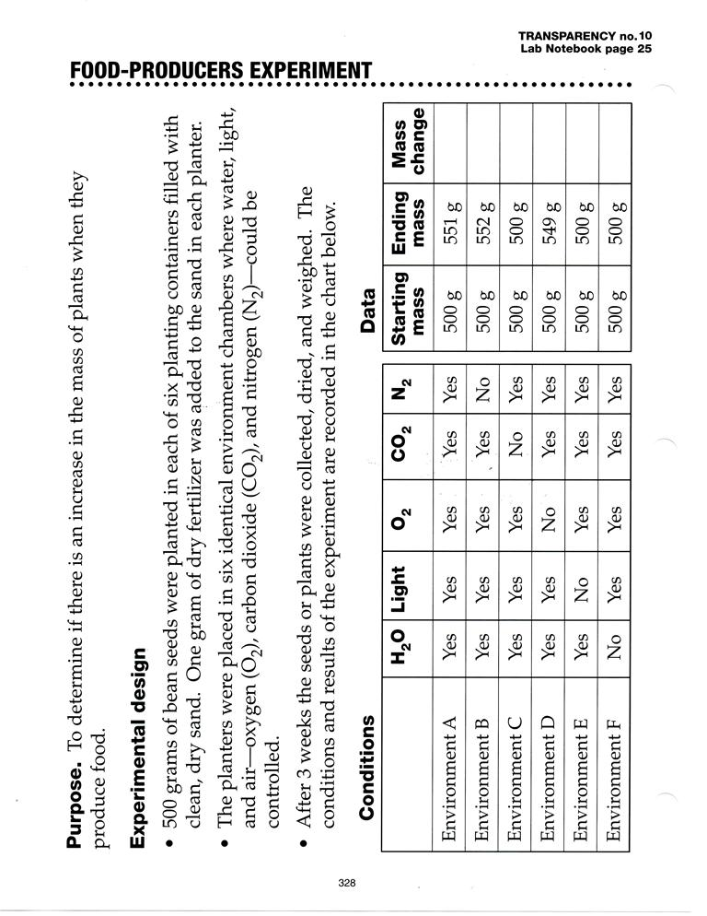**Using Claims and Evidence with Numerical Data**

**Question:** What conditions are necessary to increase the mass of plants?

**Prediction:** If/then/because…

If plants are going to grow then they will need light, oxygen, carbon dioxide and water to grow. I think this because all living things need all these things and plants also need carbon dioxide.

How can we use strategies to help students make sense of what they see in graphs and diagrams:

**Variables: (Team Tasks)**

|  |  |  |
| --- | --- | --- |
| **Controlled Variables**  (Kept the Same) | **Manipulated Variables**  (Variable Changed) | **Responding Variable**  (Measured/Observed) |
|  |  |  |

**What do I see? What does it mean? (Add pictures or real objects to help see environments)**

|  |  |  |
| --- | --- | --- |
| Environment A  Change in Mass: | Environment B  Change in Mass: | Environment C  Change in Mass: |
|  |  |  |
| Environment D  Change in Mass: | Environment E  Change in Mass: | Environment F  Change in Mass: |

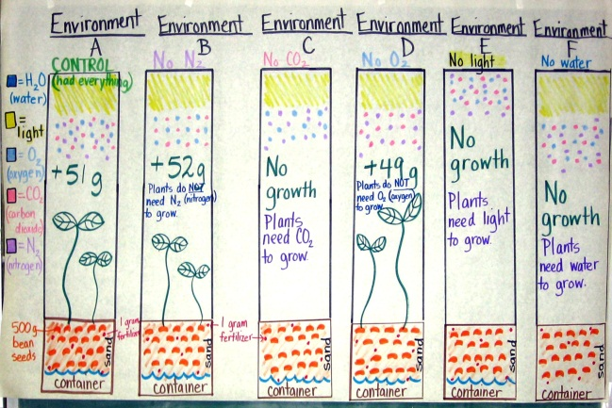

**What do I see? What does it mean?**

**Discussion Cards:**

**Ask a Question:** How did you come up with plants needing carbon dioxide, water, and light to grow? Can you explain why a plant doesn’t need oxygen and nitrogen to grow?

**Agree/Disagree:** *I agree that plants need carbon dioxide because when there was no carbon dioxide the was no growth. To grow the plant would need that component. It started at 500 grams and there was no increase in mass meaning no growth.*

**Build on an Idea:** Yes, but it is also true that plants will also need to have light. When there was no light present there also no growth-same with the water any growth. The mass started at 500 grams and stayed at 500 grams.

**Share Your Thinking:** I was surprised that a plant doesn’t need oxygen to grow. I thought all living things needed oxygen. I didn’t realize a plant didn’t need that element to grow because even without the oxygen the plant started at 500 grams and increased to 549 even with no oxygen.

**Cite Evidence:** In the table it states that in Environment B with no nitrogen the plant still gained 52 grams in mass.

|  |  |
| --- | --- |
| **Question:** What conditions are necessary to increase the mass of the plant? (show growth) | |
| **Prediction:** My predictions were partially correct because I thought plants would need light, water and carbon dioxide but I was incorrect when I thought plants needed oxygen. | |
| **Claim:**   1. Plants need carbon dioxide, light and water to grow. 2. Plants don’t need nitrogen and oxygen to grow. | **Evidence:**   1. These plants started at a mass of 500 grams and stayed 500 grams, with no increase in mass. 2. The plants started at 500 grams and ended with a mass of between 549- 552 grams. |
| **Explanation:**  In our science investigation we wanted to see under what conditions would a plant gain mass or in other words grow. In order to for plants to grow they need light, carbon dioxide, and water. I first thought that a plant would need light, water, oxygen and carbon dioxide to grow, I was partially correct, the plant does not need oxygen to grow.  The data shows that plants need carbon dioxide, light and water to grow. Plants in conditions that didn’t have either of these components did not grow. Their mass started at 500 grams and did not gain or lose anything showing that there was no growth.  When plants were in environments that did not have nitrogen or oxygen they continued to grow. Their mass increased from 500 grams up to 549-552 grams, showing an increase of an additional 49-52 grams. This shows that even without either of these gases present the plant will still grow.  The investigation strongly supports that for a plant to grow the plant will need carbon dioxide, light and water but nitrogen and oxygen are not necessary. | |

**Scaffold:**

Restate Question: *In our investigation…*

Answers Questions:

Acknowledge Prediction: *I initially thought… my prediction was… (correct, partially correct, incorrect)… why….*

State claims/evidence/reasons for low data: *The data shows…*

State claims/evidence/reasons for high data: *The data also shows…*

Conclusive statement: *The investigation strongly supports*