STRATEGY NOTES
STRATEGY: EXPERT GROUPS

WHAT IT LOOKS LIKE
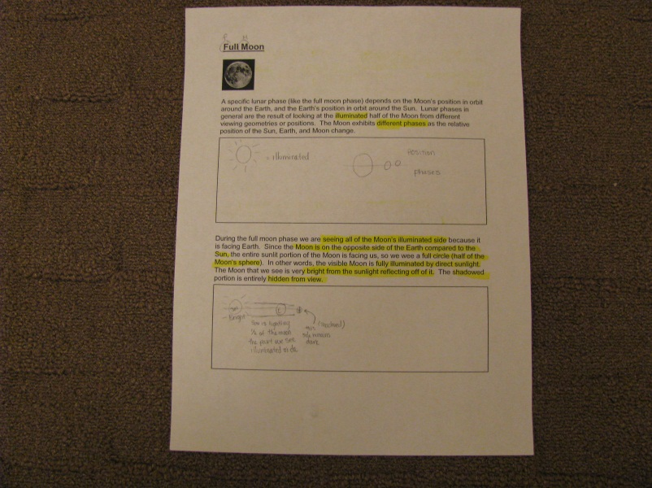

RESEARCH BASE
- Spencer Kagan—cooperative learning research (jigsaw)
WHY DO IT
- Demonstrates features of non-fiction text
- Teaches reading for information
- Promotes comprehension and communication of key concepts
- Provides scaffolding for ELLs or struggling readers.
- Teaches study skills and note-taking since text comes from textbook.

STEP-BY-STEP PROCESS
  - Create expert group text from using a Row category on the process grid. (One expert group text per row.) Chunk the text and separate the chunks with an empty sketch box between each.

  - Create a corresponding mind map (blank) that will include an arm or spoke for each column heading on the process grid. The subject of the expert group will be written in the middle of the mind map.

  - Create the expert groups by assigning a number (1-4) for each member of a team. All the 1s are an expert group (one coming from each team), all the 2s are another expert group and so forth.

  - One expert group is called up to the teacher at a time. Usually takes 30-45 minutes per group. Students sit on floor or in chairs close to teacher and are each given a clipboard, a highlighter, a pencil, the expert group chunked text and a copy of the blank mind map.

  - Teacher begins by showing pictures that will help make the information comprehensible.

  - Next, teacher previews the mind map to preview information about to be presented in the text. In this way it is used as an advance organizer to help focus students about the text they will be reading.

  - Teacher guides expert groups in reading for information and note-taking skills including highlighting, sketching, note-taking, etc.

  - Teacher reads text aloud with the students. Teacher reads fluently and then goes back and does a “Think Aloud” highlighting key points and vocabulary referring to mind map to show why highlighting that information. Teacher makes a sketch for brain imprinting and draws a line from the highlighted text to the sketch. Teacher asks students to do the same with highlights, sketching, etc.

  - This is repeated in chunks with a gradual release of control, having students say what they would highlight and why and how it connects to the mind map instead of teacher always modeling.

  - After reading the entire text passage and taking notes in the sketch box, the students transfer the information to the mind map. Students offer ideas of what they think goes in each section of the mind map, referring back to their notes.

  - Students will then return to their teams with their mind map and text. They will later (just before the Process Grid) use the mind map to teach the other members of their team about the subject in which they were the expert.

NOTES
- Expert groups are heterogeneous groups
- When modeling for students in the expert groups, use pencil for transferring facts from text to mind map. When transferring info from the pictorial chart to the large mind map in whole class group, use only one color on the mind map for later scaffolding onto the process grid using same color. The information from each mind map becomes one row on the process grid. Each process grid row is color coded to match the information from the mind map. It is worth noting that this color coding should also match the color coding on pictorial input chart so that all color coding can be used to scaffold information all the way through.

VARIATIONS
- K-2: Color code the text and the mind map sections to match

