STRATEGY NOTES
MIND MAP
(Connected to the Expert Groups and the Process Grid)

WHAT IT LOOKS LIKE
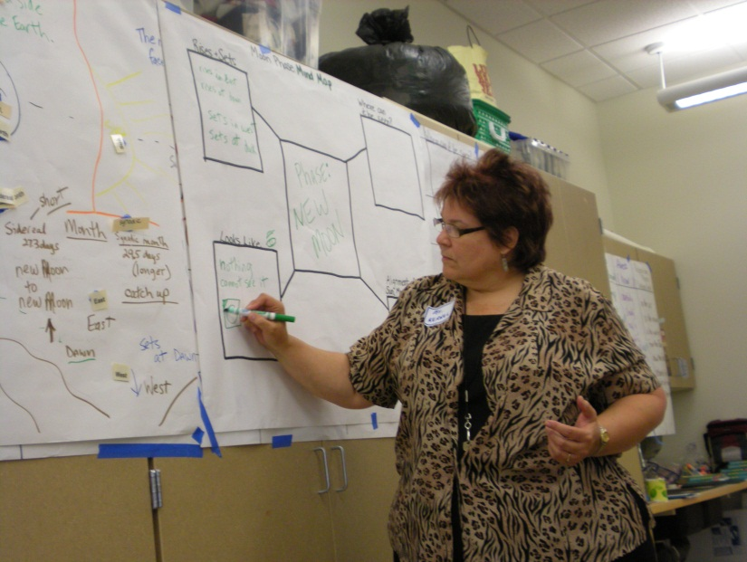
RESEARCH BASE

WHY DO IT
- Assists in the comprehension of concepts through the organization of information
- Assists in retention of content
- Graphically represents content information that is more abstract (brain imprinting)
- Helps scaffold the writing process
- Used as an intermediate step between the expert group “read and sketch” and the “process grid” bullets, or between the “pictorial chart” and the “process grid” bullets.
- Purpose is to transfer information in an organized fashion

STEP-BY-STEP PROCESS
- Main idea is written in center of the map
- Teacher then focuses on just one arm or spoke of the map at a time and instructs students to put heads together to discuss what facts from the input chart will go in that area.
- Choral call is used (“just tell me”) to elicit the information from students. Information is then written in corresponding arm of mind map.
- This process continues through subsequent arms of the map until all the important facts are organized on the mind map spokes.
NOTES
- When modeling the mind map with the whole class (moving pictorial chart info onto mind map) teachers asks students to focus on 1 arm at a time.
VARIATIONS

