STRATEGY NOTES
PROCESS GRID
(connected to Expert Groups and Mind Map)
WHAT IT LOOKS LIKE
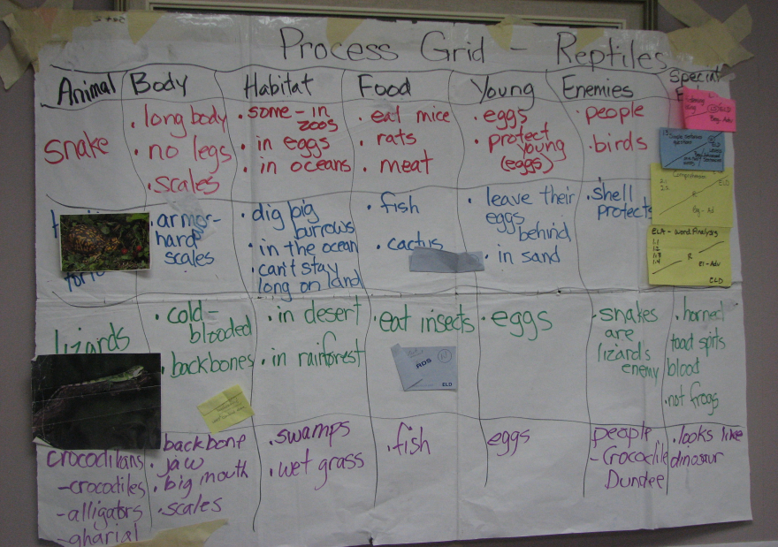
RESEARCH BASE
- Variation on Sharon Bassano’s wall grid, which is mostly an oral language grid
- The visual grid and categorizing takes advantage of brain research; if information is presented in a patterned way it is retained longer.
WHY DO IT
- It is a form of pre-write before getting to sentences and paragraphs.
- Process Grid teaches note taking, categorizing, classifying and interrelatedness of information.
- PG is used in all content areas
- Most effective in teaching students expository writing
- With the PG students become experts and teach each other
- Students summarize, classify, organize, compare, attribute, transfer knowledge (comprehension) - increasing habits of interdependence.
- Helps students organize information for paragraph writing; bridging ideas to sentences.
- The five categories needed are taken from standards and text-based

STEP-BY-STEP PROCESS
- PG is built whole class with students in teams
- Columns are labeled with five categories
- First row category is given and teams contribute information from mind map; first row is not part of the expert groups- it is completed whole class.
- Second row- signal word is given and the experts teach their team the information for 2nd row with notes from meeting with teacher and mind map
- Numbered Heads Together: Teacher calls a number to ask for information to complete rows, "Give me a fact.” “Which category does the fact go into?”
- Information is bulleted and only correct facts are written.
- Top row and 1st expert group row are completed two columns at a time. After that, for all other rows, teach everything at once and open up fact finding to all columns.
- Each row is completed in a different color.
- Process is continued and process grid completed.
NOTES
- When students are reporting out they may use the mind map for information- they must consult the expert and their team and negotiate meaning
- Process Grid Game: Do not play until all the members have become experts
- Try to do PG all in one day
- Key is to train students to use this to classify and categorize information
- Preproduction students- twin with other student
- Award team points for working together and following the T-Graph - not for facts or information given.

VARIATIONS
- Story components
- Compare & Contrast; Cause & Effect

