READING & WRITING STRATEGY: WHAT IT LOOKS LIKE
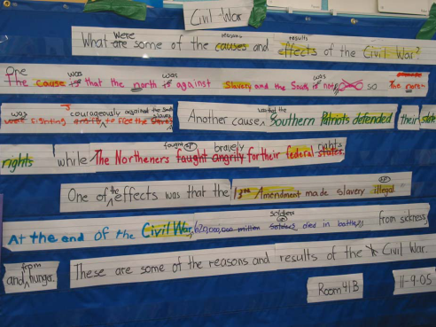
Cooperative Strip Paragraph

RESEARCH:
Developed by Nancy Whistler
Adapted by Project GLAD
Related to research by Merrill Swain and Michael H. Long regarding the importance of negotiation for meaning
Lucy Calkins developed the editing checklist
Donald Graves
USE:
Teaches and models the expository writing process, including revising and editing
Promotes metacognition regarding writing quality
Student-generated text increases ownership and interest in improving the finished product.
Anxiety-free environment for practice in writing text
Models the writing process whole-class before requiring small group or individual production

THE PROCESS:
- After students have studied and taken notes on a topic, the class produces a Process Grid with bulleted information organized in categories. Down the side of the chart are the specific groups or types of information you have studied. Across the top are the category descriptors relating to those groups. For example, you might be studying several Native American nations (Yakama, Colville, Quinault, Makah, etc.) and have information about their food, shelter, clothing, way of life, language, government, etc.)
- After reviewing the grid with the class, the teacher provides a topic sentence. “Native Americans’ lives were affected greatly by the regions in which they lived and the culture of their group.”
- The whole class reads the topic sentence together and then suggests some key words that tell what they’ll be writing about. Highlight those words.
- The teacher then refers to the process grid to review the categories and model some good sentences that relate to the topic sentence. It is very important to model several sentences, using sentences that combine information across one row as well as others using information down a column. Model sentences that compare information in common to two or more groups, as well as to contrast differences between two groups.
- Consider posting some target vocabulary to use in the composition. Words such as “in contrast,” “however,” etc. Model simple and complex sentences.
- Stress the importance of “walking the grid” for facts and encourage them to use the category vocabulary in the sentences they will write.
- In groups, students put heads together and come up with ideas for a sentence to contribute to the class paragraph. Each team comes up with one oral sentence to support or elaborate on the topic sentence. If the sentence is adequate (and different from other groups’ sentences), the teacher gives a marker to the team and they write the sentence on a sentence strip in their color. Teams place their sentences in the pocket chart as they finish. Call students forward. (?)
- Read and Respond as a whole class:
- Everyone reads the paragraph aloud together.
- Students identify and highlight the high level words or phrases that make the writing strong, interesting, or compelling.
- Ask students to read the sentences again and think about ways to rearrange them to fit better in a paragraph. Are some things out of order? Are there things that go together? What needs to be written more clearly? (It’s important that students feel ownership of paragraph. Ask permission before making any changes.)
- Revising the rough draft: Focus on rearranging the sentences to put them together and cut out repetition. Together, they edit sentences and revise the order. Write edits in a different color than the original sentence. You can tear off pieces of the sentence strips as needed to rearrange and combine them. If necessary, vote on changes; majority rules.
Look for ways to substitute more descriptive or compelling words for ordinary ones. Encourage them to use academic vocabulary, referring to sentence frames if needed. “Is there a way to combine these 2 sentences into one (compound/complex) sentence?” Can they add some adjectives, adverbs, and prepositional phrases? Add conjunctions and transitions. Write margin to margin. Tear off extra sections of paper.
- Be sure the information relates to the topic sentence. “Is some information missing?” Use the Process Grid as a source of information.
- Compose a concluding sentence, tying it in with topic sentence. Review the important words from the topic sentence and try to use them or synonyms in the concluding sentence.
- Editing - go through the “Author’s Checklist”:
Read everything again (Do this often.)
Author’s name
Date
Responding: What did I/we like?
Revising: Order- check the beginning and ending
Capitals
Punctuation
Spelling
Grammar
Add the title last.
- When revised, recopy the paragraph on to computer or copy onto new sentence strips, retaining the original colors.

VARIATIONS:
First do as whole class, then in groups, then individually. You can have different groups write about different information from the content you have studied or teams can write a supporting paragraph for sections of a larger paper. For edits, do the “3 Before Me” rule: students must have 3 peers edit their paper before they submit it to the teacher.
Use completed paragraphs with struggling readers. Give them sentence strips and have them put the paragraph back together. First, sentence by sentence, then phrase by phrase, then word by word.

STANDARDS:
College and Career Readiness Anchor Standards for Writing
- Text Types and Purposes*
1. Write arguments to support claims in an analysis of substantive topics or texts, using valid reasoning and relevant and sufficient evidence.
2. Write informative/explanatory texts to examine and convey complex ideas and information clearly and accurately through the effective selection, organization, and analysis of content.
3. Write narratives to develop real or imagined experiences or events using effective technique, well-chosen details, and well-structured event sequences.

- Production and Distribution of Writing
4. Produce clear and coherent writing in which the development, organization, and style are appropriate to task, purpose, and audience.
5. Develop and strengthen writing as needed by planning, revising, editing, rewriting, or trying a new approach.
6. Use technology, including the Internet, to produce and publish writing and to interact and collaborate with others.

