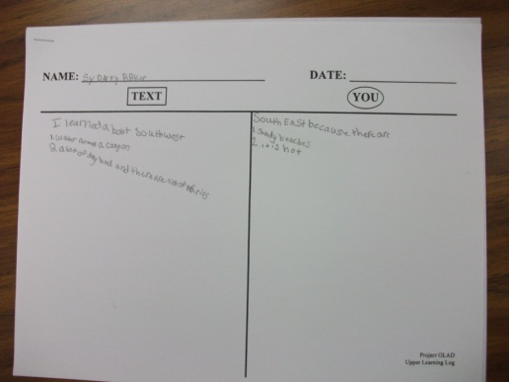
READING & WRITING STRATEGY: WHAT IT LOOKS LIKE
Learning Log

RESEARCH:
- Variation of Dialectic Journals
- University of Irvine- UCI Writing Project
RATIONALE:
- Students process their learning
- Improves metacognition
- Formative assessment

KEY POINTS:
Prompted Writing: Content based and teacher assigned.
Ask permission before sharing any of their writing. It’s private.
Can be done daily= on-going
Useful in any content area
Paper is divided in 2 columns: Text and You.
Text: Write factual information.
You: Write how it relates to you. What concerns do you have related to this information. Write your personal response to what you learned, or ask a question. This is area for personal information or reaction.
Students can write in learning log after each time they interact with text.
Sketch or write 2 new things you learned about.

STANDARDS:
College and Career Readiness Anchor Standards for Reading
- Key Ideas and Details
1. Read closely to determine what the text says explicitly and to make logical inferences from it; cite specific textual evidence when writing or speaking to support conclusions drawn from the text.
2. Determine central ideas or themes of a text and analyze their development; summarize the key supporting details and ideas.
3. Analyze how and why individuals, events, and ideas develop and interact over the course of a text.
College and Career Readiness Anchor Standards for Writing
- Research to Build and Present Knowledge
7. Conduct short as well as more sustained research projects based on focused questions, demonstrating understanding of the subject under investigation.
8. Gather relevant information from multiple print and digital sources, assess the credibility and accuracy of each source, and integrate the information while avoiding plagiarism.
9. Draw evidence from literary or informational texts to support analysis, reflection, and research.

READING & WRITING STRATEGY: WHAT IT LOOKS LIKE
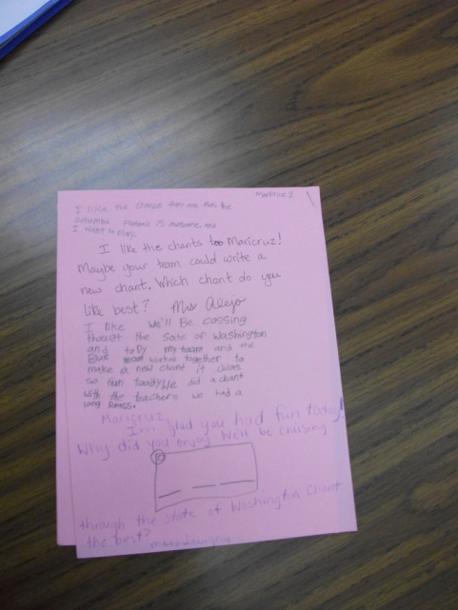
Interactive Journals

RESEARCH:
- Dr. Barbara Flores
- Kenneth and Yetta Goodman
RATIONALE:
- Students engage in silent sustained writing and sketching
- Can be based on content or personal issues
- Chance for individual communication between student and teacher about meaningful issues

KEY POINTS:
Impromptu Writing
Ask permission before sharing any of their writing. It’s private.
- 5 blank pages – Use plain paper, unlined so students have no restrictions & feel successful.
- Student decorates the cover.
- Student writes or sketches to teacher. They can choose what to write. Can ask questions.
- They can sketch and/or write.
- Unprompted communication.
- Student writes and teacher responds. It’s a way to get to know each other.
- In Primary: teacher models journal writing, give directions before kids get out the journals. For non-readers, teacher writes back while student is watching. Models writing. Teacher & student interact while the rest are doing other activities.
- Higher grades: all write together.
- Model how to address the teacher. Print in the room helps scaffold their writing.
- “When you’re done, go to reading or writing centers.” (Point to centers.)
- Teacher’s language must be authentic. End with a question to keep conversation going.

STANDARDS:
College and Career Readiness Anchor Standards for Writing
- Production and Distribution of Writing
4. Produce clear and coherent writing in which the development, organization, and style are appropriate to task, purpose, and audience.
5. Develop and strengthen writing as needed by planning, revising, editing, rewriting, or trying a new approach.
6. Use technology, including the Internet, to produce and publish writing and to interact and collaborate with others.
- Range of Writing
10. Write routinely over extended time frames (time for research, reflection, and revision) and shorter time frames (a single sitting or a day or two) for a range of tasks, purposes, and audiences.

