STRATEGY NOTES
INQUIRY CHART

WHAT IT LOOKS LIKE
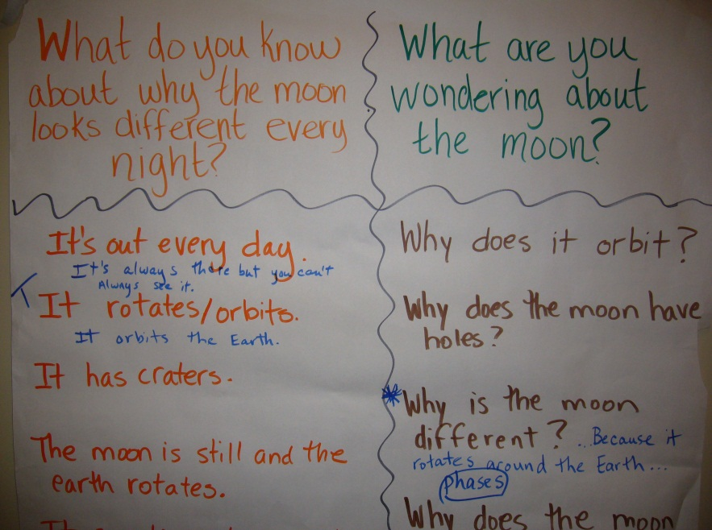

RESEARCH BASE
- These charts originated with inquiry method of science many years ago.
- Now used extensively beyond science and have many variations.

WHY DO IT
- To access and focus on background information
- To set students purpose for learning,
- To pre-assess concepts, vocabulary, and grammar,
- To obtain an ongoing diagnosis of the information learned on an almost daily basis, and to determine how the information was learned.
- To model scientific investigation method—predicting, studying, confirming, or refuting, and rewriting.
- To provide more opportunities for metacognition.

STEP-BY-STEP PROCESS
- Prepare blank grid with the following column headings:
  - “What do you know about….?”
  - “What would you like to learn…?” or “What were you wondering about…?” or “What questions do you have about…?”
  - When processing the chart, this third column may be used for where the students got the information they learned. Leave blank for now.

- On day one, after observation reports, teacher gives question prompt from column A and has students put their heads together in teams to discuss. Teams come up with one thing they know and teacher records on chart using only one color of marker.
- Teacher follows same procedure for column b and records responses in a different color than column a.
- At the end of the first day and/or subsequent days, the teacher revisits the Inquiry Chart to process it. This includes adding new knowledge and questions that have come up in the preceding days. It is a visual prompt to Inquiry Thinking. Sample questions that might be asked during the processing include:
  - “How do we know that?”
  - “Where do we find that answer?”
  - “Did we find this to be a true statement?” “If not, can we change it to make it true?”
  - “Is this the best way to say this?” “Can we make it clearer?” (grammar)
NOTES
- Write exactly what students say.
- Make sure to leave space between entries so that there is room for daily processing of the chart.
- Be sure to use a different color marker each time chart is processed. This is a great way to see how much has been learned over the course of the unit.
- Teachers must resist correcting students’ predictions at the time they are made. This defeats purpose of strategy which is to teach students to predict based on their background knowledge and then do some research and go back to self-correct.
- Inquiry Chart remains up during the entire unit.
VARIATIONS
- At K/1 level, add the student’s name in parenthesis to the facts given. This is a scaffold to assist your emergent reader in reading.
- Predicting questions: The teacher puts a set of 8-10 predicting questions on the students’ desks as they come in. Students make predictions of answers and share with a partner. These are processed during the unit.

- Interest or challenge questions: The students come up with 5-6 questions at the beginning of the unit, and write these on a transparency. During the unit a team is chosen to challenge another team to answer the questions. This is like a family feud game. If they can, they get a point. If they can’t, the challenging team gets the point.

