Cause and Effect Writing  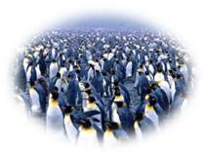  What could be some of the effects cause by global warming on the polar ice cap?  Environmental Effects  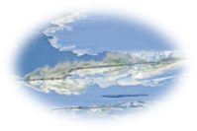  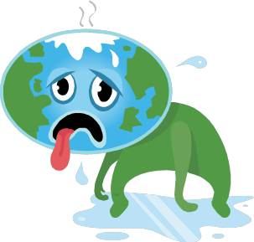  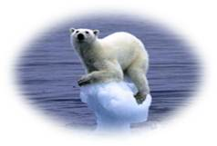  Overpopulation  Extinction of Species |  | Global warming may have a significant impact on planet Earth. Some of the major effects of global warming may cause and be traced to the environmental changes that may result in the melting of the polar ice cap. Due to the warming of the earth, the polar ice cap will melt; thus causing extinction of species such as the Polar Bear. The end result is that there may be a change in the trophic levels in the polar ice cap. This will potentially lead to the overpopulation of a species, resulting in an environmental imbalance.

