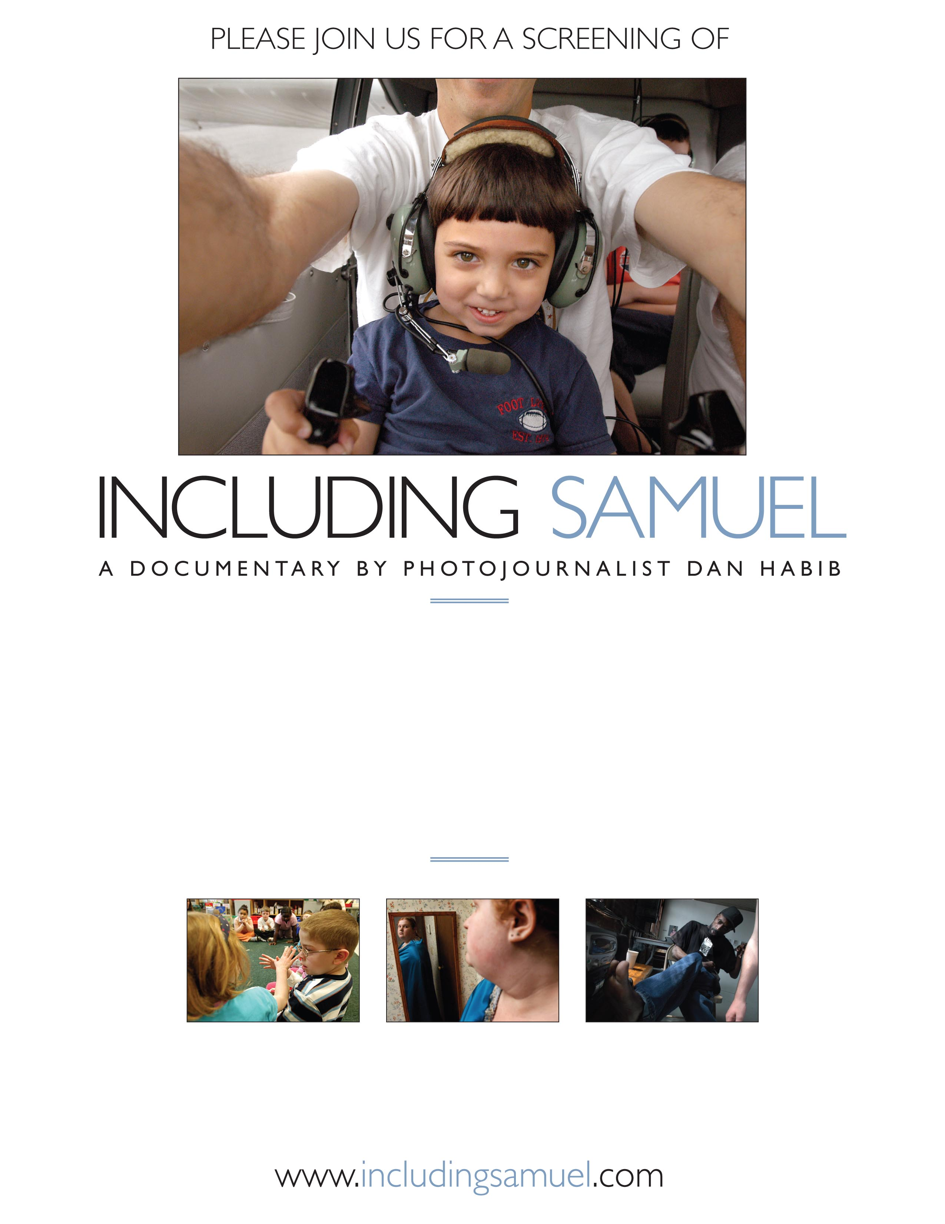
Insert date, location, time, reservation information, and price here
Insert additional details and
contact information here



