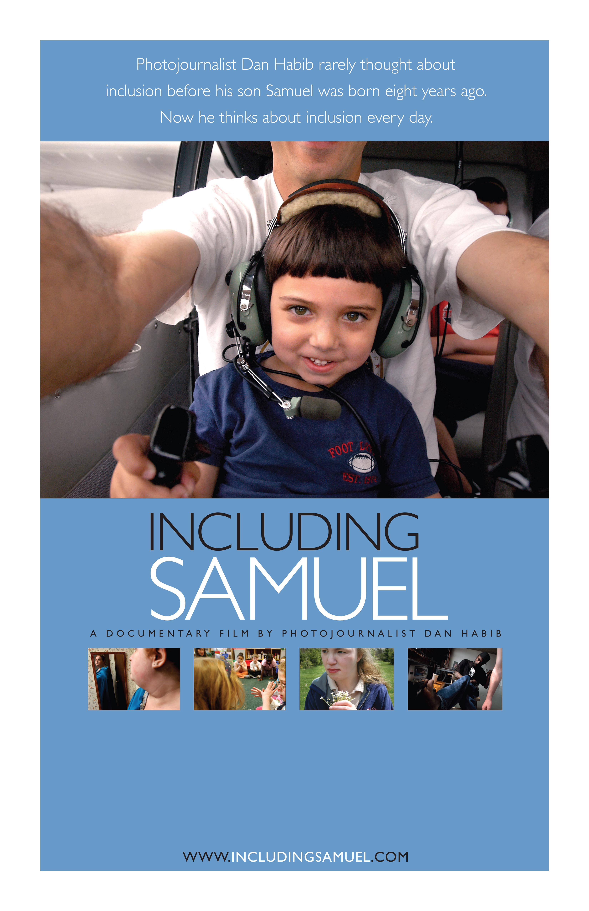
Insert date, location, time, reservation information, price, additional details, and contact information here.

