The Science and Engineering Practices self assessment comes from:

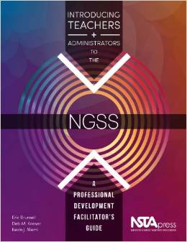

Introducing Teachers and Administrators to the NGSS: A Professional Development Facilitator's Guide

AMAZON LINK

