**Learning Progression**

Vocabulary:

**“I can**

**Formative Assessments:**

**“I can**

**Formative Assessments:**

**“I can**

**Formative Assessments:**

**“I can**

**Formative Assessments:**

**“I can**

**Formative Assessments:**

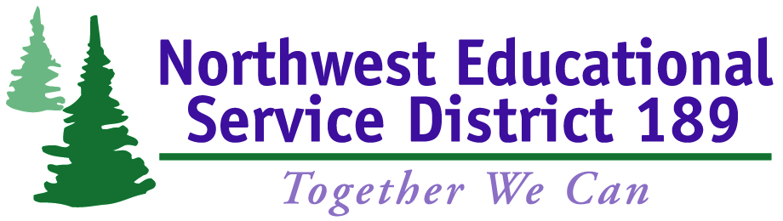

**Math & Science Collaborative Inquiry Project**