Take with you to DOL to add the CDL to your driver’s license.
- Certificate
- Yellow Skills test form
- This paper with contact information.
If there is a problem at the DOL office then do not leave. Call me first. ____________________________
- This is what to expect. Provide your documents to DOL and they will ask you for your Drivers license/Permit.
- If you haven’t already proven residency then expect to do that. (birth Certificates/marriage certificates/divorce certificates/passports etc.. see web site for approved documents)
- They may do an eye test etc…
- They should issue you a CDL, ask you to pay then take your picture.
- They will give you a paper with your CDL information on it. This is for driving purposes. See example on next page.
- They may take your hard license and keep it.
- If there is a problem then ask to speak to a supervisor, if it still is not resolved call me.
License Endorsements and restrictions have changed. Please check your form to see if they put the right information in the boxes. You should have at a minimum: EM but you could have BEKM or EMK, or MBJ etc.. See examples below.
If you have a motorcycle endorsement that could add a J to restrictions and L to endorsements.
Please check carefully before you leave. If you have a L or Z under restrictions that means no airbrakes. Do not leave without calling me and telling the supervisor.
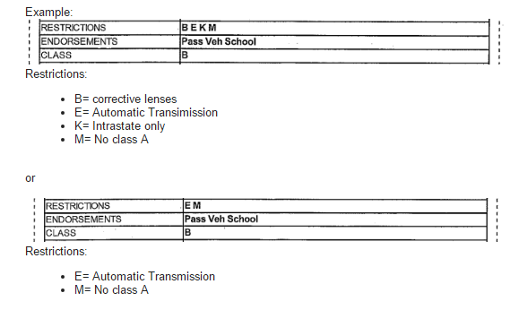
Restrictions:
- M= No class A passenger
- B= corrective lenses
- J= 2 wheel motorcycle
Endorsements:
- P= passenger
- S= School bus
- L= Motorcycle

