ELL SBA Universal, Designated and Accommodations Tip Sheet
Log into SBA’s Accommodation website: TIDE (Test Information Distribution Engine) and click on the student information icon.  The TA can view testing options; only the SC can make permanent changes to the individual student’s information for SBA testing options.
Below are screenshots of the Student Details to view or access the fields for designations or accommodations—scroll down the page to see all the options within TIDE.
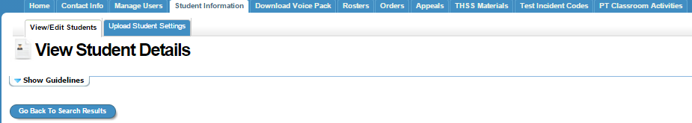
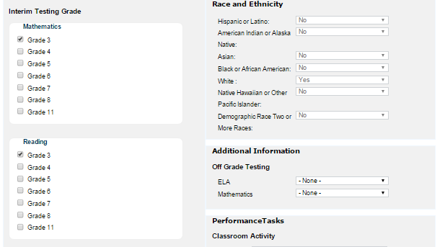
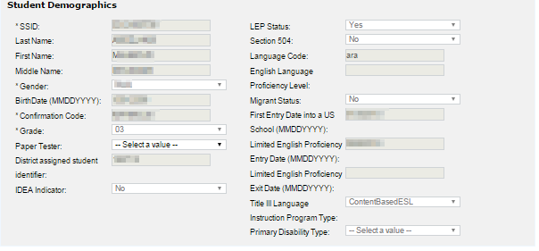
Scroll down the TIDE web page to see the SBA Accommodation options…

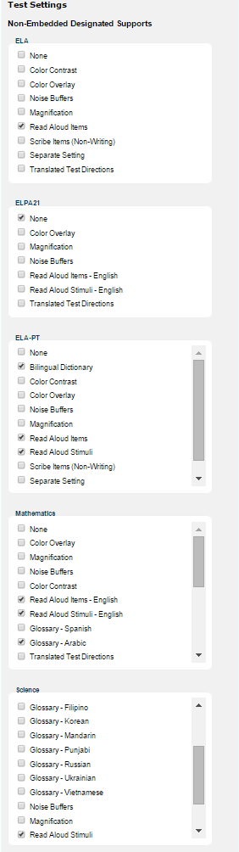
Non-Embedded Designated Supports-ELA-PT
- Bilingual Dictionary
- Read Aloud Items
- Read Aloud Stimuli

Non-Embedded Designated Supports-Mathematics
- Read Aloud Items
- Read Aloud Stimuli
- Translated Glossary (if needed)

Non-Embedded Designated Supports-Science
- Read Aloud Stimuli
- Translated Glossary (if needed)

Non-Embedded Designated Supports-ELA
- Read Aloud Items

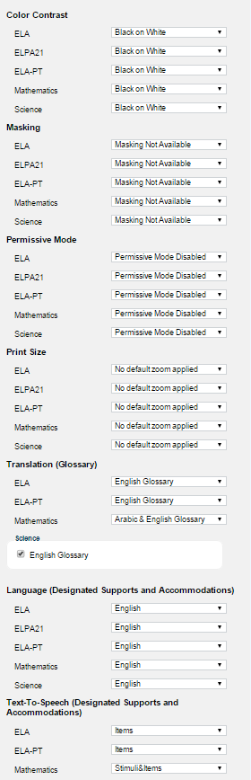
Language (Designated Supports and Accommodations):
Mathematics is the only segment that has the option of stacked Spanish & English (this is a designated support).

Only advisable for students who read Spanish proficiently and speak minimal English.
Text to Speech (Designated Supports and Accommodations):
- ELA: Items (Not *Passages)
- ELA-PT: Items (Not *Stimuli)
- Mathematics: Stimuli & Items
*These are Text to Speech accommodations (not shown) and are only allowed if the student has an IEP/504 plan.
Translation (Glossary):
- ELA: English Only
- ELA-PT: English Only
- Mathematics: Has several options for translation. If choosing a translated glossary, be sure to choose both the translated version AND the English option so the student can choose either.

ELA-PT: Check the box for
- Bilingual Dictionary
- Read Aloud Items
- Read Aloud Stimuli

Mathematics: Check the box for
- Read Aloud Items
- Read Aloud Stimuli
- Translated Glossary (if needed)

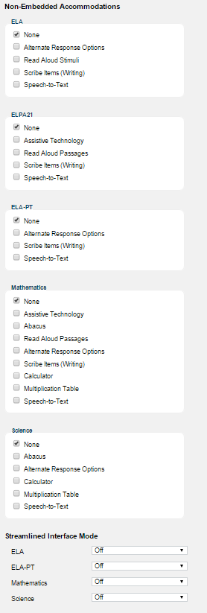
Non-Embedded Accommodations: Students must have Read Aloud passages in their IEP/504 plan

**DO NOT CHECK “READ ALOUD STIMULI” in this section unless part of the student IEP/504 plan.

