TO PRINT OUT AN SBA SCORE REPORT FOR A STUDENT
- Using Google Chrome  as your browser.

- Go to wa.portal.airast.org or select WCAP in “Managed Bookmarks” bar.
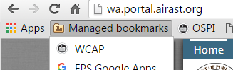
- Select Test Coordinator (SC role is needed to print an ISR)
- Next, select Online Reporting System
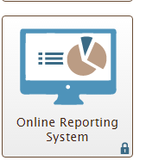
- Choose Score Reports
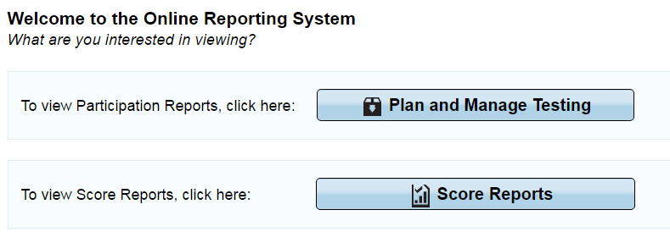
- Select Test and Year next: Test = Smarter Summative Year = School year you are looking for the student SBA report for.
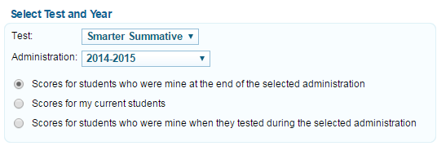
- At the top of the page, click on Search Students

- Paste in the student’s SSID (student state ID number) and click on Search.

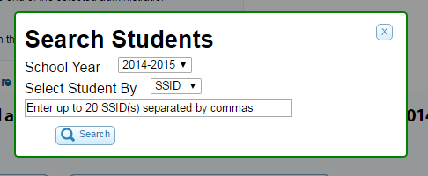
- All tests taken by this student will appear in a list. Click on the name of the Smarter Summative test you want to print (i.e ELA & math Grade 5). Print icon is located in the upper right-hand menu bar.
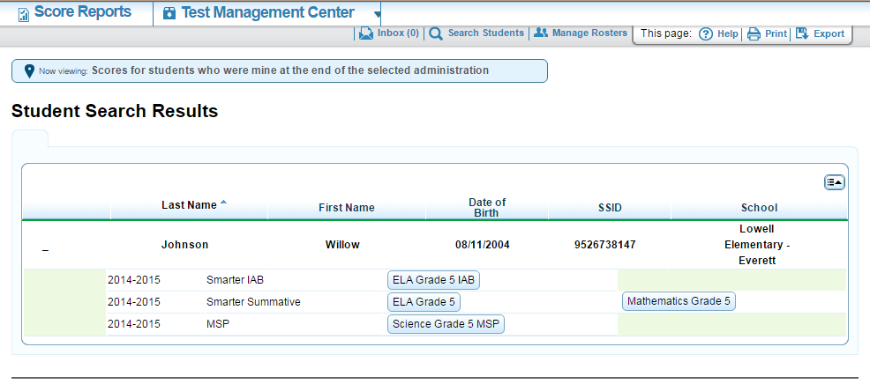

TO SAVE AN SBA SCORE REPORT AS A PDF FOR A STUDENT
After you have selected print it will download in the open window. Open the PDF and save as Student Name SBA score report to your desktop for the student.

