DRAFT Elementary and Middle Schools Assessment Schedule for Bellingham Public Schools, 2016-17

State Annual Assessments

Assessment | Grades (Students) |  | District Testing Window | Format
Grade 2 Reading Assessment (BAS) | Grade 2 (All) - see BAS under Interims |  | Aug 29 - Sept 30 | Paper
Smarter Balanced – ELA | Grade 3 – 8 (All) – prioritize early Gr 3 testing |  | Mar 13 – Apr 27 (make ups until Jun 8) | Online
Smarter Balanced – Math | Grade 3 – 8 (All) – prioritize early Gr 5 testing |  | May 1 – May 26 (make ups until Jun 8) | Online
MSP – Science | Grades 5 and 8 (All) |  | Apr 17 – May 26 (make ups until Jun 2) | Online
Classroom-Based Assessments – Social Studies, the Arts, Health and PE | Grades 3 – 12 (All) | The Arts, Civics, Social Studies, Health and Physical Education assessed at all grades taught, with at least one CBA completed by the end of the year for grades 5, 8 and 12

District Interim Assessments

Assessment | Grades (Students) | Testing Windows/Checkpoints
K Screen – Literacy and Math | Kindergarten (All) | Aug 19 – 31 | Oct 17 – 28 | Jan 9 – Feb 9 | May 15 – Jun 8
Phonemic Awareness - Literacy | K – 1 (All): Fall; (NYAS): Win and Spr | Aug 29 – Sept 30 |  | Jan 9 – Feb 9 | May 15 – Jun 8
TS GOLD for WaKIDS Checkpoints | Kindergarten (All) |  | Oct 28 | Mar 16 | Jun 15
Fountas & Pinnell  BAS – Reading | K (All): Winter and Spring  Gr 1-2 (All): Fall, Win* and Spr  Gr 3 (All): Fall; (NYAS): Win and Spr  Gr 4-5 (NYAS): Fall, Win and Spr | Aug 29 – Sept 30 |  | Jan 9 – Feb 3  * Non-Title Gr 2 Winter only NYAS required | May 15 – Jun 8
MAP – Math | Gr 3-5 (All): Fall and Winter  Gr 6-8: (Small sample) Fall and Win | Aug 29 – Sept 30  required |  | Jan 9 – Feb 3  required | May 15 – Jun 8 optional
MAP – Reading | Gr 3 – 8: (optional) | Aug 29 – Sept 30 |  | Jan 9 – Feb 3 | May 15 – Jun 8
Smarter Balanced Interim –  ELA and Math | Gr 3 – 12: (optional) | Comprehensive and block assessments available Sept- June from WCAP portal

Program and Special Populations Assessments

Program | Assessment | Grades (Students) | District Testing Window
IEP | WA-AIM – ELA, Math, and Science | Grades 3 - 8 (per IEP team) | Oct 17 (opens) |  | March 31 (closes)
HCL | CogAT – Screener | Grade 2 (All) – considering Gr 5 |  | Jan 9 – 20
HCL | BAS – Reading | Gr 3 (verbal): Spr  Gr 4-5 (verbal): Fall and Spr | Aug 29 – Sept 30 |  | May 15 – Jun 8
ELL | ELPA 21 – English Language Proficiency | Grades K – 12 (ELL) |  | February (TBD)
Title I  LAP | SRI – Reading | Gr 3-4 in Title I schools | Aug 29 – Sept 9 Jan 9 – 20 May 5 –Jun 8
Title I  LAP | SRI – Reading | Gr 5 in Title I schools | Aug 29 – Sept 9 Jan 9 – 20 May 5 –May 26
Title I  LAP | SRI – Reading | Gr 4-9 in READ 180 or System 44 | Aug 29 - Sept 9 Oct 25 - Nov 9 Jan 9 - 20 Mar 6 - 17 May 5 - Jun 8

Assessments by Purpose
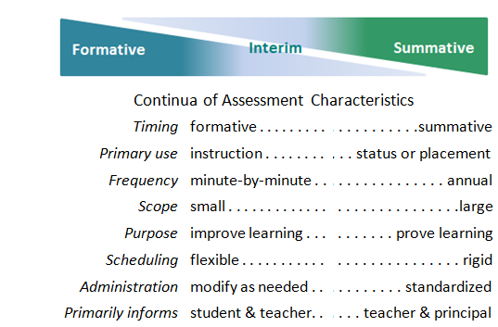
- Screening assessments – happen before the instructional process to make an early identification of a student’s strengths or weaknesses to allow classification, placement, or intervention.

- Diagnostic assessments – narrowly-focused tools used to identify needs and the causes of specific student weaknesses, with intent to guide or modify instruction or to design differentiated instruction.

- Formative assessments – a process used by students and teachers during instruction that provides timely and ongoing non-evaluative feedback to adjust instruction and learning.

- Progress monitoring – feedback characterized by frequent, repeated use of a common tool to determine how well students are responding to instruction or a particular instructional intervention.

- Interim assessments – to evaluate students’ progress toward academic standards, these are less-frequent snapshots that can inform decisions at the classroom, school or district level.

- Summative assessments –tools to evaluate performance after the instructional process, these are used for grading and to guide policy.

