Editing Student Settings in TIDE, Spring 2017
Go to: WA Portal, then Test Coordinators, then TIDE, and sign in by using your complete district email address and your password. If you do not remember your password, choose Forgot Your Password?
You will be prompted to select a test administration. From the drop down menu, choose WA Spring 2017 if that selection is available. If you are not seeing WA Spring 2017, choose WA Fall 2016 or Winter EOC 2017. When the TIDE site is updated, then begin using Spring on the drop down menu. You will not need to re-do any previous entries.
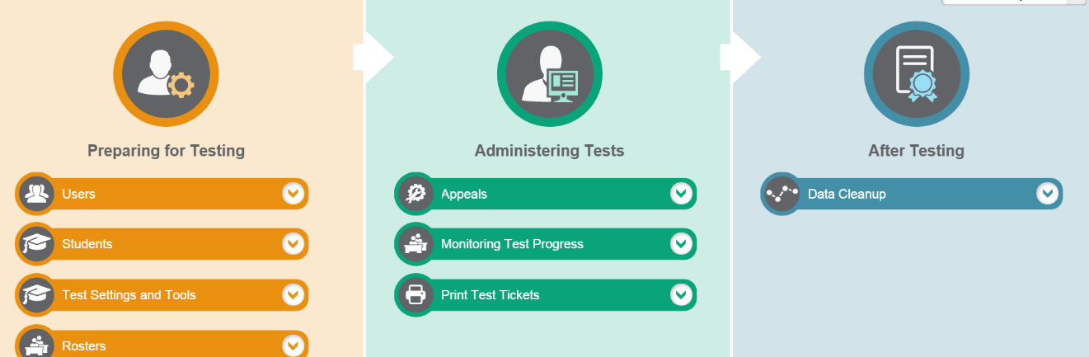
The screen looks like this:

Editing Student Settings
For accessing students’ supports choose Preparing for Testing, Test Settings and Tools, then View/Edit/Export test Settings and Tools
- You may search for students in several ways such as: by individual, by grade level, or by programs such as LEP.
- Select student(s) by using the check box to the left of their name and then click on the pencil icon next to the check box by their name.
- The window looks like the picture below. The numbers to the left are a quick link to selections located further down the page. The arrow in a circle to the bottom right scrolls to more subjects than shown in the initial window.
  - The settings for Text-to-Speech as a Designated Support and as an Accommodation are both located in the same area of TIDE. It is the last item under the Embedded Designated Support window.
  - The Stacked Spanish Translation choice for Math is located under Embedded Accommodations, Math, Language (Designated Supports and Accommodations).
  - For 5th and 8th Science MSP Translated CDs kits, use Non-Embedded Designated Support, Science, Translated Test Directions.
  - For High School, the Off-Grade for ELA, Math and Science are located towards the top of the page.
- Choose the Save (or Cancel) button at the top of the page. You will receive an “edits saved” message.
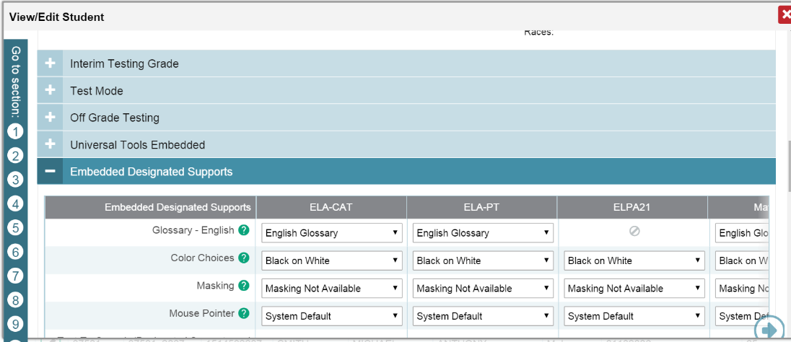
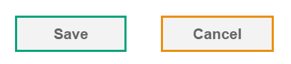

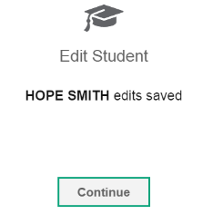
JAMES SMITH

