Monitoring Test Completion and Student Status in TIDE
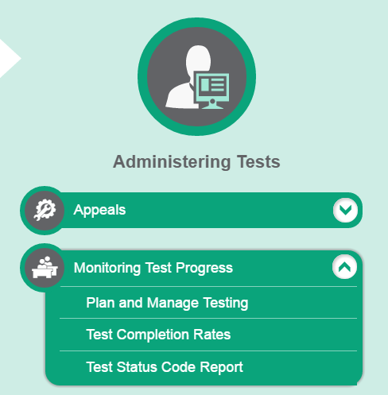
- Go to wa.portal.airast.org
4. Go to Administering Tests and select Plan and Manage Testing
- Click on the TIDE icon
- Sign in with your TIDE log in
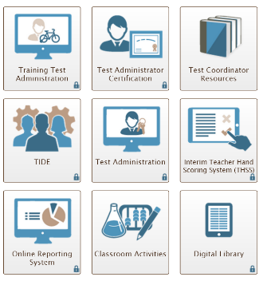

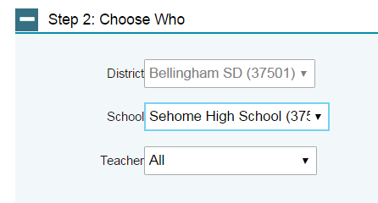
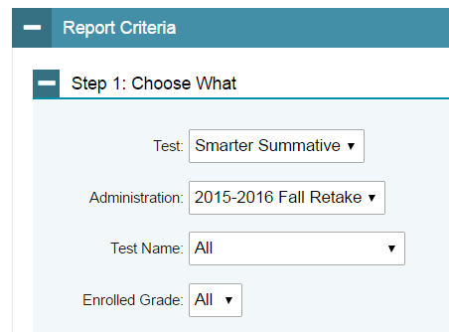
- Under Report Criteria, complete the three steps.
Step 1: Choose What
- Select Smarter Summative, MSP Science, or Off Grade from the Test drop down menu.
- Select 2016-17 in the Administration field.
- You may also select Enrolled Grade.
- Leave Test Name as shown.

Step 2: Choose Who
- Select a School if needed.
- Leave the Teacher as shown.

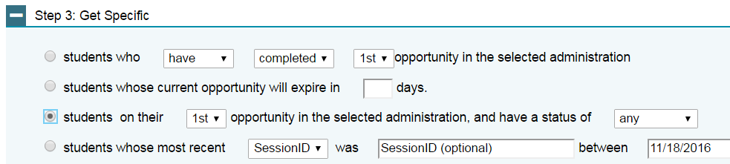

Step 3: Get Specific to look for specific students.
- First bullet searches for students who have (or have not) completed the first opportunity. This is a good report to run to find students who have not begun testing.
- Second bullet searches for students whose tests may expire. We suggest choosing 12 days.
- Third bullet can search for students on 1st opportunity with a test status of any to see all students, or a group of students with a particular test status. This report works well to help determine whether students have taken all sessions in all subjects.
- Fourth bullet allows for specific searches by session ID/TA and date. If you don’t know Session ID/TA, you can leave it on default and it will give you all Session ID’s/TA’s for dates selected.


- Selecting Generate Report or Export Report
- Generate Report displays data on the webpage.
- Export Report displays the information in Excel. The Excel report downloads to the bottom left corner of your ORS screen. Sort your Excel report by student name then by test to make the report easier to view all rows for a student.

IMPORTANT: Use the bullet report function in Step 3 (students on 1st opportunity with test status of any) to track the progress of students through their tests. Once your school’s testing is done, export the report and save the excel file for future reference. Your District Assessment Coordinator may need to view those reports at your end-of-testing check-In appointment.

Generating a Test Status Code Report
The report includes all tests for which a student is eligible. Students have a line for each of their eligible tests. For each test listed, the report provides student’s name, SSID, test name, date started, test status code (if applicable and current test status. The test status column includes a status for each of the students’ tests (e.g., Paused 9/65). This report does not include student grade level.

- Go to wa.portal.airast.org
4. Go to Administering Tests and select Plan and Manage Testing
- Click on the TIDE icon
- Sign in with your TIDE log in

- Under Report Criteria, complete select a test and administration, such as 2016-17.
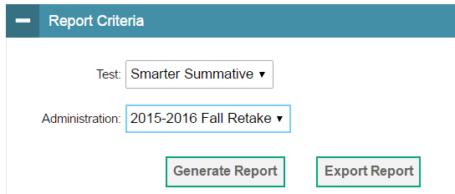

- Click either Generate Report or Export Report.
- Generating or exporting the report may take time, depending on the amount of data selected.
- The Excel report downloads to the bottom left corner of your ORS screen.
- Refer to the Test Information and Distribution Engine (TIDE) User Guide and the Test Information Distribution Engine (TIDE) Power Point for more details.

