Viewing Score Reports in the Online Reporting System (ORS)
Important: The Online Reporting System is a secure site with data for internal use within the schools and the district. Proficiency rates in ORS are based on the students who tested and do not include all who should have tested. Therefore, ORS rates will not match official accountability reports or the State Report Card website.

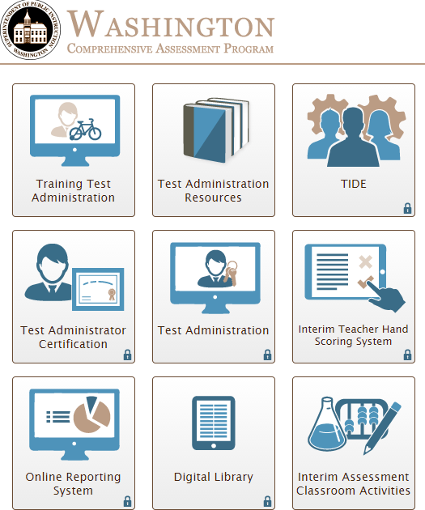
Start: Access the WCAP Portal page, and click on the ORS tile.
- This requires a login name and password. Contact your District Assessment Coordinator for more information.
- On your first visit, you will see the confidentiality acknowledgement page. Click on the box to progress to the next page.
- If you are associated with more than one school, select your school from the drop down box.

Part A: Capturing and printing pdf of Individual Score Reports
Part B: Summary reports with proficiency rates, claims and target data
Part C: Student rosters with scale scores and claims data

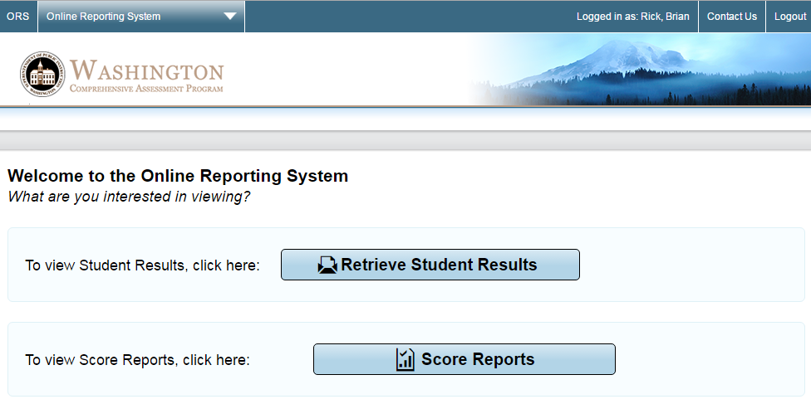
Part A: Click on Retrieve Student Results to access pdf of individual student reports.

- Select PDFs of Student Reports from the Report Type drop down field. (Selecting Student Data will return and Excel spreadsheet, one row per student.)

- For the Test field, select Smarter Summative for the annual state test. Other options are the Smarter ICA Interim Comprehensive Assessment and the IAB Interim Assessment Block tests.

- For the Administration field, select the year, such as 2015-16.

- Select the PDF type to get a zip file with one Individual Student Report (ISR) per student. The Simple ISR includes a scale score and claim area descriptors. The Detailed ISR also include and interim data as well as the summate test’s writing rubric score.

- In Step 2 on the right of the screen, select the desired options for school, teacher, and rosters, as applicable. [Bellingham] The Roster names include information on the season, teacher, grade level of students, course title abbreviations, and period. We use two naming conventions for Rosters:
  - Middle & High School – 3 digit Year & Season / 5 digit Last Name Abbreviation / 2 digit Student Grade / 5 digit Course Abbreviation / Period – i.e: 16F_MILLE_11_Span2_1
  - Elementary School – Course Code i.e.: ELM3

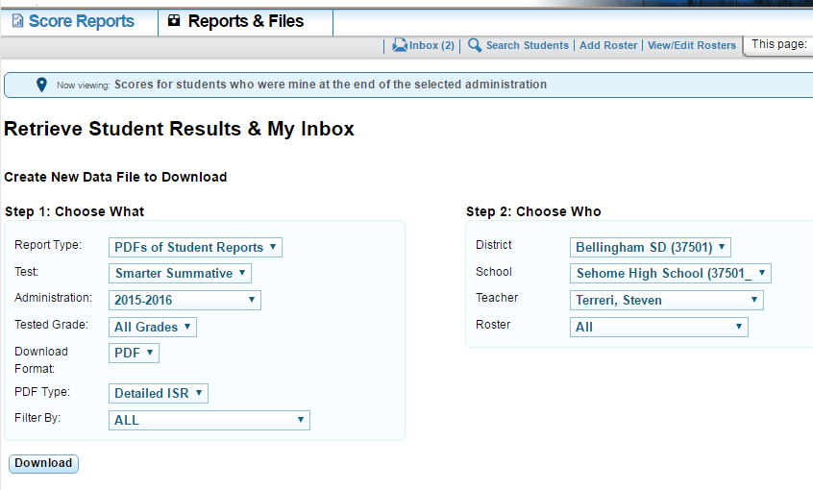
- Click the Download button.
- You receive an email when the download is ready. “My Inbox” at the bottom of the page shows all downloads and their status. This is where you click to access the download. The Zip folder created through this process contains PDFs of Individual Scores Reports for the selected class.

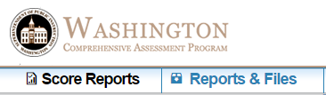
Part B: For summary reports with proficiency rates, claims and target data, click on Score Reports from the welcome screen or from the menu bar.

- From the Score Reports Home Page Dashboard, select the test and administration year.

- Click on the second radio button for Score for my Current Students.

- Once you have selected the correct test administration window, tables will appear at the bottom of the page which list score information about your class roster.
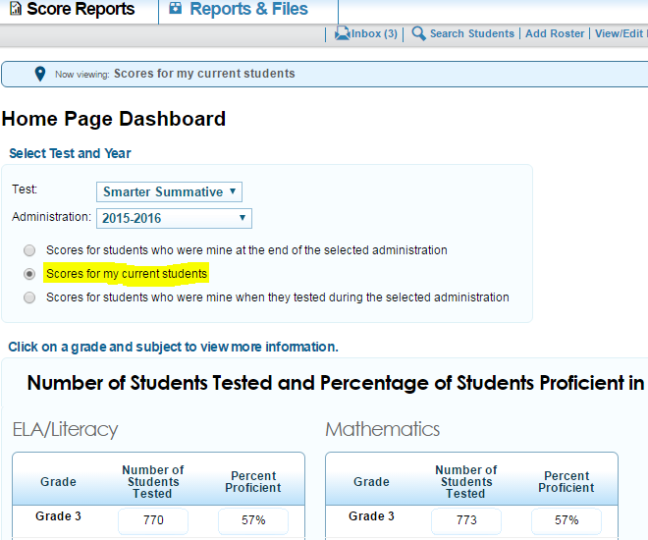

- Click on a grade and subject to see average scores, proficiency and achievement level rates – by Teacher for school level users or by class Roster for teacher level users.

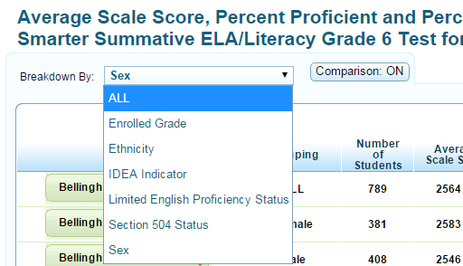
- To view proficiency levels by population demographics and special programs, you can change the selection in the Breakdown By field.

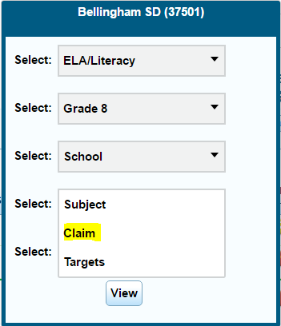
- To view the data by Claim performance level, click on the magnifying glass to change from Subject to Claim.
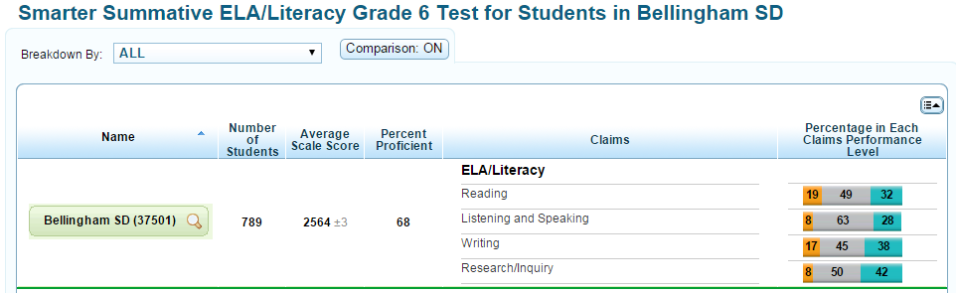

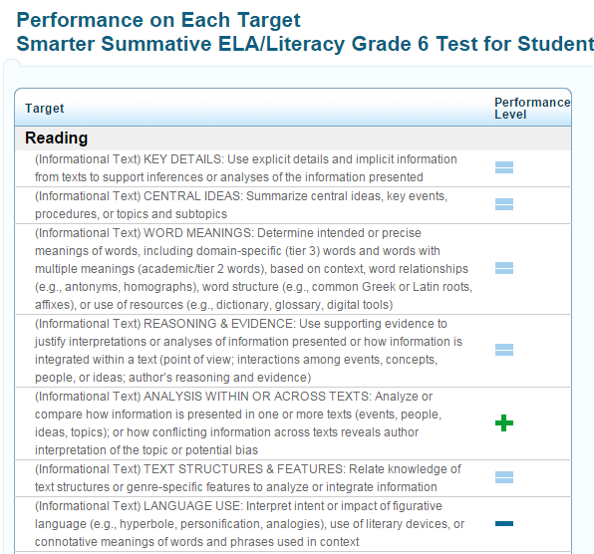
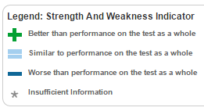
- To drill down from claim level proficiency ratest to performance by targets within each claim, change Claim to Targets for the selecte group of students (School, Teacher or Roster).

Part C: Student rosters with scale scores and claims data
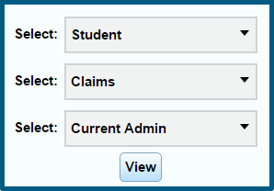
- Starting from the Score Reports dashboard with test, administration, subject and grade selected (steps 1-4 in Part B), click on the magnifying glass of the level you are viewing.

- Select Student and Claim. Target data is not available at the student level.

- This roster can be sorted by clicking on the headers for Name, Score, Level, and Categories.
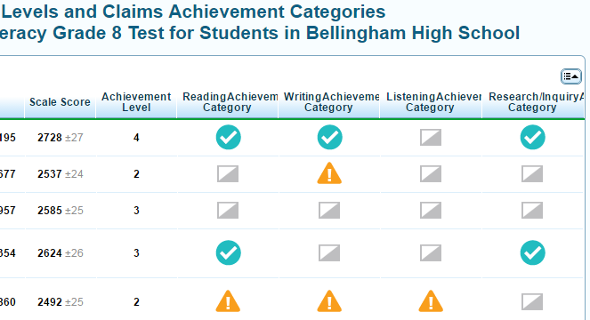
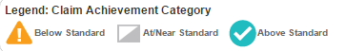

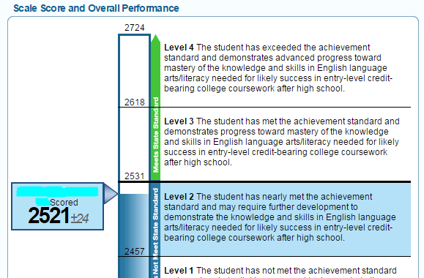
- To view an individual score report for any particular student, click on the student’s name.

