College and Career Readiness and Equity: Case Studies
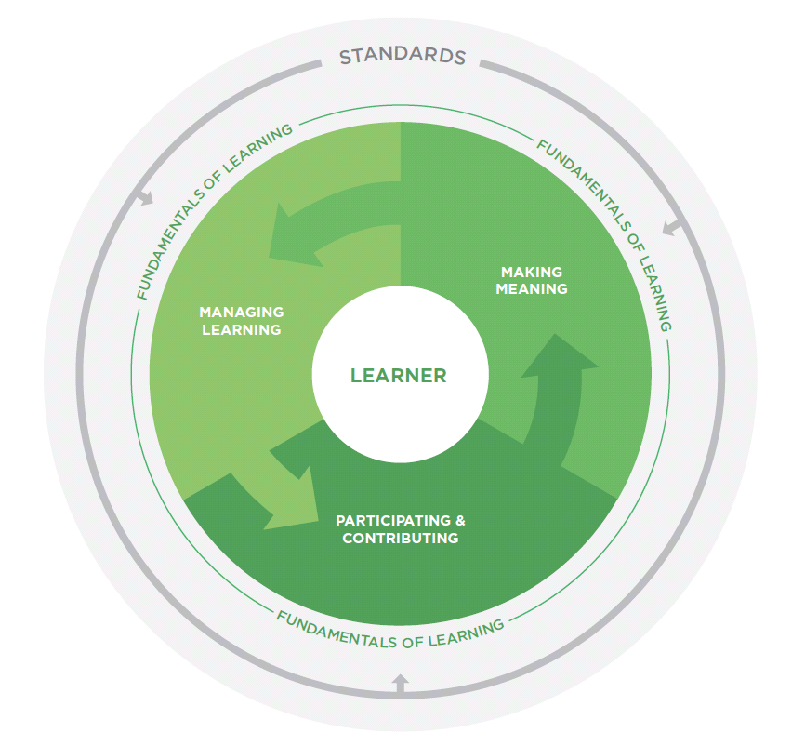  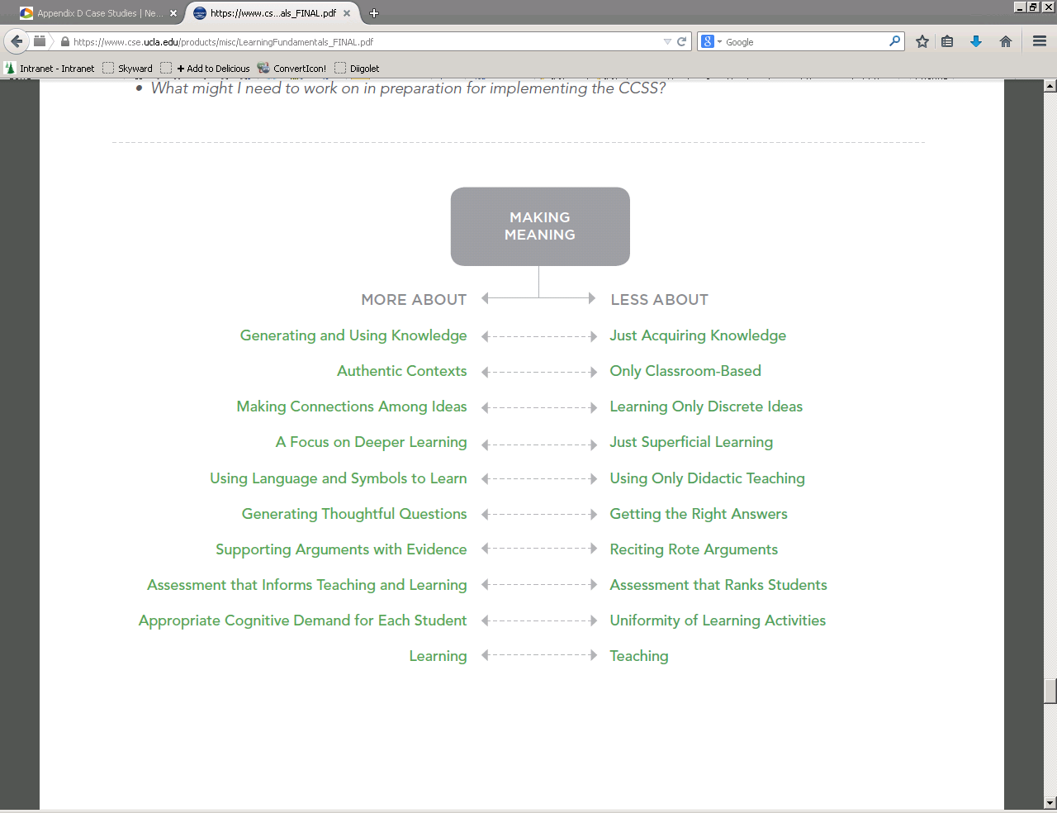 | Choose a Fundamental of Learning and review the  More About-Less About tool.  Focus Questions:  - In my district, how is classroom practice consistent with the “more about” column?  - How does it differ?  - What might we need to work on next to prepare for implementing the Washington State Learning Standards?

