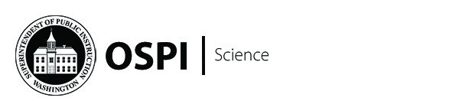

Update: Grades 5 and 8 date correction.
Both Grade 5 and Grade 8 Item Cluster Writing work groups will run April 9-11, 2018.
We apologize for the previous message with incorrect dates.

Item Cluster Writing Work Group Application
This is your invitation to APPLY for item cluster writing work groups for the Washington Comprehensive Assessment of Science (WCAS).
Item Cluster Writing Work Groups: Teams of two writers produce stimuli and items aligned to the state learning standards. The teams also draft rubrics designed to measure student understanding of the science standards.
Grade 5 April 9–11
Grade 8 April 9–11
High School April 9–13
Participants will be chosen to provide a well-balanced work group in terms of previous science assessment experience, content and grade-level expertise, and state demographics. Each work group will include both experienced and new applicants.
The assessments are three-dimensional—assessing Science and Engineering Practices and Crosscutting Concepts in the context of Physical Sciences; Life Sciences; Earth and Space Sciences; and Engineering, Technology, and Applications of Science. Educators are encouraged to apply for work groups at multiple grades based on content expertise. For example, a middle school teacher with content expertise in earth science is encouraged to apply for grades 5, 8, and/or high school work groups.
Teachers who have not yet participated in an assessment development work group for the WCAS will be required to complete an online pre-meeting training. STEM clock hours will be provided for the online training.
Teachers who have previously participated in a development work group for the WCAS are not required to complete the pre-meeting training.
Logistics
The work groups will begin with breakfast each morning at 7:30 a.m. and will run from 8:00 a.m. until 5:00 p.m. Participants are expected to attend the entire day.
- Breakfast and lunch will be provided.
- Free STEM clock hours will be provided.
- Personal travel reimbursement (mileage, dinner, parking, etc.) will be provided as long as all state guidelines and regulations are met.
- Lodging for those living more than 50 miles from the meeting location will be provided.
- Flights are available if needed.
- Substitute reimbursement is offered during the school year. No compensation is available during the school year.
Our application database is updated each year. Please complete the application in its entirety, even if you have applied for science assessment work groups in the past. Once you have completed this application you can use it for all events you would like to apply for in 2018.
Science Assessment Item Cluster Writing Application
Please complete the application survey by 5:00 p.m. Friday, March 2, 2018.
We recommend downloading the Application Example prior to applying. This is only an example so that you can view the questions prior to logging into the survey.
Please forward this invitation to your colleagues.
All work groups will be held in the Olympia, WA area.
Please let us know if you have any questions or need any further information.
Science Assessment Team
Science@k12.wa.us

EVERY STUDENT READY FOR CAREER, COLLEGE, AND LIFE  Led by State Superintendent Chris Reykdal, OSPI oversees K-12 public education in Washington state. Our mission is to provide funding, resources, tools, data and technical assistance that enable educators to ensure students succeed in our public schools, are prepared to access post-secondary training and education, and are equipped to thrive in their careers and lives. |  | 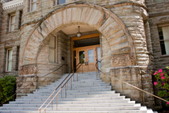

STAY IN TOUCH
Website | Twitter | Facebook | Flickr | YouTube | Contact Us
SUBSCRIBER SERVICES
Update your subscriptions, modify your password or email address, or stop subscriptions at any time on your Subscriber Preferences page. You will need to use your email address to log in. If you have questions or problems with the subscription service, please visit subscriberhelp.govdelivery.com.
OSPI provides equal access to all programs and services without discrimination based on sex, race, creed, religion, color, national origin, age, honorably discharged veteran or military status, sexual orientation, gender expression, gender identity, disability, or the use of a trained dog guide or service animal by a person with a disability. Questions and complaints of alleged discrimination should be directed to the Equity and Civil Rights Director, P.O. Box 47200, Olympia, WA 98504-7200, 360-725-6162 (TTY: 360-664-3631), equity@k12.wa.us.

