Emergency waiver rulemaking: Background for discussion

Statutory authority from EHB 2965.PL, Section 10
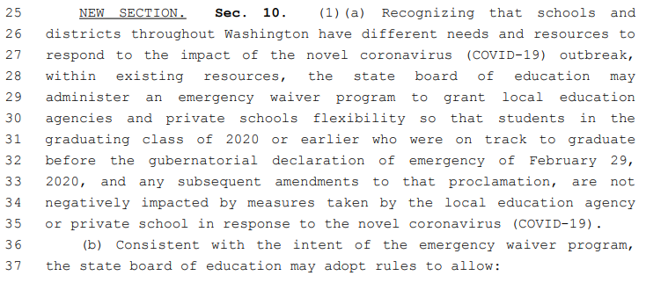
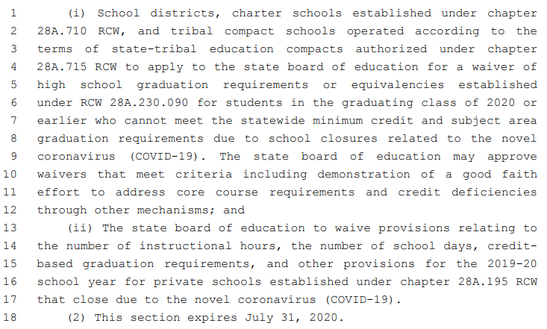

Rulemaking timeline
Monday, March 16 at 3:00 – 4:00 | Private School Partners Zoom
Thursday, March 19 at 2:30 – 4:00 | K-12 Partners Zoom
Friday, March 20 at 9:30 – 11:00 | K-12 Partners Zoom
Monday, March 23 at 3:00 – 4:00 | Higher Ed Partners Zoom
Monday, March 23 at 3:00 – 4:00 | Private School Partners Zoom
Thursday, March 26 at 1:30 – 3:30 | Special Board Meeting to review draft timeline and considerations for rulemaking
Monday, March 30 at 3:00 – 4:00 | Private School Partners Zoom
Wednesday, April 1 | Draft rules shared with Board for feedback
Friday, April 3 | Feedback due
Monday, April 6 | Revised draft rules to Board for consideration
Monday, April 6 at 3:00 – 4:00 | Private School Partners Zoom
Wednesday, April 8 at 1:30 – 3:30 | Special Board Meeting to adopt rules
Thursday, April 9 | If adopted, rules become effective
*Additional stakeholder meetings may be added as needed
Feedback received: Public K-12 Partners on 3/19 call appreciate the accelerated timeline and urged even faster if possible.

Agenda for partner conversations
- SBE to share current thinking about principles for the emergency rules, process for districts, and timeline for rulemaking
- Partners to provide feedback and identify considerations

Intent of waiver program
- Temporary solution for immediate problem at hand – focused on credit requirements for class of 2020 seniors (public and private) and 2019-20 academic year hours and days for private schools
  - Authority expires July 31, 2020
- To provide flexibility so that students who were on track to graduate this school year are not negatively impacted by school closures due to the novel coronavirus
- To provide for hour or day waivers for private schools

Scope of waiver for LEAs
- Limited to students in the graduating Class of 2020 or earlier who were on track to graduate before the gubernatorial declaration of emergency of February 29, 2020, and any subsequent amendments to that proclamation, who cannot meet the statewide minimum credit and subject area graduation requirements due to school closures related to the novel coronavirus.
  - TBD in rule: “On track to graduate”
    - SBE staff initial thinking: “On track to graduate” should mean the students has completed or is enrolled in courses that would fulfill the state credit requirements for graduation (may be focused on core credits?)
    - Feedback received: Public K-12 Partners on 3/19 call expressed agreement with this definition
    - Side note: Clarify that local school districts have authority to waive local graduation requirements
  - Does not cover potential impacts on earlier grades or students graduating after this school year
- What can be waived? High school graduation requirements or equivalencies established under RCW 28A.230.090
  - SBE staff initial thinking: The waiver does not serve to grant credits, but rather waives the need for the credits in order to earn the diploma.
    - To discuss with higher ed partners: Potential downstream impact on college admissions
  - Previously limited to waiving up to two elective credits, Section 11 of the bill lifts that limit for the emergency waiver program and also allows for waiver of core credit.
  - TBD in rule: How many credits and what type
    - Considerations: Should there be a limit on credits waived? Should core and elective be treated differently?
    - Feedback received: Public K-12 Partners on 3/19 call urged for allowing latitude and flexibility for decisions to be made by officials at local level so that districts can meet the equity needs of their community.
- Condition for LEAs to receive waiver (SBE approves LEA’s authority to grant individual student waivers):
  - TBD in rule: “Demonstration of a good faith effort to address core course requirements and credit deficiencies through other mechanisms”
    - SBE staff initial thinking: Certification by LEA with a description of the effort
      - Our understanding is that OSPI will be providing resources, including suggested practices, to help schools meet good faith effort (e.g., use of mastery-based crediting for those students who already met standard prior to Feb. 28)
  - Question: Any other conditions? (keep simple)
    - Assurance of equity
- Language is permissive: Allows LEAs to waive credit requirements for graduating students, but does not require
- Clarify this waiver is not for hours/days which are addressed by OSPI

Process for LEAs
- School districts, charter schools, and tribal compact schools must apply to the State Board of Education
- SBE staff initial thinking:
  - Expect all LEAs to apply given statewide closure
  - Application should be short, simple, and web-based
  - Criteria for approval are simple and will focus on “good faith effort”
    - SBE staff initial thinking: Certification by LEA and description of effort, potential OSPI suggested practices (see scope section above)
    - Question: Any other criteria? (keep simple)
  - Application should be signed by Superintendent or designee if not available
    - Feedback received: Public K-12 Partners on 3/19 call agreed with allowing Superintendent to sign rather than requiring School Board, but expressed desire for a WSSDA model policy to provide legal cover. WSSDA is happy to work on that. Abigail and SBE staff to connect.
  - Waiver will very likely be granted if application is complete
  - Schools and districts to be responsible for reviewing individual student circumstances and determining number and type of credits to waive in accordance with program rules
  - It would be good to build in a reporting requirement to collect information from LEAs on how many graduating Seniors used the waiver
    - Question: When and how would this info be collected? As part of the BEA in Fall 2020? Combine with any OSPI reporting requirements or requests?
- Tentative timeline for application process:
  - Question: What is the latest date waivers can meaningfully be granted?
    - Assume schools will want to know no later than mid-May
    - Authority to grant waivers expires at end of July
  - April 16: Application opens
  - May 1: Applications due (though late applications will be accepted)
  - May 13-14 Board Meeting (or call an earlier Special Meeting): Board approves
    - Question for AAG: Can Board delegate approval authority to staff?
      - Executive Director or Executive Committee can act if the Board cannot achieve a quorum in a timely fashion
  - Second Special Meeting: For approval of late applicants or incomplete applications

Scope of waiver for private schools
- For context: Private schools law regarding minimal state controls (RCW 28A.195.010)
- What can be waived?
  - Credit-based graduation requirements
    - TBD in rule: SBE staff initial thinking: Would be defined same as above for LEAs
  - Number of instructional hours for the 2019-20 school year
    - TBD in rule: How many
  - Number of school days for the 2019-20 school year
    - TBD in rule: How many
  - Other provisions for the 2019-20 school year under RCW 28A.195
    - Question: Are there other provisions that may need to be waived?
- Conditions for receiving waiver: Minimal, aligned with intent, TBD in rule
- SBE will draft a disclaimer about what the waiver does and does not address (e.g., contractual requirements, etc.)

Process for private schools
- Private schools do not need to apply, but SBE may require notification/reporting

Questions
- What about other requirements for graduation?
  - Pathway requirement
    - OSPI believes they have sufficient flexibility under RCW 28A.655.065 to waive this (expedited appeal)
    - Feedback received: Public K-12 Partners on 3/19 call raised concern about the CTE pathway credits and whether this waiver could apply to that. We do not believe so, and OSPI suggested expedited appeal is a better way to address that. SBE and OSPI will explore further.
  - HSBP requirements
    - There are more requirements now, but schools can work one-on-one with Class of 2020 students to complete this even if not done before closures. LEA determines if this requirement is met.
    - SBE staff initial thinking: Do not require schools to incorporate the emergency waiver into the student’s HSBP, but do we need to provide an option for parents or students to opt out of receiving the waiver?
- Should this waiver extend to community colleges and similar institutions?
- Any special considerations for students in Running Start?
- Any special considerations for schools that operate on trimesters?
- What other flexibility might we need to ask for in next (or special) session?
  - Expand expedited appeal

