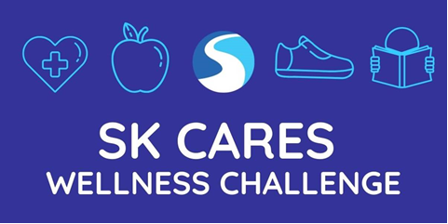

#SKCares 30-Day Wellness Challenge – These daily self-care reminders are meant to encourage YOU to keep taking good care as we stand shoulder-to-shoulder successfully navigating the events of each day.
- Get outside! Take a walk, enjoy the sunshine on your face and breath in the fresh air for at least a few minutes today.
- Cook and/or bake something from scratch
- Make a list of short-term goals you’ll accomplish by the end of the month - set deadlines
- Practice gratitude, journal things you’re thankful for.
- Engage in your favorite hobby today.
- Pay if forward & do a random act of kindness for someone today.
- Unplug from technology for one whole hour.
- Make a commitment to go a one whole day without complaining
- Get rid of 5 things you don’t use.
- Drink more water & more than servings of fruits/vegetables than you usually do each day.
- Try a new workout for a minimum of 15 minutes
- Declutter a space in your office, home or car.
- Meditate for a minimum of 5 minutes. If that goes well, try 10 the next time.
- Send encouraging texts messages to 5 people you appreciate.
- Go for a 20-minute walk and enjoy the gifts of nature.
- Listen to an informative podcast
- Reach out to a friend of family member you have connected with in a while & say hi.
- Take 10 slow deep breaths.
- Read a good book for 30 minutes today.
- Break out the crayons and color something fun.
- Fix something that’s been bugging you.
- Talk about how you are feeling with someone you trust.
- Do something out of your comfort zone today.
- Write downs 5 things you like/appreciate about yourself.
- Choose an affirmation for today and repeat it to yourself throughout the day. Practice positive self-talk.
- Ask for help or have a real heart-to-heart with someone about what’s on you mind/heart these days.
- Focus on resting and relaxing today. Take a nap, sleep in, go to bed early.
- Practice self-care and treat yourself to something special that makes you extra happy today.
- Brighten up your favorite space. Add flowers, a plant, or a framed photo from your phone.
- Listen to your favorite song on high volume.

