Grade Mark Overrides in the Gradebook
Path: Teacher Access\My Gradebook\Select Class Gradebook\Locate S2 column\Click on options dropdown\Enter S2 Grade Adjustments

- From the Gradebook Main Screen, click the Options dropdown in S2 Grade column.

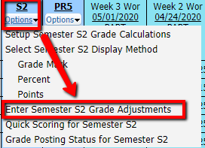
- Select “Enter Semester S2 Grade Adjustments”.

- On the Grade Adjustment window, find the student you wish to give the Override Grade to and follow the row to the Override column.

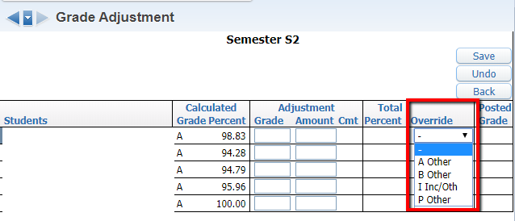
- Using the dropdown, select on the Override Grades for this student.

- Repeat Steps 3 and 4 for any additional student Grade Mark Overrides.
Save.
- Click Save. .

