Newcomer Artifact Box
Welcome Kit for New ELLs by Colorincolorado:
http://www.colorincolorado.org/article/welcome-kit-new-ells

Department of Education Newcomer ToolKit
https://www2.ed.gov/about/offices/list/oela/newcomers-toolkit/ncomertoolkit.pdf

Multilingual Newcomer Toolkit
http://multilingual.mpls.k12.mn.us/newcomer_toolkit

Family Visit Article:
https://learningforward.org/docs/leading-teacher/dec07_ginsberg.pdf?sfvrsn=
2

Newcomer Resources:
https://sites.google.com/a/mvsd320.org/rodriguez-s-resource/home

Instructional Supports:
http://www.ballard-tighe.com/frames-for-fluency/

Programs for Newcomer Supports:
http://www.ncela.us/files/feature_topics/newcomers/ElevatingELs_ProgramsForNewcomerStudents.pdf

Wayne P. Thomas and Virginia P. Collier Research:
http://www.ascd.org/ASCD/pdf/journals/ed_lead/el200310_thomas.pdf

OSPI EL program models and overviews:
http://www.k12.wa.us/MigrantBilingual/pubdocs/ProgramModels.pdf

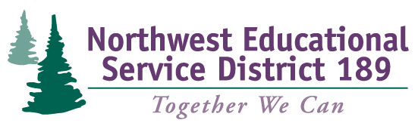
Push In Models & Resources:
https://prezi.com/kwtos7dlleq9/push-in/
http://blog.tesol.org/pull-out-vs-push-in-esl-programs-in-elementary-schools/
http://gssaweb.org/wp-content/uploads/2015/11/Best-Practices-in-Inclusive-Instruction-for-ELLS.pdf
Apps:
https://www.eschoolnews.com/2016/07/18/the-best-apps-and-resources-for-english-language-learners/

