Academic Language Posters - Teacher Training on March 28, 2017
Comprehension & Collaboration  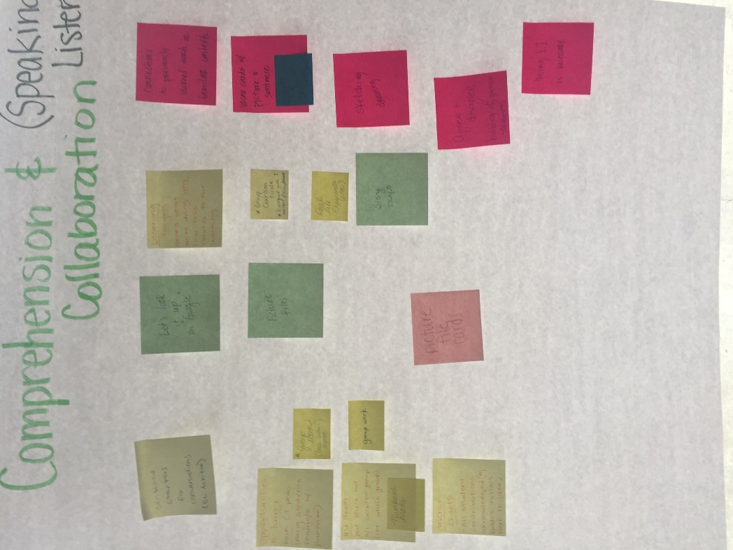 | Conventions  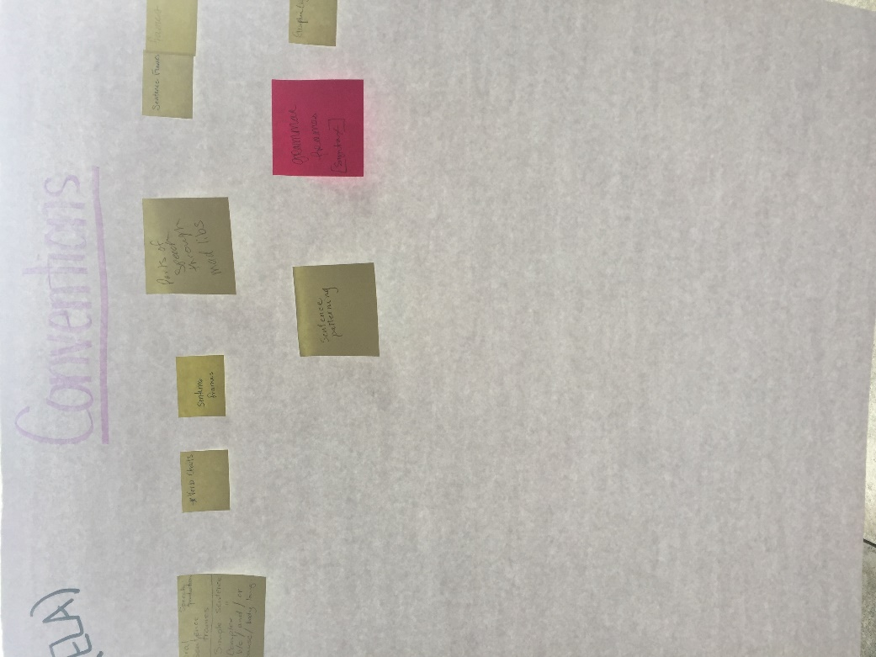
Presentation of Knowledge & Ideas  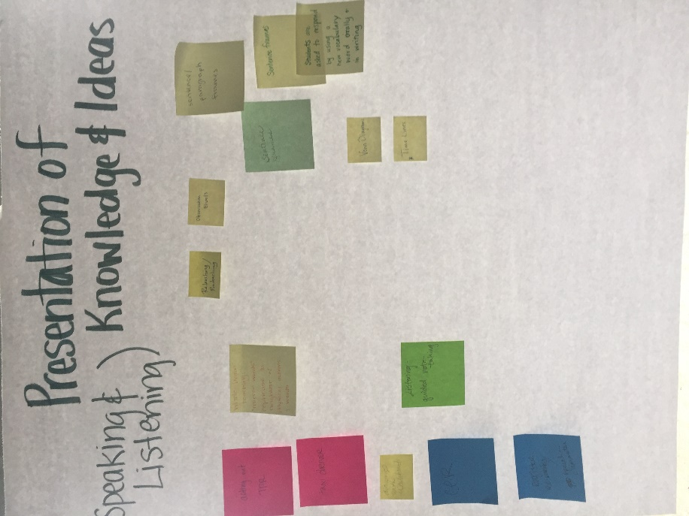 | Knowledge of Language  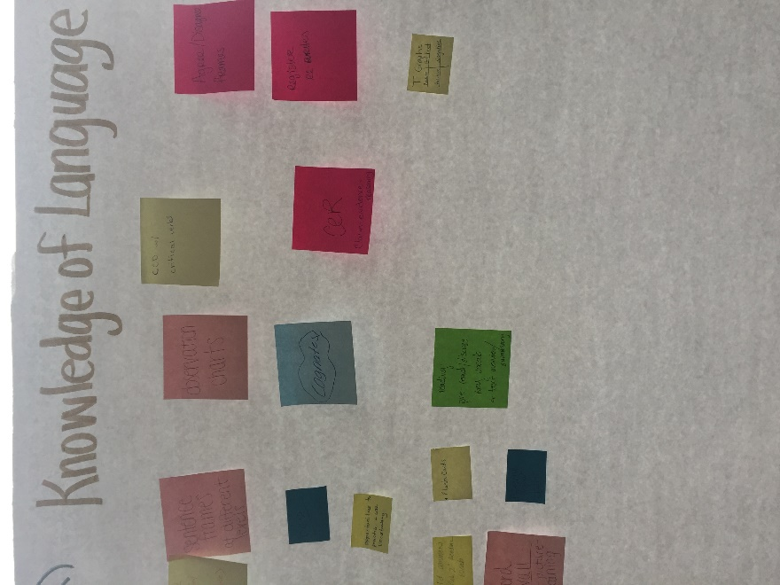
Vocabulary Acquisition & Use


