Four Corner Debate Posters from Teacher Training on March 28, 2017
Background Knowledge  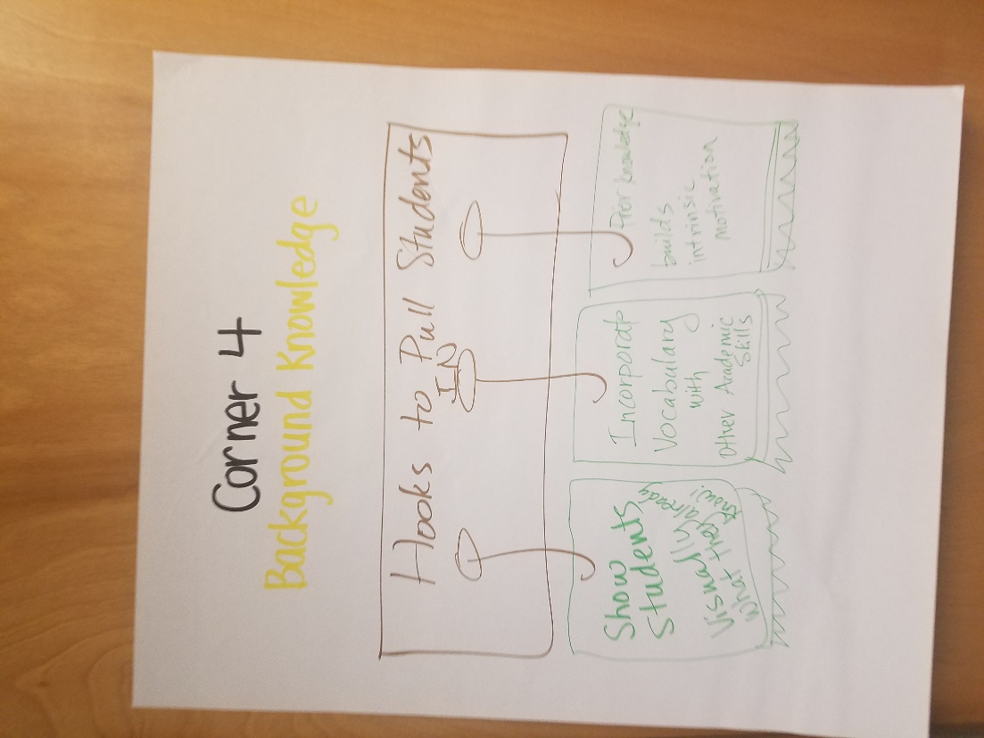 | Graphic Organizers  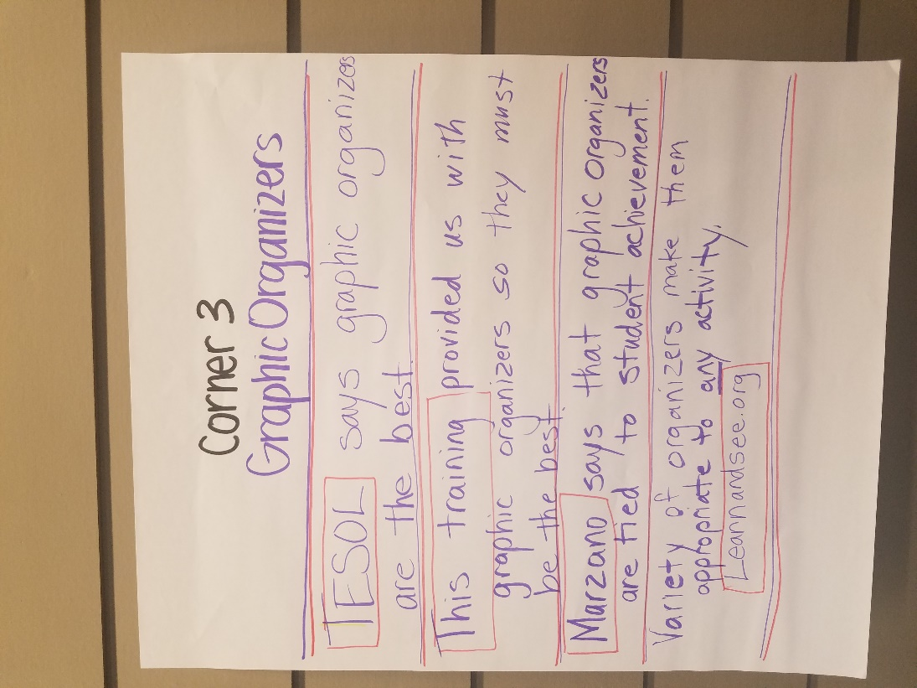
Sentence Frames  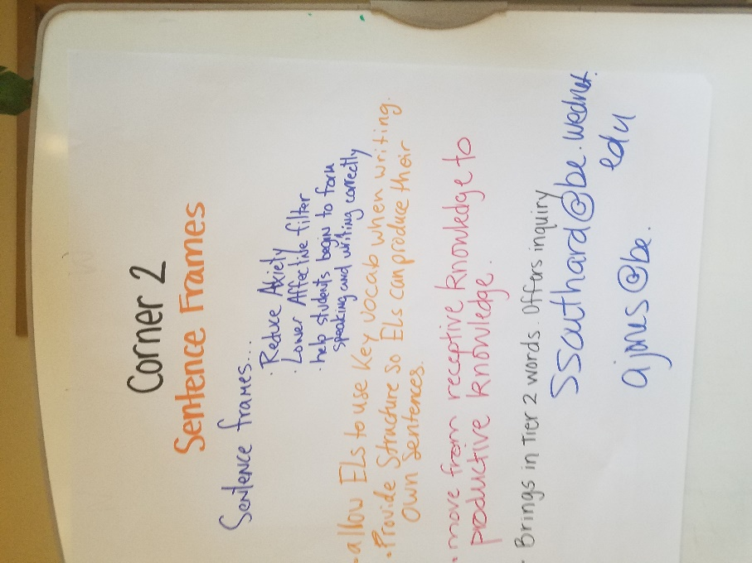 | Pre-Teaching  