Invoice Back up Documentation Instructions 2016-17
- Go to MSDRS website, www.msdr.org
- Login into MSIS (top right corner of webpage)
- On MSIS Webpage click on MEP located on top of page
- Click on 2016-17 Reporting Tool
- Click on Select Report Category
- Click on Coordination and Regional Communication located on the top menu bar
- Click on Submitted Reports. It defaults to “My Submitted Reports”. If needed, use the drop down menu to find the report. The report will be associated with whomever is the person entering the data into the MSIS reporting tool.
- Click on Invoice Documentation
  - Download Invoice box appears; input date range for invoice
  - Show Comments: No
  - Sort by: Scope
  - Click Submit Query
- Upload and save Invoice Document from MSIS.
  - Save as: ESD Name-Date Submitted-Invoice Backup
  - i.e. NWESD-Nov15-2016-Invoice Backup
- Add Header, Copy/Paste:
Invoice Backup Documentation ESD name # (Contract # ) to Accompany Invoice # ___________
Billing Period ___________ through ________________
- Helpful Hint: Somewhere in the blank area of the spreadsheet, add hourly rates for each staff member billing time to the MEP program. This will save you a lot of time in the end. See example below:
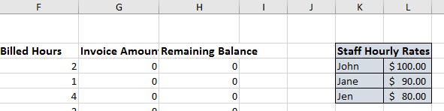
*This is not a necessary step, but it will aide in populating the invoice amount column.

- Add Travel Colum after the Billed Hours Column
  - Click on Invoice Amount Column until down arrow appears, left click on mouse
  - When area is highlighted, right click the mouse
  - Select insert; a new column will appear to the left.
  - Title column “Travel”
  - Add travel expenses associated with each activity in the “Travel” column
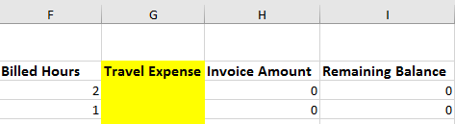

- Add your fiscal data in the Invoice Amount column. This is where the Staff Hourly Rate table comes in handy. There may be instances where two people worked on an activity. Make sure you include all of the time/costs associated with each activity. A sample spreadsheet can be viewed here so you can see the formulas that are used. View Sample HERE.

- Hide the Created By & Staff Columns
  - Highlight both columns
  - When area is highlighted, right click mouse
  - Select ‘Hide’
- Add Subtotal row after each SOW area and add the Invoice Amount column. At this point, you’ll need to refer to your submitted Agreement with OSPI to know how much you’ve allocated to each SOW category. In this example, $75,000 was allocated to SOW #1. View Sample HERE.

- Submit to fiscal department to create invoice

- Submit invoice to OSPI Contract Manager, Lupe Ledesma, lupe.ledesma@k12.wa.us

