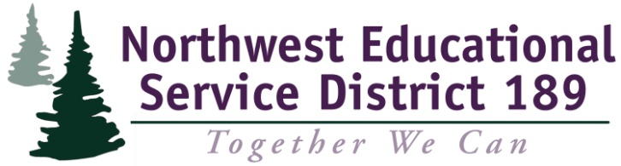 | 1601 R Avenue  Anacortes, WA 98221  Telephone: 360-299-4000  FAX: 360-299-4070

Teacher and Principal Evaluation Project
Session 3: Winter 2015

Essential Questions for the year:
- How do we deepen our knowledge of the purpose and substance of Washington State’s requirements for Student Growth in order to guide decisions which have the promise to improve adult and student learning?
- How do we guide District development and use of appropriate student growth goals?
- How do we connect the work of implementing Washington State Learning Standards with the ‘TPEP’ work?
- How do we establish, implement, and improve systemic professional development support systems regarding adult and student growth within our District(s)?

Learning Targets Session 3
Participants will:
- Understand the Continuous Improvement Process and its role with the District TPEP Leadership Team.
- Understand the current TPEP landscape of their District Team and District Staff.
- Identify a data-driven process to locate gaps within a system and develop a plan to address those gaps.
.

Success Criteria
Participants will:
- Consistently use individual and group norms.
- Analyze District TPEP Leadership Team perception data for reliability and frequency of answers.
- Analyze staff TPEP survey data for frequency within groups, differences between groups, and gaps between this data and the TPEP Leadership Team data.
- Use Data results to create an 18-month professional learning goals with a continuous cycle of action/monitoring.

Content/Purpose | Process | Materials | Key or Fundamental | Slide | Time
Opening, Norms, Essential Questions, Review the Day’s Agenda  Purpose:  To model effective instruction focusing on purpose, student engagement, and classroom environment and culture  To set the expectations for the day | Theory of Action: If we operationally define and plan the professional learning for teachers, building leaders and district leaders, there will be an increased systemic coherence which will result in higher levels of performance and learning from principals, teachers, and students.  Welcome  What does it mean to operate as a collaborative learning team?  - Review of Norms (participants read and reflect…choose one team norm to focus on today….highlight)  What’s the work of the series? Learn as a team; operationalize your learning to share your learning in a systematic way back home…all singing the same song. Need for Operational definitions.  What’s the work of the day? | Copy of Norms  Plus deltas | ML, MM, PC | 1  2  3 | 9:00  9:05

Purpose:  Understand the Continuous Improvement Process and its role with the District TPEP Leadership Team |  | Section 1: What is Continuous Improvement and How does it Apply to Today?  Go over slides. Pause on 4 and 9 for discussion.  Actions 2011-2015 What were our plans? Participants complete a reflection of what they did as a group and individuals to inform their district peers about TPEP implementation.  Group members merge in groups of 3-5 (unlike by role in district) to examine reflections. One serves as recorder.  Members lay out their reflections to be examined by the entire group.  Each team has 25 minutes to do steps 1-4.  Each team reports out to group.  Group considers 2-3 points to guide action planning at end of day. | Two reflection forms  Protocol for Examining Data  Highlighters  Posters | MM, PC  MM, PC | 4-9  10  11 | 9:05-9:15  9:15-9:25  9:25-9:45
Purpose:  Understand the current TPEP landscape of their District Team and District Staff |  | Section 2: Section 2: What was the result of our TPEP PD Efforts?  Big Picture of the Protocol  Begin with the Predictions  Use a note card, number 1-2, answer in general terms. Which group will have the best understanding? When done, collect note cards. Put teams into pairs.  Protocol Instructions  - Predict  - Observe  - Infer  Groups use ‘Data-Driven Dialogue’ process and documents. I document per data point/summary.  Allow 8 minutes per data point/summary per group; groups rotate on their own but review all.  Each pair gets 1-2 documents to analyze and report on to larger group.  Report out. | Data Driven Dialogue Tool  Posters  Survey Results | ML  MM. PC  MM, PC  MM | 12,13  14  15 | 9:45  9:50  11:00  11:20
 | LUNCH
Identify a data-driven process to locate gaps within a system and develop a plan to address those gaps. |  | Section : Action Planning | Action Plan tool |  |  | 12:00-2:00
 |  | Closure, Evaluation  Clock hours  Evaluation | Plus Deltas  Clock hours |  |  | 2:00

