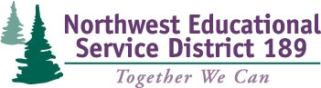

TPEP Professional Learning Series
February 3, 2015 Session #3

Essential Questions for the year:
- How do we deepen our knowledge of the purpose and substance of Washington State’s requirements for Student Growth in order to guide decisions which have the promise to improve adult and student learning?
- How do we guide District development and use of appropriate student growth goals?
- How do we connect the work of implementing Washington State Learning Standards with the ‘TPEP’ work?
- How do we establish, implement, and improve systemic professional development support systems regarding adult and student growth within our District(s)?

Agenda
- Welcome
- The Continuous Improvement Model
- Actions from 2011-2015: What did you do?
- Data results: What effect did your PD have?
- Lunch
- Plan: What do you do next?
- Close

