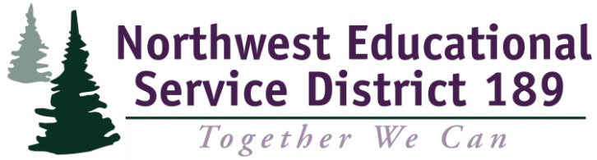 | 1601 R Avenue  Anacortes, WA 98221  Mental Health Services  Office Telephone: 360-299-4017  Office FAX: 360-299-4005  Customer Service: 888-299-4080  TTY: 360-299-4006
Child Behavioral Health Services
Referral Form
Student Name: Gender:
DOB: Age: Grade:
School District: School:
Teacher: Phone #:
School Counselor: Phone #:
Parent/Legal Guardian Name:
Relationship to Student/Client:
Address:
Home Phone: Cell/Other Phone:
Is Child’s Primary Language English: Yes No
Child’s Other Language(s): Other Language(s) Spoken in Home:

DEMOGRAPHICS AND REFERRAL

Ethnicity: (check all that apply)
Asian/Pacific Islander Latino/Hispanic Caucasian/White
Black/African American American Indian Russian/Ukranian
Other (Specify):
Living Situation: (check one)
Both parents Foster Care Partnered Adults
Parent and Stepparent Alone or with Friends Unknown
Single Parent Other Out of Home Placement
Relatives Other (Specify):
Participating in Special Program: (check all that apply)
English Language Learner (ELL) Local Program Head Start/Early Head Start
Special Education McKinney-Vento Free/Reduced Lunch
Title I or Learning Assistance 504 Migrant
Program (LAP) Gifted Other (Specify): Reason(s) for Referral: (one or more must be checked)
Poor Attendance Low Interest in School Early Intervention
Academic Problems Developmental Delay (must have at least one
School Behavior Problems Kindergarten Readiness additional reason below)
Additional Reasons: (check all that apply)
Limited English Proficiency Family Basic Needs Homeless
Health Needs for Child Family Violence Substance Abuse Issues
Reported Physical/Sexual Abuse At Risk of Being Homeless Developmental Concerns
Mental Health Needs Other (Specify):

NEEDS ASSESSMENT
Social/Emotional: (check all that apply) or No Identified Need in this Area
Behavioral Problems Family Violence
Parenting Other Mental Health Concerns
Emotional Problems Physical Abuse/Sexual Abuse/Neglect
Substance Abuse Other – Please Describe:
Cultural Factors: (check all that apply) or No Identified Need in this Area
Language Family Customs/Beliefs
Literacy Cultural Approach to Help-Seeking/Acceptance
Communication with School/Other Professionals
Other – Please Describe:

GLE TEACHER RATING FORM - INTIAL
Utilizing the Grade Level Expectations (GLEs) for this child’s current grade placement, please check the appropriate box for EACH of the outcomes below.
For assistance with the GLEs, please consult: http://www.k12.wa.us/ealrs/default.aspx

Mathematics | Below Standard | Meets Standard | Not Observed
1. The student understands and applies the concepts and procedures of mathematics:
2. The student uses mathematics to define and solve problems:
3. The student mathematical reasoning:
4. The student communicates knowledge and understanding in both everyday and mathematical language:
5. The student understands how mathematical ideas connect within mathematics, to other subject areas, and to real-life situations:
Reading | Below Standard | Meets Standard | Not Observed
1. The student understands and uses different skills and strategies to read:
2. The student understands the meaning of what is read:
3. The student reads different materials for a variety of purposes:
4. The student sets goals and evaluates progress to improve reading:
Attendance (past 90 days)
Number of Excused Absences: Number of Unexcused Absences:
Number of Times Tardy:
Comments:

Discipline (past 90 days)
Number of Suspensions: Number of Expulsions:
Number of Discipline Referrals:
Comments:
Reason for Referral: Please briefly state Behavioral, Family, Social, Emotional, Academic and other concerns/needs. Include other services Child/Family Currently Receiving (e.g. IEP, 504, DSHS):

Desired Outcome(s):

Parent/Guardian contacted regarding this referral? Yes No
Informed Consent Form completed and attached? Yes No
Insurance information: Medicaid Private Insurance None Unknown

Name, contact information, signature of referent:

Referent’s Signature Date Referent’s Agency

Referent’s Printed Name Referent’s Phone Number

