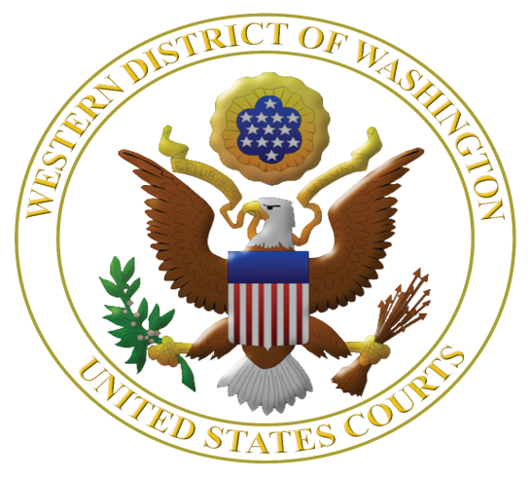
Fifth Annual

Judicial Institute for High School Teachers: June 22, 23 and 24, 2016

Learn More about the U.S. Constitution, Federal Judiciary, Civil Rights, and Federal Criminal Law
www.wawd.uscourts.gov/educators-media/educational-resources

The U.S. District Court for the Western District of Washington in collaboration with the Seattle University School of Law is offering high school teachers a unique opportunity to learn about the U.S. Constitution, federal judiciary, and issues of civil rights, federal-state courts, and federal criminal law. The institute is highly interactive.

Washington State Supreme Court Justice Mary Fairhurst and Chief Magistrate Judge Mary Alice Theiler will contrast how state courts differ from federal courts. Judges who hear the cases you read about in the news will be faculty along with long-term law-related education expert Margaret Fisher to help translate this content into lessons immediately usable in the classroom.

Teachers from 2015 had this to say:

“It is fascinating as well as an efficient use of time for teachers (like me) who need a crash course in the judicial branch. This was a semester's worth of information packed in an understandable way into 2.5 days. Incredible.”

“Not only did I gain ideas that will be useful for a classroom, I learned new things every day to help myself be a better citizen.” “

“Best professional development I have been to (and I have already been to 3 conferences this summer). It was so interesting and interactive and really brought the law to life. I want to bring my students to experience the courtroom.”

“I will recommend this institute to other teachers in my school. The information was great and the time spent will prepare me more for teaching. I have taught for 20 years and I had new learning through this institute and that will make me a better teacher. Thank you for this experience!

Judicial Institute for High School Teachers

June 22, 23 and 24, 2016

Sponsored by the U.S. District Court, Western District of Washington and the
Seattle University School of Law

Eligible applicants: Thirty high school teachers teaching in any of 19 western counties of Washington* who did not participate in a prior Judicial Institute for High School Teachers.

Dates and times: Program starts at 8 a.m. on June 22 and ends on June 24 at 3 p.m. A group dinner is schedule for Thursday, June 23.

Judicial Institute Location: U.S. District Court, 700 Stewart St., 19th floor, Seattle, WA 98101.

Clock hours: 20.5 clock hours pending, credit hours paid by teacher at $2/credit.

Cost: No registration fee, breakfasts and lunches provided on June 22-24, group dinner provided on June 23, parking is provided, and double occupancy hotel rooms provided for the nights of June 21, 22 and 23. If single occupancy is required, teachers are required to pay the additional $101 per day plus half of the room tax and fees.

Registration: Rolling registration until 30 slots are filled.

Selection: Based on time of application and geographic diversity.

More information: Margaret Fisher, Seattle University School of Law, fisherm2@seattleu.edu or 206-501-7963.

Please apply early and send your completed application as soon as possible to:

Margaret E. Fisher
Distinguished Practitioner in Residence
Seattle University School of Law
P. O. Box 222000
Seattle, WA 98122 or send by email to: fisherm2@seattleu.edu

*Counties in the Western District of Washington are: Clallam, Clark, Cowlitz, Grays Harbor, Island, Jefferson, King, Kitsap, Lewis, Mason, Pacific, Pierce, San Juan, Skagit, Skamania, Snohomish, Thurston, Wahkiakum, and Whatcom.

APPLICATION to the Judicial Institute for High School Teachers 2016

Name: ___________________________________________________________________

Name of High School: ______________________________________________________

School Dist./Employer: ______________ County School Located: ___________________

School Address: ___________________________________________________________

City: ______________, WA Zip: ______

Phone Numbers: Work ______________ Home _______________ Cell _______________

Work Email Address: ___________________________________________________
Preferred during school year: ____ Yes ____ No; During summer 2016: ____ Yes ____ No

Personal Email Address: __________________________________________________
Preferred during school year: ____ Yes ____ No; During summer 2016: ____ Yes ____ No

Washington Teaching License #: ______________________________________________

Home Mailing Address: ________________________City: _____________, WA Zip: ________

Provide a brief statement of intent – no more than 300 words – as to how you will use the Judicial Institute experience in your teaching assignment and share your experience with teaching colleagues.

By submitting this application, I certify that (please initial):

I will commit to attending all sessions on all three days of the Judicial Institute. NOTE: Absent an emergency, teachers will not be excused from full participation in all sessions.

And

I have notified my principal of my application to this Institute. Name of Principal or
Administrator: _____________________________________________________

Please send your completed application as soon as possible to:

Margaret E. Fisher
Distinguished Practitioner in Residence
Seattle University School of Law
P. O. Box 222000
Seattle, WA 98122 or send by email to: fisherm2@seattleu.edu

