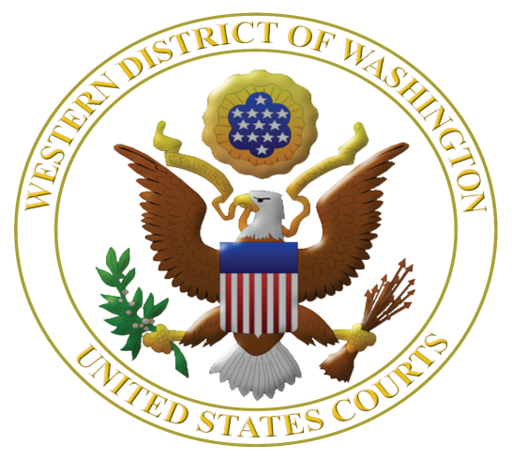
Third Annual

Judicial Institute for High School Teachers: June 25, 26, and 27, 2014

Featuring Mary Beth Tinker of Tinker v. Des Moines School District

Learn More about the U.S. Constitution, Federal Judiciary, Civil Rights, and Federal Criminal Law

Every social studies teacher should rush to sign up for this institute and then prepare for a treat! There will be drug dogs, FBI agents, ex-offenders, and judges galore. You will be wined and dined and treated like the intelligent professional that you are. What a delight after a long year of teaching! Holly Miller, Emerson High School (Kirkland) Teacher, 2013.

There are very few instances in a public school educator's life that they will feel valued, be treated as a professional and will obtain pertinent and interesting information that they will most certainly use in the classroom willingly. This judicial institute did all of these and then some. Karl Heuterman. Sedro-Woolley High School High School Teacher, 2013.

The Judicial Institute was the most outstanding learning experience about our judicial system I have encountered in my 23 years of teaching. I learned so much about the inner workings of our judicial system directly from the judges, lawyers, and staff who are on the front lines in the courtroom. I have already worked with a team of teachers to create engaging new ways of not only educating my students about their rights and responsibilities but allowing them to take on the roles of both accused and members of the legal system. If you can, I would highly recommend that you take advantage of this dynamic program. Sheila Gavigan, Lincoln High School, Tacoma, 2013.

I, for one, haven’t stopped talking about it since we left (three months ago). I have found that the information we learned has come up several times already, and we are only in the first full week of school. Seattle High School Teacher, 2013.

The U.S. District Court for the Western District of Washington in collaboration with the Seattle University School of Law is offering high school teachers a unique opportunity to learn about the U.S. Constitution, federal judiciary, and issues of civil rights, federal-state courts, and federal criminal law. This year the program features Mary Beth Tinker, plaintiff in Tinker v. Des Moines School District, 1969, in which the U.S. Supreme Court ruled that public school students do not shed their free speech rights at the school house door.

Judges who hear the cases you read about in the news will be faculty along with long-term law-related education expert Margaret Fisher to help translate this content into lessons immediately usable in the classroom.

Judicial Institute for High School Teachers

June 25, 26, 27, 2014

Sponsored by the U.S. District Court, Western District of Washington and the
Seattle University School of Law

Eligible applicants: Thirty high school teachers teaching in any of 19 western counties of Washington* who did not participate in 2012 or 2013 Judicial Institute for High School Teachers.

Dates and times: Program starts at 8 a.m. on June 25 and ends on June 27 at 3 p.m. A group dinner is schedule for Thursday, June 26. Teachers will be provided single-occupancy rooms at the nearby downtown Westin Hotel for the nights of June 24, 25, and 26.

Judicial Institute Location: U.S. District Court, 700 Stewart St., 19th floor, Seattle, WA 98101.

Clock hours: 21 clock hours pending, credit hours paid by teacher.

Cost: No charge, meals, mileage, parking, and hotel rooms provided.

Registration: Rolling registration until 30 slots are filled.

Selection: Based on time of application and geographic diversity.

More information: Margaret Fisher, Seattle University School of Law, fisherm2@seattleu.edu or 206-501-7963.

Please apply early and send your completed application as soon as possible to:

Margaret E. Fisher
Distinguished Practitioner in Residence
Seattle University School of Law
P. O. Box 222000
Seattle, WA 98122 or send by email to: fisherm2@seattleu.edu

*Counties in the Western District of Washington are: Clallam, Clark, Cowlitz, Grays Harbor, Island, Jefferson, King, Kitsap, Lewis, Mason, Pacific, Pierce, San Juan, Skagit, Skamania, Snohomish, Thurston, Wahkiakum, and Whatcom.

APPLICATION to the Judicial Institute for High School Teachers 2014

Name: ___________________________________________________________________

Name of High School: ______________________________________________________

School Dist./Employer: ______________ County School Located: ___________________

School Address: ___________________________________________________________

City: ______________, WA Zip: ______

Work Email Address: _______________________________________________________

Personal Email Address: _____________________________________________________

Washington Teaching License #: ______________________________________________

Home Mailing Address: ________________________City: _____________,

WA Zip: ________

Phone Numbers: Work ______________ Home _______________ Cell _______________

Preferred email method of contact:

School Year: ___________________________ (When school ends): ____________

Summer 2014: _________________________

Provide a brief statement of intent – no more than 300 words – as to how you will use the Judicial Institute experience in your teaching assignment and share your experience with teaching colleagues.

By submitting this application, I certify that (please initial):

I will commit to attending all sessions on all three days of the Judicial Institute; and

I have notified my principal of my application to this Institute. Name of Principal or
Administrator: _____________________________________________________

Please send your completed application as soon as possible to:

Margaret E. Fisher
Distinguished Practitioner in Residence
Seattle University School of Law
P. O. Box 222000
Seattle, WA 98122 or send by email to: fisherm2@seattleu.edu

