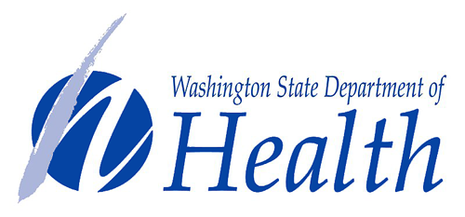

2017 National Rural Health Day Drawing Contest

In honor of National Rural Health Day on November 16, 2017, the Washington State Department of Health is holding a drawing contest! All second through sixth grade students in Washington are invited to participate. All entries will be considered for a 2018 Department of Health calendar to be distributed statewide.

The Department of Health, in partnership with the Eastern Washington Area Health Education Center, will provide an age-appropriate lesson plan on some of the differences between urban and rural communities. The curriculum provided is aligned with Common Core Standards. Students will be asked to draw a picture of what rural health means to them. The drawing should be on letter-sized (8.5” x 11”) paper, horizontal.

Drawings can be scanned and emailed to bonnie.burlingham@doh.wa.gov (this way you can display the original drawings in your school, home, or other location). Please scan at the highest resolution available to you. Each drawing should be clearly labeled on the back with the student’s first name and last initial, grade, and school name. Each submission must be accompanied by the release form provided to you.

If the school is not able to scan the drawings, please mail them, along with the release forms, to:

Bonnie Burlingham
Department of Health
Community Health Systems
PO Box 47853
Olympia, WA 98504-7853
(360) 236-2819

The Department of Health will give five calendars to each student whose drawing was selected for the calendar. Additionally, 50 calendars will be given to each school that has a drawing selected for the calendar.

ENTRY DEADLINE: November 22, 2017

