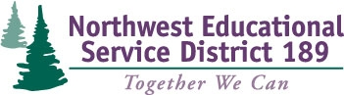

Learning Conversations
Team Registration Form

This two-day workshop offers an introduction to and an initial application of practical tools, technical tips and standards-driven protocols for promoting professional excellence. Teachers will learn how to develop the skills and confidence for engaging in conversations with their principals where learning and professional growth are the focal points.

Participants will work with a team of colleagues and their principal to gain a better understanding and to grow in their ability to conduct learning-focused conversations (about student growth goals, about data, about their instructional choices) with principals.

Workshop Dates: May 28th & 29th, 2014
Registration Fee: FREE
Clock Hours: 12 Available ($29)
(8:30am-3pm)

Registration Deadline: May 9, 2014

 | School Name:
 | Name | Email | Title
1 |  |  | Principal
2 |  |  | Teacher
3 |  |  | Teacher
4 |  |  | Teacher

District Contact Information
District: |  | Contact:
Phone: |  | Email:

Return team registration form to:
Jennifer Longchamps
jlongchamps@nwesd.org
Phone (360) 299-4095
Fax (360) 299-4071

