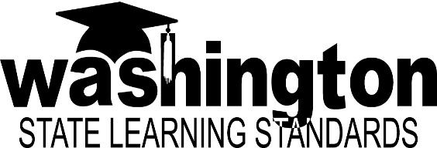
Implementing Career and College Ready Standards in Washington State

Washington state adopted the Common Core Standards for English language arts and mathematics in July 2011; and the Next Generation Science Standards in October 2013. These two sets of “career- and college-ready” learning standards are intentionally built on a progression that prepares students for the future. Washington’s State Learning Standards in other subject areas such as social studies, health and fitness, and the arts remain intact and are complementary to the CCSS and NGSS.

This document connects these standards with Washington’s vision for basic education and provides background on state timelines, what the standards are, and resources available to support their implementation.

Washington’s Basic Education Act and State Learning Goals (1993): A basic education is an evolving program of instruction that is intended to provide students with the opportunity to become responsible and respectful global citizens, to contribute to their economic well-being and that of their families and communities, to explore and understand different perspectives, and to enjoy productive and satisfying lives.
To these ends, the goals of each school district, with the involvement of parents and community members, shall be to provide opportunities for every student to develop the knowledge and skills essential to:
- Read with comprehension, write effectively, and communicate successfully in a variety of ways and settings and with a variety of audiences;
- Know and apply the core concepts and principles of mathematics; social, physical, and life sciences; civics and history, including different cultures and participation in representative government; geography; arts; and health and fitness;
- Think analytically, logically, and creatively, and to integrate technology literacy and fluency as well as different experiences and knowledge to form reasoned judgments and solve problems; and
- Understand the importance of work and finance and how performance, effort, and decisions directly affect future career and educational opportunities.

Our Vision for Implementation: Every student will have access to the Career- and College-Ready (CCR) standards through high quality instruction aligned with the standards every day; and that all teachers are prepared and receive the support they need to implement the standards in their classrooms every da

Our Purpose: To develop a statewide system that supports all school districts in their preparation of educators and students to implement CCR standards using a 2-pronged approach focused on:
- The “What”: Key Content Shifts
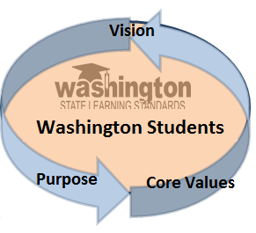
- The “How”: System “Remodeling” to support building capacity for sustained professional learning that supports implementation now and be applied to other initiatives in the future.

Our Core Values: This vision can only occur through core values of clarity, consistency, collaboration, coordination, and commitment from classrooms, schools, and communities to the state level.

Washington’s Career- and College-Ready (CCR) Standards:
Common Core State Standards (CCSS) for English language arts and Mathematics
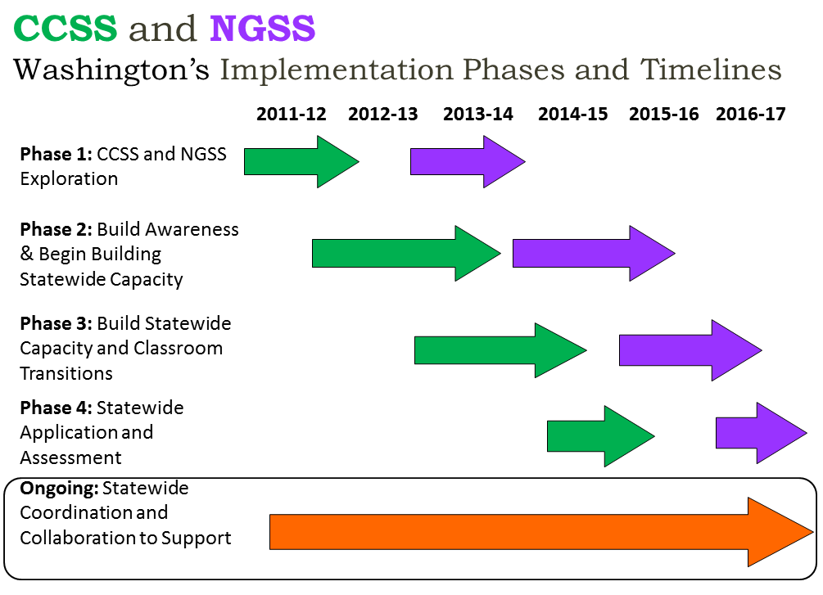
Next Generation Science Standards (NGSS)

Washington State Career and College Ready Learning Standards
Opportunities and Resources
http://k12.wa.us/CurriculumInstruct/default.aspx
http://www.k12.wa.us/CoreStandards/default.aspx

The Standards - Awareness and Professional Learning
- WA transition to CCSS (http://www.k12.wa.us/CoreStandards/Transition.aspx)
- CCSS Professional Learning offering statewide through each ESD (http://www.k12.wa.us/CoreStandards/ProfDev.aspx)
- English Language Proficiency Standards (based on CCSS) (http://www.k12.wa.us/MigrantBilingual/ELD.aspx)
- WA transition to NGSS (http://www.k12.wa.us/Science/NGSS.aspx)
- Mathematics and Science Partnerships build capacity around CCSS/NGSS common learning (http://www.k12.wa.us/Mathematics/Partnerships.aspx)
- Instructional Materials Alignment (http://www.k12.wa.us/CurriculumInstruct/InstructionalMaterialsReview.aspx)
- CCSS instructional materials supports (http://achievethecore.org/page/285/materials-alignment-toolkit)
- NGSS instructional materials supports (http://nextgenscience.org/resources)

Assessment Systems
- CCSS – Smarter Balanced Assessment System
- OSPI’s Smarter Balanced Web Page (http://k12.wa.us/SMARTER/default.aspx)
- Smarter Balanced Released Practice Tests (http://www.smarterbalanced.org/pilot-test/)
- Digital Library Development (http://www.k12.wa.us/SMARTER/DigitalLibrary.aspx)
- NGSS – Assessment system under development. NGSS assessments to be piloted in 2016-17.

Teacher-Leadership
- Math and ELA Teacher Leader “Fellows” (http://www.k12.wa.us/CoreStandards/Fellows.aspx)
- Leadership and Assistance for Science Education (LASER) (http://www.wastatelaser.org/)

Statewide CCSS Collaborations and Communications Supports
- OSPI Quarterly Webinar Series (http://www.k12.wa.us/CoreStandards/UpdatesEvents.aspx)
- Educator Content Association Collaborative Group (http://k12.wa.us/CoreStandards/ECACG.aspx)
- District Professional Learning Network Collaborations (http://www.k12.wa.us/CoreStandards/DistrictProject.aspx)
- Ready Washington, Communications Campaign (http://www.readywa.org/)
- CCSS supports for families and communities (http://www.k12.wa.us/CoreStandards/Families/default.aspx)

The “What”: Key Content Shifts in the CCSS
Three Shifts in English Language Arts/Literacy:

1. Building knowledge
through content-­‐
rich nonfiction
Building knowledge through content rich non-­‐fiction plays an essential role in literacy and in the Standards. In K-­‐5, fulfilling the standards requires a 50-­‐50 balance between informational and literary reading. Informational reading primarily includes content rich non-­‐fiction in history/social studies, science and the arts; the K-­‐5 Standards strongly recommend that students build coherent general knowledge both within each year and across years. In 6-­‐12, ELA classes place much greater attention to a specific category of informational text—literary nonfiction—than has been traditional. In grades 6-­‐12, the Standards for literacy in history/social studies, science and technical subjects ensure that students can independently build knowledge in these disciplines through reading and writing. To be clear, the Standards do require substantial attention to literature throughout K-­‐12, as half of the required work in K-­‐5 and the core of the work of 6-­‐12 ELA teachers.

2. Reading, writing and speaking grounded in evidence from text, both literary and informational
The Standards place a premium on students writing to sources, i.e., using evidence from texts to present careful analyses, well-­‐defended claims, and clear information. Rather than asking students questions they can answer solely from their prior knowledge or experience, the Standards expect students to answer questions that depend on their having read the text or texts with care. The Standards also require the cultivation of narrative writing throughout the grades, and in later grades a command of sequence and detail will be essential for effective argumentative and informational writing. Likewise, the reading standards focus on students’ ability to read carefully and grasp information, arguments, ideas and details based on text evidence. Students should be able to answer a range of text-­‐dependent questions, questions in which the answers require inferences based on careful attention to the text.

More on the shifts at achievethecore.org

3. Regular practice with complex text and its academic language
K | 1 | 2 | 3 | 4 | 5 |  | 6 | 7 | 8 | 9-10 | 11-12
Foundational Skills
- Print concepts and alphabetic principle  - Phonological awareness  - Phonics and word recognition  - Fluency |  |  |  |  |  | Although foundational skills are addressed prior to grade 6, students who struggle in these areas will need further support.
Reading Literature and Informational Texts
Focus on teaching students reading skills to engage with rigorous texts across a broad spectrum of content; balance the types of texts students read.
*Percentages represent comprehensive use (teaching, learning, and student production) across a school year.
- Balance grades K-5 = 50%* literature; 50%* informational text |  |  |  |  |  | - Balance grade 6-8 = 45%* literature; 55%* informational text
 |  |  |  |  |  | - Balance grades 9-12 = 30%* literature; 70%* informational text
Literacy (Reading and Writing) in History/Social Studies, Science, and Other Technical Subjects
Focus on teaching key ideas, details, using evidence from text to support conclusions, contextual vocabulary acquisition, and point of view.
Writing Standards
Focus on teaching the processes of writing, including a balance of text types and the role of argument in History/ social studies, and science
*Percentages represent comprehensive use (teaching, learning, and student production) across a school year.
Balance of writing types, including writing in the content areas  - By grade 4—opinion =30%; information = 35%; narrative =35% |  |  |  |  |  | Balance of writing types, including writing in the content areas  - Grade 8 – argument = 35%; information = 35%; narrative = 30%  - Grade 12 – argument = 40%; information = 40%; narrative = 20%
Speaking & Listening Standards
Focus on teaching use of rhetorical and critical thinking in speaking, listening, and collaborative study and work
- Comprehension and collaboration
- Presentation of knowledge and ideas
- Evaluate speaker’s point of view
Language Standards
Focus on teaching conventions of standard English, knowledge of language in different contexts, and vocabulary acquisition.
Rather than focusing solely on the skills of reading and writing, the Standards highlight the growing complexity of the texts students must read to be ready for the demands of college and careers. The Standards build a staircase of text complexity so that all students are ready for the demands of college-­‐ and career-­‐level reading no later than the end of high school. Closely related to text complexity—and inextricably connected to reading comprehension—is a focus on academic vocabulary: words that appear in a variety of content areas (such as ignite and commit
The “What”: Key Content Shifts in the CCSS
Three Shifts in Mathematics:
1. Focus strongly where the Standards focus | Focus: The Standards call for a greater focus in mathematics. Rather than racing to cover topics in today’s mile-­‐wide, inch-­‐deep curriculum, teachers use the power of the eraser and significantly narrow and deepen the way time and energy is spent in the math classroom. They focus deeply on the major work* of each grade so that students can gain strong foundations: solid conceptual understanding, a high degree of procedural skill and fluency, and the ability to apply the math they know to solve problems inside and outside of the math classroom.
2. Coherence: think across grades, and link to major topics* within grades | Thinking across grades: The Standards are designed around coherent progressions from grade to grade. Principals and teachers carefully connect the learning across grades so that students can build new understanding onto foundations built in previous years. Teachers can begin to count on deep conceptual understanding of core content and build on it. Each standard is not a new event, but an extension of previous learning.  Linking to major topics: Instead of allowing additional or supporting topics to detract from the focus of the grade, these topics can serve the grade level focus. For example, instead of data displays as an end in themselves, they support grade-­‐level word problems
3. Rigor: in major topics* pursue: conceptual understanding, procedural skill and fluency, and application with equal intensity | Conceptual understanding: The Standards call for conceptual understanding of key concepts, such as place value and ratios. Teachers support students’ ability to access concepts from a number of perspectives so that students are able to see math as more than a set of mnemonics or discrete procedures.  Procedural skill and fluency: The Standards call for speed and accuracy in calculation. Teachers structure class time and/or homework time for students to practice core functions such as single-­‐digit multiplication so that students have access to more complex concepts and procedures  Application: The Standards call for students to use math flexibly for applications. Teachers provide opportunities for students to apply math in context. Teachers in content areas outside of math, particularly science, ensure that students are using math to make meaning of and access content.

Grade Priorities in Support of Conceptual Understanding and Fluency
K–2 Addition and subtraction-­‐-­‐concepts, skills, and problem solving
3–5 Multiplication and division of whole numbers and fractions – concepts, skills, and problem solving
6 Ratios and proportional relationships; early expressions and equations
7 Ratios and proportional relationships; arithmetic of rational numbers 2
8 Linear algebra

Standards for Mathematical Practice  - Make sense of problems and persevere in solving them.  - Reason abstractly and quantitatively.  - Construct viable arguments and critique the reasoning of others. | - Model with mathematics.  - Use appropriate tools strategically.  - Attend to precision.  - Look for and make use of structure.  - Look for and express regularity in repeated reasoning.
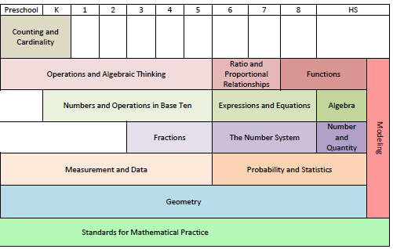
More on the shifts at achievethecore.org
CCSS TOP NATIONAL RESOURCES for Implementation and Communications (updated December 2013)
Cross-Content:
Achieve The Core Guidance and templates on how to begin implementing the shifts, assembled by the nonprofit Student Achievement Partners. Includes instructional materials alignment tools, annotated lessons and tasks for ELA and math, professional development materials, and more. www.achievethecore.org

Achieve – Three new CCSS Implementation Action Briefs (Dec. 2012) targeted to provide role-specific guidance and support to a variety of audiences including policy makers; elementary and secondary school leaders; and school counselors. http://www.achieve.org/publications

Council of the Great City Schools – This consortium of the nation’s largest, most diverse school districts offers a plethora of CCSS resources for educators, families, and communities. http://www.cgcs.org/Page/239

EngageNY/ New York Materials for teachers and teams, videos of classroom application www.engageny.org/teachers

Understanding Language This project aims to heighten educator awareness of the critical role that language plays in the new Common Core State Standards and Next Generation Science Standards. The long-term goal of the initiative is to increase recognition that learning the language of each academic discipline is essential to learning content. http://ell.stanford.edu/

For Mathematics:
Inside Mathematics: Video excerpts of mathematics lessons correlated with the practice standards, resources on content standards alignment, and videos of exemplary lessons in both elementary and secondary settings. www.insidemathematics.org

Illustrative Mathematics: Guidance to states, assessment consortia, testing companies, and curriculum developers by illustrating the range and types of mathematical work that students experience in a faithful implementation of the Common Core State Standards. www.illustrativemathematics.org

Progressions Documents for the Common Core Math Standards: Narrative documents describing the progression of a topic across a number of grade levels. Http://math.arizona.edu/~ime/progressions/

Publishers Criteria for Mathematics: Provides criteria for aligned materials to CCSS. Based on the two major evidence-based design principles of the CCSSM, focus and coherence, the document intends to guide the work of publishers and curriculum developers, as well as states and school districts, as they design, evaluate, and select materials or revise existing materials. www.corestandards.org/resources

For English Language Arts:
Literacy Design Collaborative (LDC) : Focuses on secondary with an eye to cross-content integration. The LDC work can also inform all ELA teachers as we move to more comprehensive literacy teaching. www.literacydesigncollaborative.org

Shanahan on Literacy Blog: Dr. Tim Shanahan’s ongoing discussion with the field provides information and dialogue around literacy issues in the classroom, in research and in community. Shanahanonliteracy.com

National Council of Teachers of English is convening multiple experts and partners to provide teachers with comprehensive supports for English Language Arts and professional collaborative learning. www.ncte.org/standards/commoncore

Publishers Criteria K-2 and Publishers' Criteria 3-12: Provides criteria for aligned ELA materials to CCSS. The documents intend to guide the work of publishers and curriculum developers, as well as states and school districts, as they design, evaluate, and select materials or revise existing materials. www.corestandards.org/resources
The “What”: Key Content Shifts in the NGSS

The Next Generation Science Standards (NGSS) provide an important opportunity to improve not only science education but also student achievement. Based on the Framework for K–12 Science Education, the NGSS are intended to reflect a new vision for American science education. The following conceptual shifts in the NGSS demonstrate what is new and different about the NGSS (www.nextgenscience.org):

1. The NGSS Reflect the Interconnected Nature of Science through Focus, Understanding, and Application of Content | Interconnected Nature: Given the importance of science and engineering in the 21st century, students require a sense of contextual understanding with regard to scientific knowledge, how it is acquired and applied, and how science is connected through a series of concepts that help further our understanding of the world around us. Student performance expectations have to include a student’s ability to apply a practice to content knowledge. Performance expectations thereby focus on understanding and application as opposed to memorization of facts devoid of context.  Deeper Understanding of Content: The Framework identified a smaller set of Disciplinary Core Ideas that students should know by the time they graduate from high school, and the NGSS are written to focus on the same. It is important that teachers and curriculum/assessment developers understand that the focus is on the core ideas—not necessarily the facts that are associated with them. The facts and details are important evidence, but not the sole focus of instruction.
2. The Science Concepts in the NGSS Build Coherently from K–12.  3. Science and Engineering are Integrated across K–12 in the NGSS. | Build Coherently: There are two key points that are important to understand: First, focus and coherence must be a priority. What this means to teachers and curriculum developers is that the same ideas or details are not covered each year. Rather, a progression of knowledge occurs from grade band to grade band that gives students the opportunity to learn more complex material, leading to an overall understanding of science by the end of high school and building towards College and Career Readiness.  Second, the progressions in the NGSS automatically assume that previous material has been learned by the student. Choosing to omit content at any grade level or band will impact the success of the student in understanding the core ideas and put additional responsibilities on teachers later in the process.  Science and Engineering are Integrated: A significant difference in the Next Generation Science Standards (NGSS) is the integration of engineering and technology into the structure of science education. This integration is achieved by raising engineering design to the same level as scientific inquiry in classroom instruction when teaching science disciplines at all levels and by giving core ideas of engineering and technology the same status as those in other major science disciplines.

Science and Engineering Practices  - Asking questions (for science) and defining problems (for engineering)  - Developing and using models  - Planning and carrying out investigations  - Analyzing and interpreting data  Crosscutting Concepts:  - Patterns  - Cause and effect  - Scale, proportion, and quantity  - Systems and system models  Disciplinary Core Ideas  - Physical Science  - Life Science  - Earth and Space Science  - Engineering, Technology and Applications of Science | - Using mathematics and computational thinking  - Constructing explanations (for science) and designing solutions (for engineering)  - Engaging in argument from evidence  - Obtaining, evaluating, and communicating information  - Energy and matter  - Structure and function  - Stability and change
NGSS TOP NATIONAL RESOURCES for Implementation and Communications
(updated Spring 2014)

A Framework for K12 Science Education: Background research guiding the development of the NGSS. www.nextgenscience.org/framework-k–12-science-education

Next Generation Science Standards: Access to the NGSS and supporting materials, including appendices, history of the NGSS development and voices of support. http://www.nextgenscience.org/

Next Generation Science Standards Upcoming Resources: Access to the newest materials available for supporting and implementing NGSS. http://www.nextgenscience.org/upcoming-ngss-resources

National Science Teachers Association: Guidance to science educators, online professional development opportunities including webinars, videos and short courses, educator discussion board and curriculum materials supporting the NGSS. http://www.nsta.org/about/standardsupdate/default.aspx, http://ngss.nsta.org/

National Association of State Boards of Education: Provides resources for local and state boards of education in developing deeper understanding of the NGSS. http://www.nasbe.org/project/next-generation-science-standards/

Tools for Ambitious Science Teaching: This University of Washington web site provides tools and resources that support ambitious science instruction at the middle school and high school levels. Ambitious teaching deliberately aims to get students of all racial, ethnic, and class backgrounds to understand science ideas, participate in the discourses of the discipline, and solve authentic problems. http://tools4teachingscience.org/

http://www.k12.wa.us/Science/NGSS.aspx | 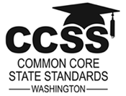  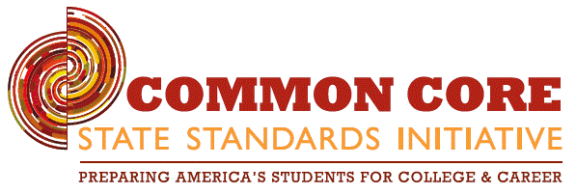  www.k12.wa.us/CoreStandards/ |  | 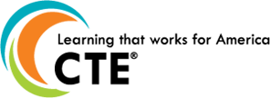  www.careertech.org/career-technical-education/cctc/info.html | 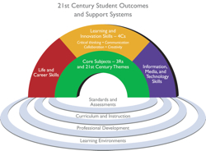  www.p21.org/overview/skills-framework
Science and Engineering Practices  S1. Ask questions (for science) and define problems (for engineering)  S2. Develop and use models  S3. Plan and carry out investigations  S4. Analyze and interpret data  S5. Use mathematics and computational thinking  S6. Construct explanations (for science) and design solutions (for engineering)  S7. Engage in argument from evidence  S8. Obtain, evaluate, and communicate information | Mathematical  Practices  M1. Make sense of problems and persevere in solving them  M2. Reason abstractly and quantitatively  M3. Construct viable arguments and critique the reasoning of others  M4. Model with mathematics  M5. Use appropriate tools strategically  M6. Attend to precision  M7. Look for and make use of structure  M8. Look for and express regularity in repeated reasoning | English Language Arts Practices/Portraits  E1. Demonstrate independence  E2. Build strong content knowledge  E3. Respond to the varying demands of audience, task, purpose, and discipline  E4. Comprehend as well as critique  E5. Value evidence  E6. Use technology and digital media strategically and capably  E7. Understand other perspectives and cultures | Career Ready  Practices  Act as a responsible and contributing citizen and employee.  - Apply appropriate academic and technical skills.  - Attend to personal health and financial well being.  - Communicate clearly, effectively and with reason.  - Consider the environmental, social and economic impacts of decisions.  - Demonstrate creativity and innovation.  - Employ valid and reliable research strategies.  - Utilize critical thinking to make sense of problems and persevere in solving them.  - Model integrity, ethical leadership and effective management.  - Plan education and career path aligned to personal goals.  - Use technology to enhance productivity.  - Work productively in teams while using cultural/global competence. | 21st Century Skills  1. Learning & Innovation  Creativity and innovation  Critical thinking and problem solving  Communication and collaboration  2. Information, Media and Technology  Information literacy  Media literacy  Information, communications and technology literacy  3. Life and Career  Flexibility and adaptability  Initiative and self-direction  Social and cross-cultural skills  Productivity and accountability  Leadership and responsibility  Core Subjects and 21st Century Themes  Global awareness  Financial, economic, business and entrepreneurial literacy  Civic literacy  Health literacy  Environmental literacy
Student Practices across Learning Standards and Skills Frameworks in K-12 Education
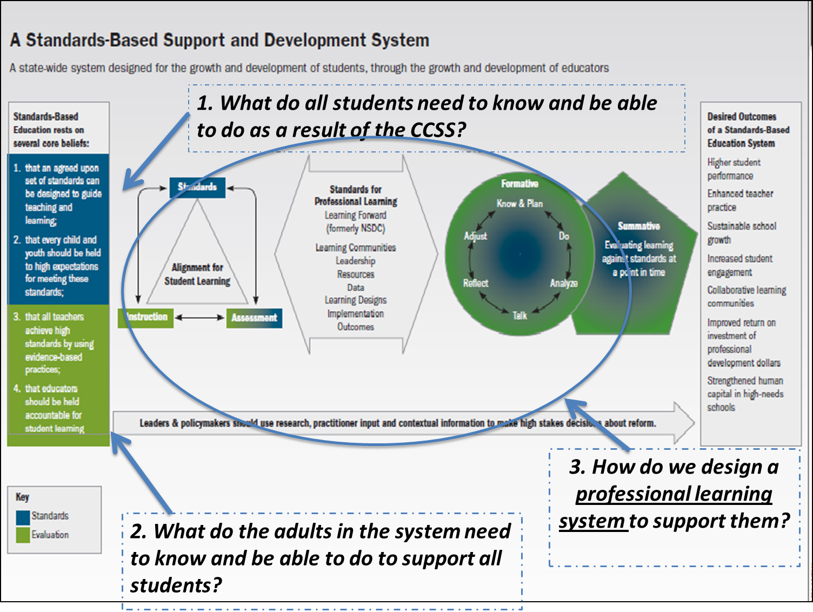
The “How”:
System “Remodeling”

