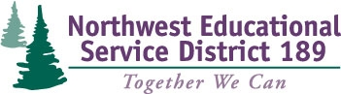

Improving Conversations Centered on Student Learning
Facilitator: Barbara Lawson

Team Registration Form

This 3-day series focuses on the following topics:
- Day 1 will guide principal and teacher teams on how to have learning focused conversations to examine data, set goals and make plans for the school year.
- Day 2 will focus on how to have learning focused conversations to offer feedback about observations and plans to adjust instruction.
- Day 3 participants will use conversations to analyze the work for the year, conduct summative evaluation learning conversations, and make some initial plans for future learning.

Dates: October 14, 2014
Registration Fee: FREE
Clock Hours: 19.5 Available ($44)
(8:30am-3:30pm) January 15, 2015
March 12, 2015
Event ID: 30842

Build Your Team! The intended audience for these workshops is a school team of administrators and teachers.

 | Name | Email | Title
1
2
3
4
5
6

School Contact Information
School: |  | District:
Contact: |  | Phone:

Return team registration form to:
Jennifer Longchamps
jlongchamps@nwesd.org
Phone (360) 299-4095 - Fax (360) 299-4071

