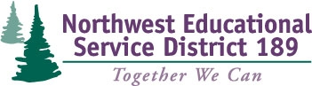
TPEP Professional Learning Series

Team Registration Form

Session #1: Participants will learn the most current decisions/understandings about student growth issues in Washington State including examination of state approved student growth examples.
Session #2: Participants will understand the connections between TPEP practices and Washington state learning standards (CCSS) to gain a coherent vision of improvement.
Session #3: After 4-years of TPEP implementation practices in your district, learn how far you've come and where you have to go. District teams will analyze survey information from their own district to form next steps.
Workshop Dates: October 21, 2014
Registration Fee: FREE
Clock Hours: 16.5 Available ($38)
(9am-3pm) December 2, 2014
February 3, 2015

Build Your Team! The intended audience for these workshops is a district team of administrators and teachers.

 | Name | Email | Title
1
2
3
4
5
6

District Contact Information
District:
Contact: |  | Phone:

Return team registration form to:
Jennifer Longchamps
jlongchamps@nwesd.org
Phone (360) 299-4095
Fax (360) 299-4071

