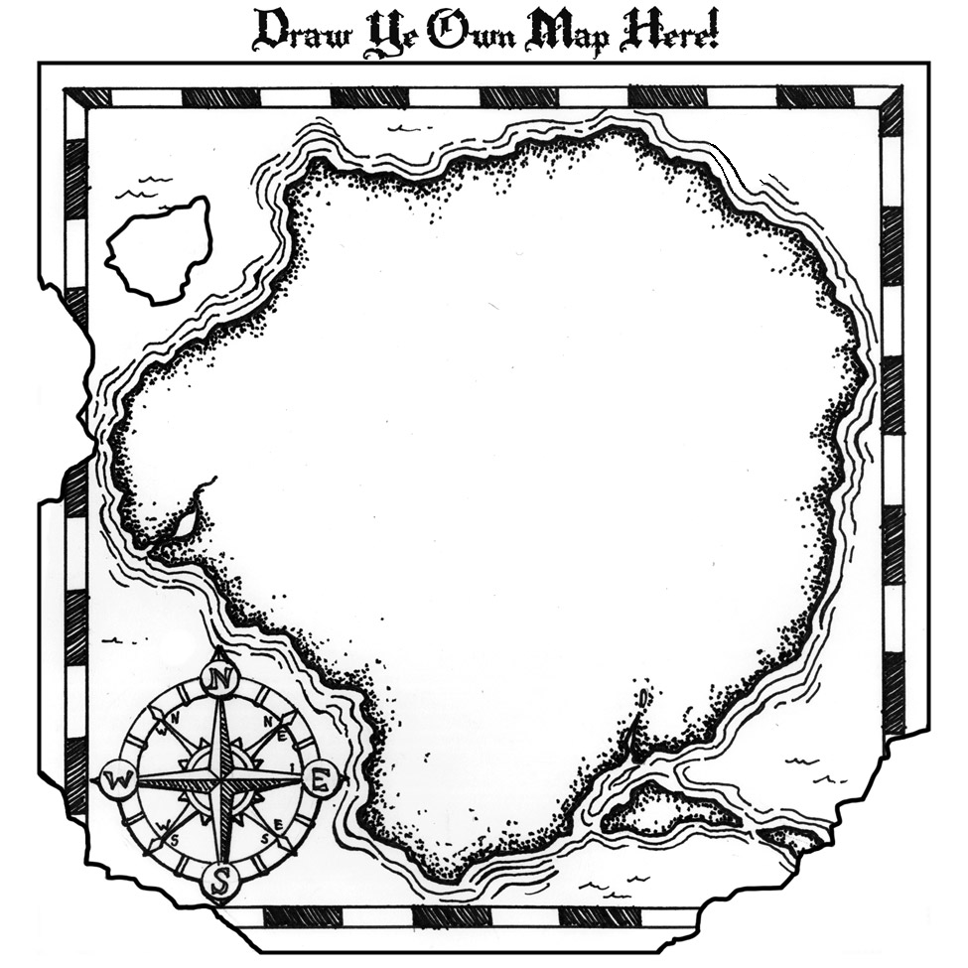

**#2:** [**National Association for Gifted Children (NAGC)**](http://www.nagc.org/resources-publications/resources/national-standards-gifted-and-talented-education/pre-k-grade12)

Artifact: *Pre-K to Grade 12 Gifted Programming Standards*

**#3:** [**Belin-Blank Center, Acceleration Institute**](http://www.accelerationinstitute.org/Nation_Empowered/Default.aspx)

Artifact: *A Nation Empowered: Vol. II* Chapter 4: “The Role of Acceleration in Policy Development in Gifted Education”

**#1:** [**Belin-Blank Center, Acceleration Institute**](http://www.accelerationinstitute.org/resources/policy_guidelines/Acceleration%20Guidelines.pdf)

Artifact: *Acceleration Policy Guidelines* (long-form)

**ACCELERATION POLICY DEVELOPMENT**