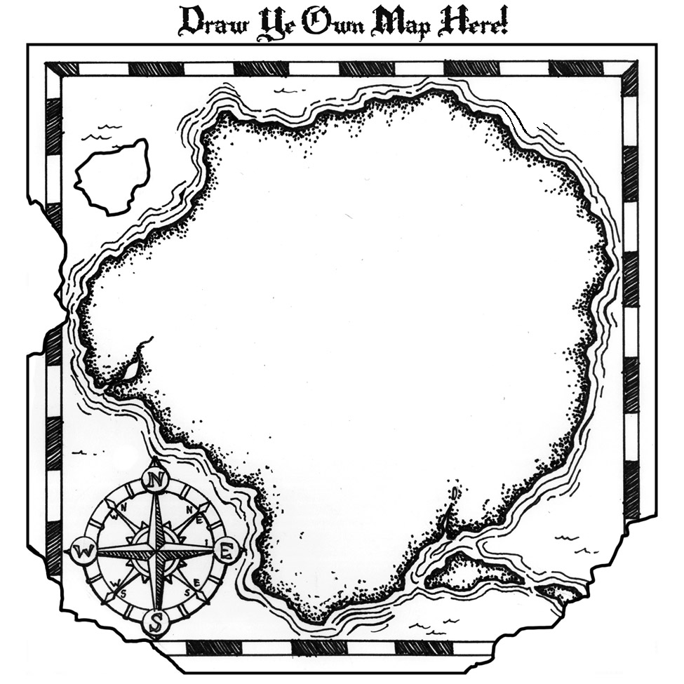

**#3:** [**Prufrock Press**](http://www.prufrock.com/Common-Core-Standards-C1243.aspx)

Artifacts: Common Core State Standards with Gifted and Advanced Learners (assorted texts)

**# 2:** [**Belin-Blank Center, Acceleration Institute**](http://www.accelerationinstitute.org/Nation_Empowered/Default.aspx)

Artifact: *A Nation Empowered: Volume II.* Chapter 8: “Content Acceleration: The Critical Pathway for Adapting the Common Core State Standards for Gifted Students”

**# 1:** [**NAGC**](http://www.nagc.org/resources-publications/resources/timely-topics-gifted-education/common-core-state-standards-national)

Artifact: *Common Core State Standards, National Science Standards*

**ACCELERATION:**

**Common Core State Standards (CCSS)**