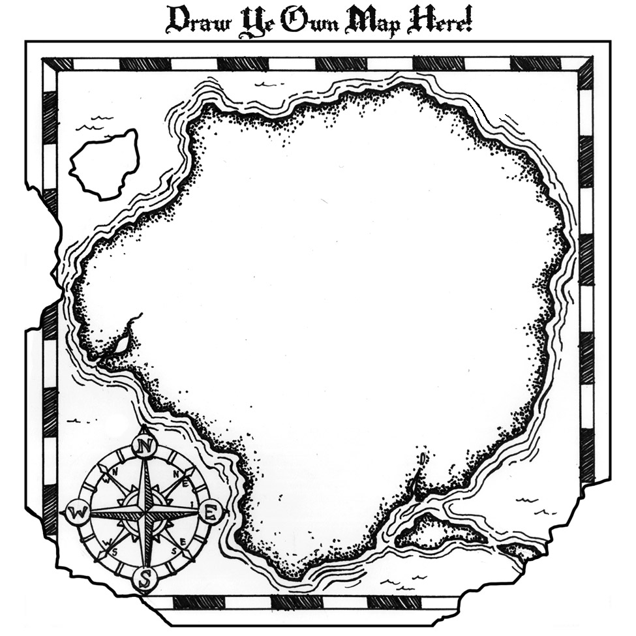

**ACCELERATION: Curriculum Compacting**

**# 4:** [**NRC/GT**](http://www.gifted.uconn.edu/sem/pdf/curriculum_compacting.pdf)

Artifact: Power Point on how to implement Curriculum Compacting.

**#3:** [**Univ. of Connecticut**](http://www.gifted.uconn.edu/Siegle/CurriculumCompacting/8steps.html)

Artifact: Article describing 8 steps of Compacting

**#2:** [**NRC/GT (National Research Center for Gifted and Talented**](http://www.gifted.uconn.edu/sem/semart08.html)

Artifact: *Curriculum Compacting*, by Reis and Renzulli, the originators of the procedures for curriculum compacting.

**#1:** [**NAGC**](http://www.nagc.org/resources-publications/gifted-education-practices/curriculum-compacting)

Artifact: Description of Curriculum Compacting